Might need a cheap mobile based website instead of app

Can check sales etc

Launch screen is the first one that shows up when the app opens

View: what appears

ViewController: What happens when a user. Clicks etc

Model: manipulates the data

Ex contact app - model get data and d. Controller returns to view

If removing contact, the controller communicated with model

Mvc separates parts of code in packages -helps easy controller

That way its easy to maintain and debug

Lol I am rich app

Most pros use single view app and then add features

ORG is unique identifier

X,y 0,0 starts to left and extends right and down

Can find values to pin n code screen resolutions etc available

2x 3x etc naming conventions

LOL pixel- picture element

Points 1pt = 1/72 inch

Ppi pixels per inch

Retina: one point has 4 pixels

No 1x pics available since old apps not really supported

Lins/details might disappear if downloaded

Check iOS Developer Library

 Can use photoshop to scale pic!!!

Don’t tap the emulator icon to test app!! Run it again!!!

Xcode autosaves every 2-3secs?!

Side loading-installing app in phone to view it

DECIMAL versions of Xcode need to match with iOS

KEY: Info does not become knowledge until you put it in practice and it becomes your own

Git/github started from the founder of linux

When you work with designers they will usually give you the exact location of where they want various elements

Outlet changes appearance if ui element

Buttons have both outlets and actions

Outlets cause they might change appearance

Actions cause use might change

When error says: this class is not key value coding-compliant:

How to modify/delete -right click  item -BREAK CONNECTION FIRST

Then drag drop to variable name

 https://forums.developer.apple.com/welcome

UIKit has plenty of tools

Programming-controlled environment has PSEUDO-randomness ;)

If you test as you write you are far less likely to make mistakes

Vr is used to create  Var

On the right the playground shows values

VAR IS like open box, constants are like closed boxes

Functions group together tasks

Swift code doesn’t (also) get executed top to bottom, but when its called

**Apple Developer Forum**

<https://forums.developer.apple.com/>

**Apple API Reference**

<https://developer.apple.com/reference/>

**Apple Guides and Sample Code**

<https://developer.apple.com/library/content/navigation/>

Checking error codes:

https://www.osstatus.com/

Swift was made to be a safe language aka warn the user when writing risky statements

*A way to generate revenue is by uploading question bank apps

Status bar can be light and

DEVICE  orientation- portrait

A method is a function associated with a class!

Not within a class ex free floating - function!

Procedural programming-list of procedures

OOP modules tasks

Class contains instruction of how to make something ex make car

Object actual car

Properties VARS INSIDE CLASS/ VARS ARE CALLED THE OUTSIDE

Actions ex methods

Events ex what to do in certain events ex onDrive() onBrake()

STEVE JOB OOP analogy:

everything occurs on a high level of abstraction because the requester doesn’t need to know how their request is executed

MVC made by Norwegian expert

MVC-good pattern ex building houses fro straw to mud huts to wood and bricks

Spaghetti code- lots of code in one file

Model -manages data, its NOT the data itself

View-what u see on screen

Controller- controls how the two communicate

Controller -waiter

Model- kitchen

Data-raw ingredients

View- customers table

Benefits:

1 structure

2 commonly used/easily recognized

3 code reuse

4 multitasking

Self in console refers to view controller .swift

Whenever you see “in” use ”self”

Make sure YOU GIVE CREDIT TO OPEN SOURCE LIB CREATOR

Solutions to layout:

1 programmatic solution

2 autolayout

Programmatically:

Width- self.view.frame.width/2

Height-self.view.frame.height/2

Center: —self.view.frame.width/2 - self.view.frame.itemslength/2

Pinning: ex length from edge of screen

Alignment: ex center vertically and horizontally

ORDER:

1 uncheck constrain to margins

Blue means constraints are goo

Red or yellow doesn’t

you can create a central container and include items as child members

Set constraints of child elements for side and top

Pin background all sides to 0

Numbers will be diff for each canvas

When selecting constraints you can make the relative to each other and setup equal heights

stackViews: easier and more updated

Fill equally when connecting ui items

Advanced Concepts:

No vars as keywords!

Could use back ‘ ‘ to do it worst case

Classes upper case

Enums are like creating a new data type

Like string ints etc but this time we create war!

Gray icons means item not saved!!!!!

Initializers are seen as constructors

 Designated initializer-needs specified thE param alues

Convenience allows custom objects

Use : to inherit class

Override keyword is in front of method

Super.method() carries over parent class’s implementation

Nil means no data

? Mean it could contain a nil value!!

! (Force unwrapping) Means you know guaranteed a value is not null

It removes safety features

Used when var is declared with ?

solution-Optional binding

Optional- making it safe to run code ex if statement that checks whether a condition is met

To run the code

Cocoapods is a collection of libraries

$ means the terminal is ready to receive commands

Root is the user dir

Ruby:

cocoapods  are ruby gems

Do- end code blocks

Adding PODS:

1 Go to project file

2 Initialize pod file

3 Add pod names found from cocoapods or GitHub

4 Run pod install

5 READY!

*Will need to run pod update to keep up to date!

White xcworkspace has…

Delegation

Swift DICTIONARIES: word and associated meaning

in this case: KEY VALUE PAIRS

API; contract for rules app needs to follow to get data fro website’s server

Pre written and specified in documentation

Ex lat long app id to get weather data

API not only way to get data!

Common Network requests

GET

POST

DELETE

JSON is used in many languages regardless of its name

SEGUES:

Can drag drop from button or identifier

DELEGATES AND PROTOCOLS:

Some packages like coreLocation are closed source :S

Protocols are upper level- could have their own class files

Receiver-adopts the protocol and required methods

Protocol: with required methods

Sender; can contain delegate, check if equal to receiver, call delegate methods

Command B to Build

FIREBASE

Web back end provider

Allows to save and retrieve data

Auth analytics etc!

1 real time DB

Rear by

Can look into firebase API!!!

Closures:

ANONYMOUS FUNCTIONS

You can have a fn as a param input and output

Can make calc with params passed asa nums and the operation as an additional one

Type inference: no need to declare type! :)

LOL can remove RETURN data type?!

CLOSURES can remove return type?!

$0 first param

$1 second param

Can make trading closure aka have closure after param parentheses

Downside: readability

“Map” function can transform arrays!

Anatomy of app:

Button send message to view controller of event

Ex call is from os to controller

Or db message

Events: messages triggered by OS buttons APIs etc

App lifecycle

Battery usage is monitored from OS

Launch-visible-recedes in background-killed by OS ex. when not enough memory

For view controllers:

Editor -> embed in- > navigation controller

Root view controller: the bottom of stack- the FIRST one

GUARD- guard allow to early termination if conditions are not met

TO create new custom Cell

CocoaTouch subclass o UITableViewCell

Check XIB file

ANIMATIONS:

SVProgressHUD updates user when the app is hanging

MACHINE LEARNING:

Computers learn without being explicitly programmed

SUPERVISED ML:

With a teacher

Ex. Recognizing a cat

Data fed and matched with labels

Testing date -> model (machine)-> output

If it sees something new, it might use existing knowledge to classify it

Ex lots of links in email might go to spam lol

-Regression

-Classification data issues

Ex discrete vs continuous

UNSUPERVISED ML:

-clustering: learns that data belong in diff categories

REINFORCEMENT LEARNING:

Rewards & punishments

CoreML:

1 load pre trained model

2. Make predictions

Can’t do!:

No training

Static model

Not Encrypted! -not for proprietary apps!!!

you can find open source converters

Available options:

1 plug and play models

2 icreate your own model

———————

COREML STUFF

———————

INTRO TO APP DESING

Pareto Principle

Why is app Design Important?

a user gets to love the app is the design - the EMOTIONAL RESPONSE created by the app!!!

Designer vs not designer thinker:

Color and typography

Good design is like a unicorn-identifiable but rare ;)

COLOR Theory:

Moods

Red; love energy intensity

(Persuasion human manipulation)

Yellow: intensity energy intelligence

Good for attention grabbing!!!!

Green: freshness safety growth

Blue: stability trust serenity

Lol job interview-to appear trustful-wear blue

Purple: royalty wealth femininity

***What emotions are you trying to convey to the user?

How to combine colors:

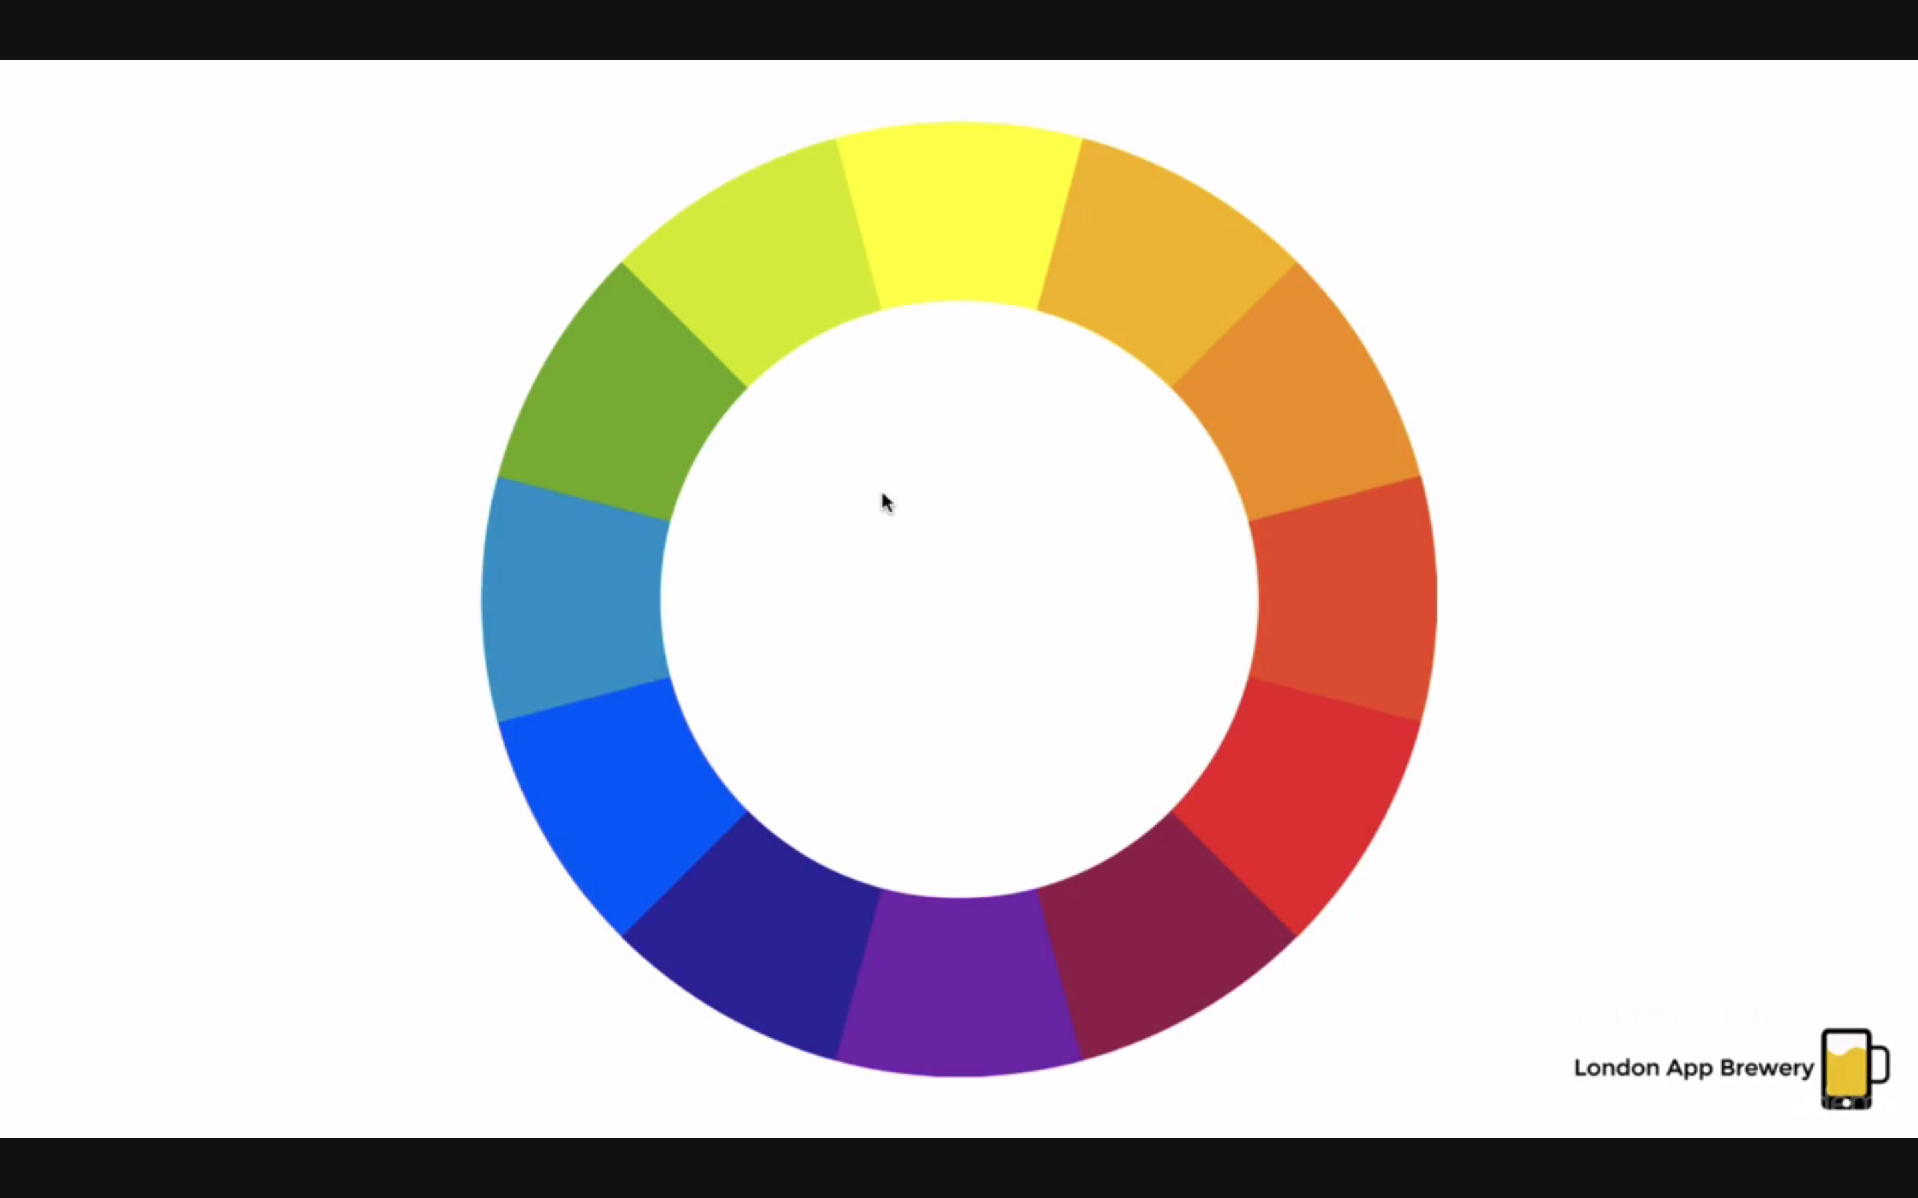

Analogous pallets-colas adjacent to each other

Ex orange and red

Complementary colors;

Opposite in color wheel

Not very good for looking for long time!!

Split colors:

Can choose things adjacent to opposite colors

Triadic colos:

Attention grabbing BUT

Overiused in 90s lol

MODERN:

Monochromatic

A color combined with shades of white or black

TOOLS:

Colorhunt

Flatuicolors

Materialpalette

Colorzilla

TYPOGRAPHY:

Serif

Feet like stone carving

Jenson, Old Style

transitional

Modern

Slab serif-designed to not follow the rule below-created for newspaper-like comics, made to look good on poor quality paper

Difference: modern style has more difference in letter thickness modulation

Grotesque

Humanist-curves

Futura-geometric-like perfectly drawn from a protractor

Readability:

Ex dashboard of grotesque vs humanist

**\*\*\*Ex humanist more open shape, more spaces vs letter,unabmiguous forms,  varying proportions**

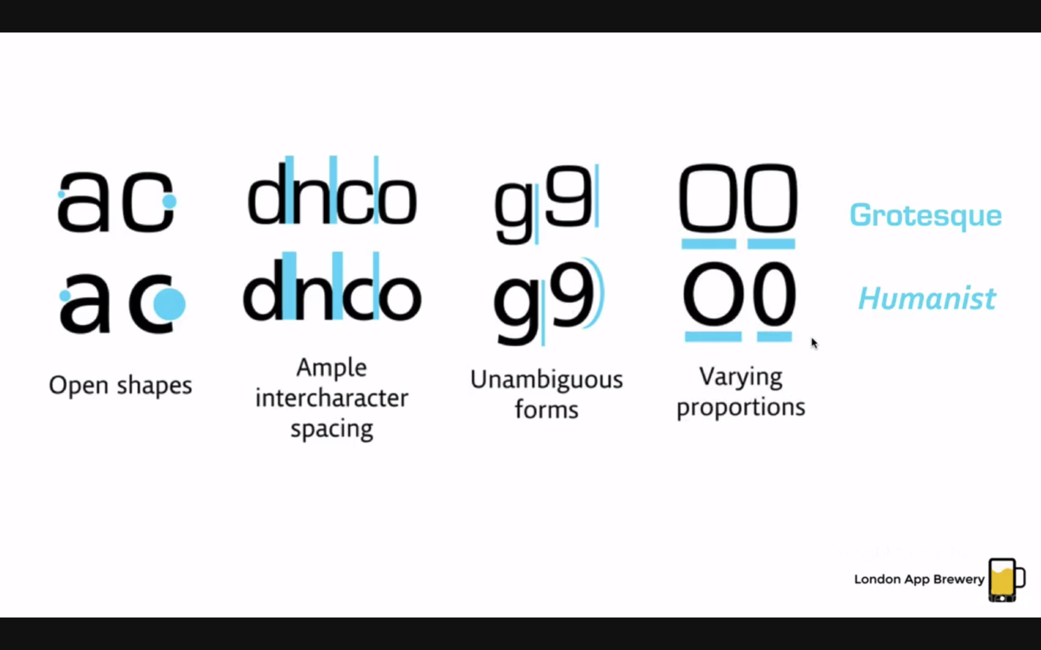

Combining Fonts:

Usually

Serifs and san serifs work together well!!!

DONT mix too many fonts

Two fonts are top

Appreciate the MOOD of the font!!

Combine TIME ERAS

And SERAFS

TOOLS!!!:

WhatFont

FontSquirrel-free for commercial use!

Sky Fonts

UI DESIGN:

1 if an app was a journey

You guide the user

ex. Our attention is first drawn on bigger items

Uxdesign.cc for examples

Better to have a tailored page than having a block of code lol

Jeremy Thomas

Alignment

Minimize alignment lines

Types:

Edge

Centre

Edge alignment photoshop sketch etc

Good practice:

Light comes from top!!

How to get more clickthrough

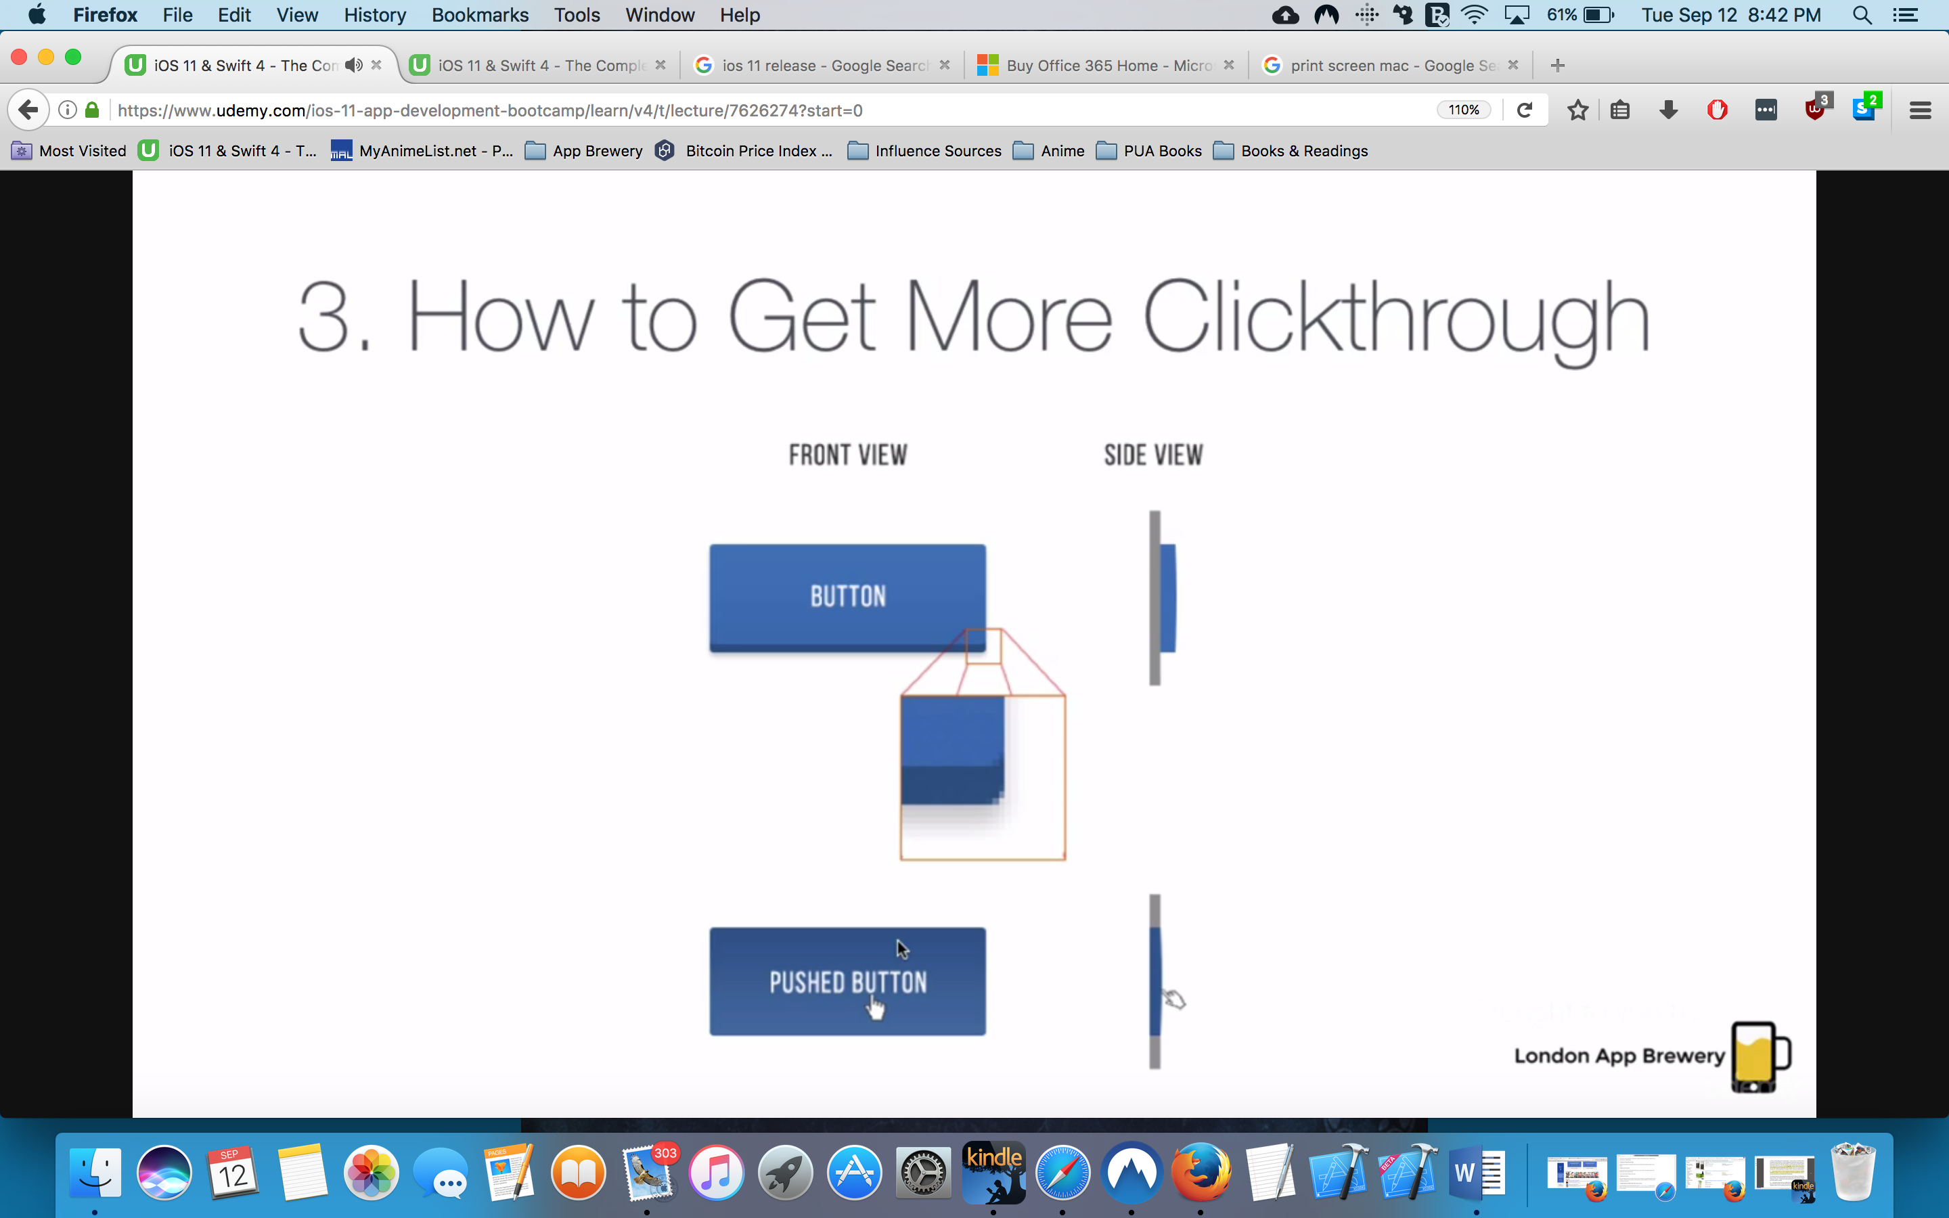

UI that remind of real world ex button

Rethink sacrificing form for function

Good better best:

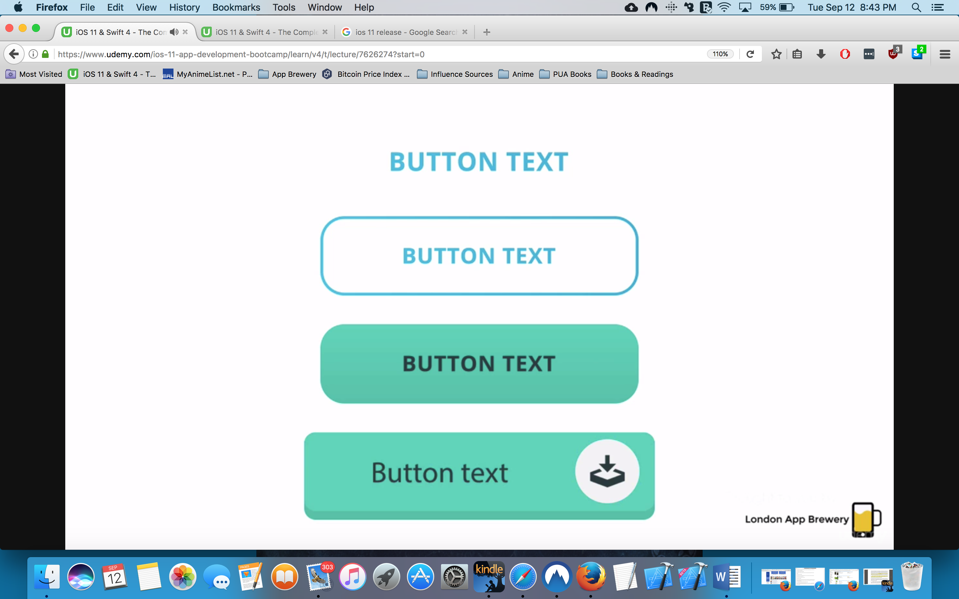

YEEEES WTFFFFFFFFF

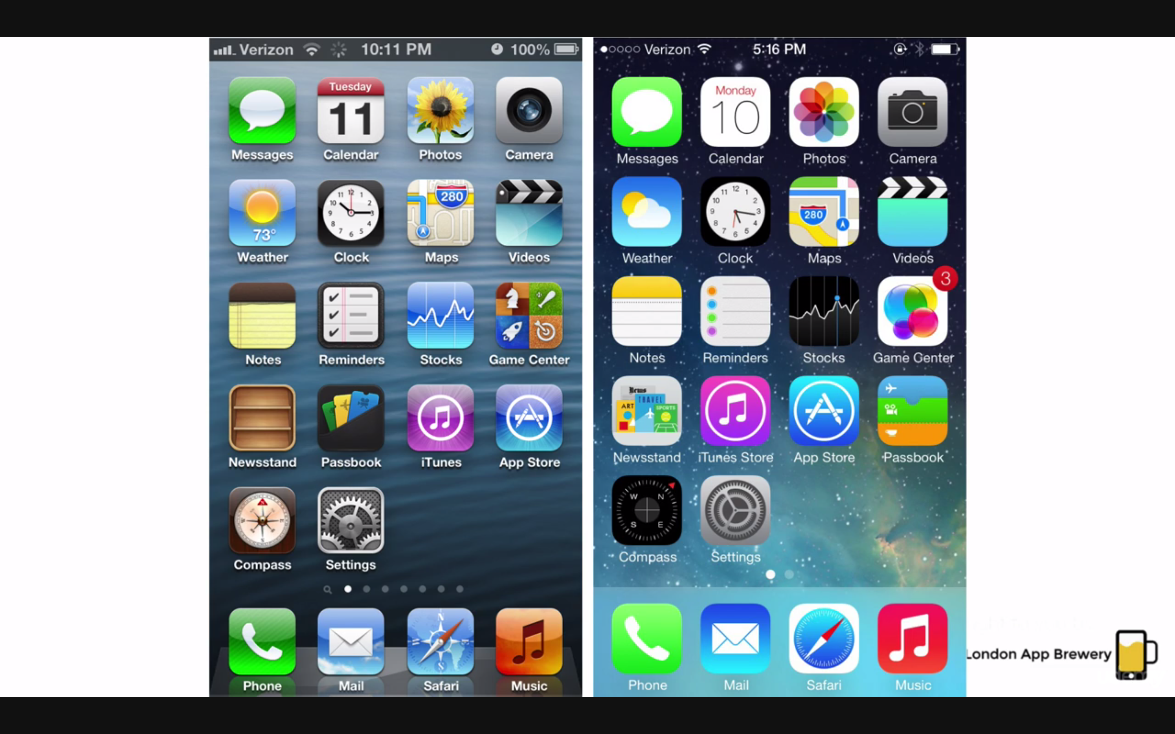

How to design if you don’t know UI design?

Keep it as simple as you can

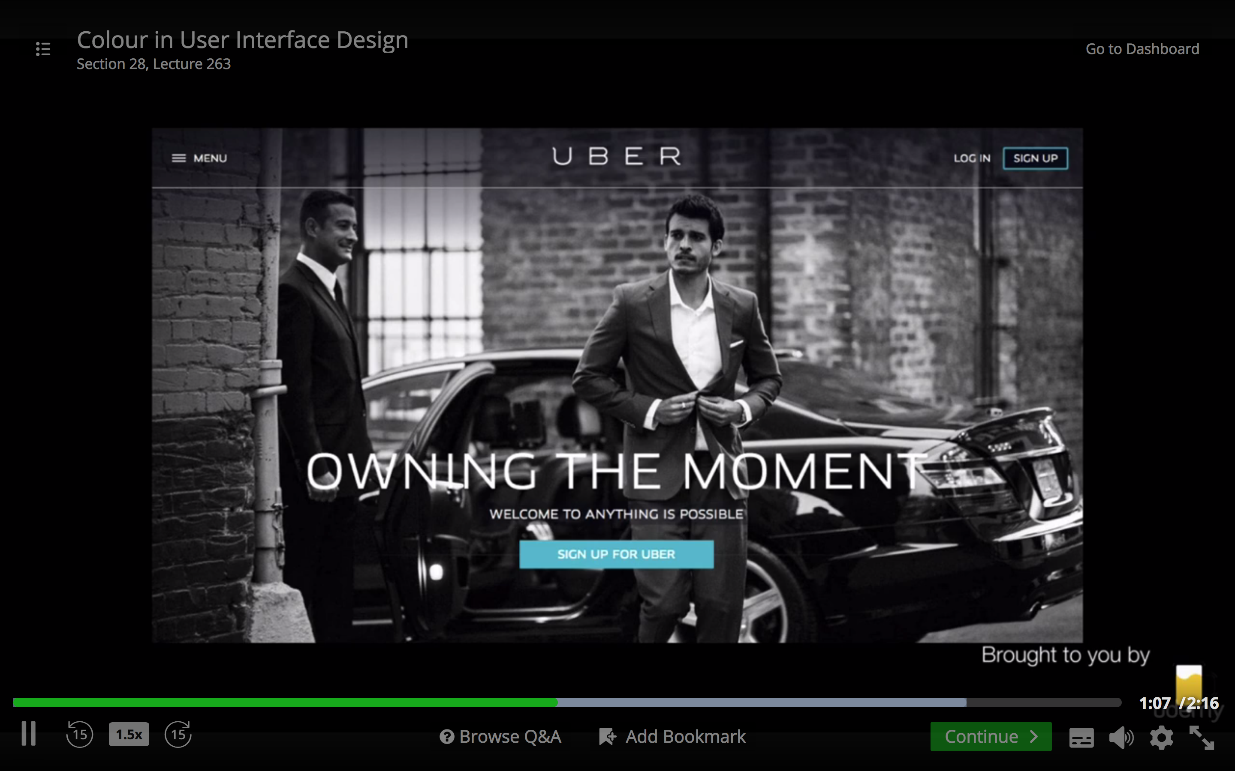

then go upwards

visit dribble!!!!

Text on images -____-

If its same color with image gaga

Use high opacity with back ground image!!!

This is smart: almost no opacity but increased as you look down:

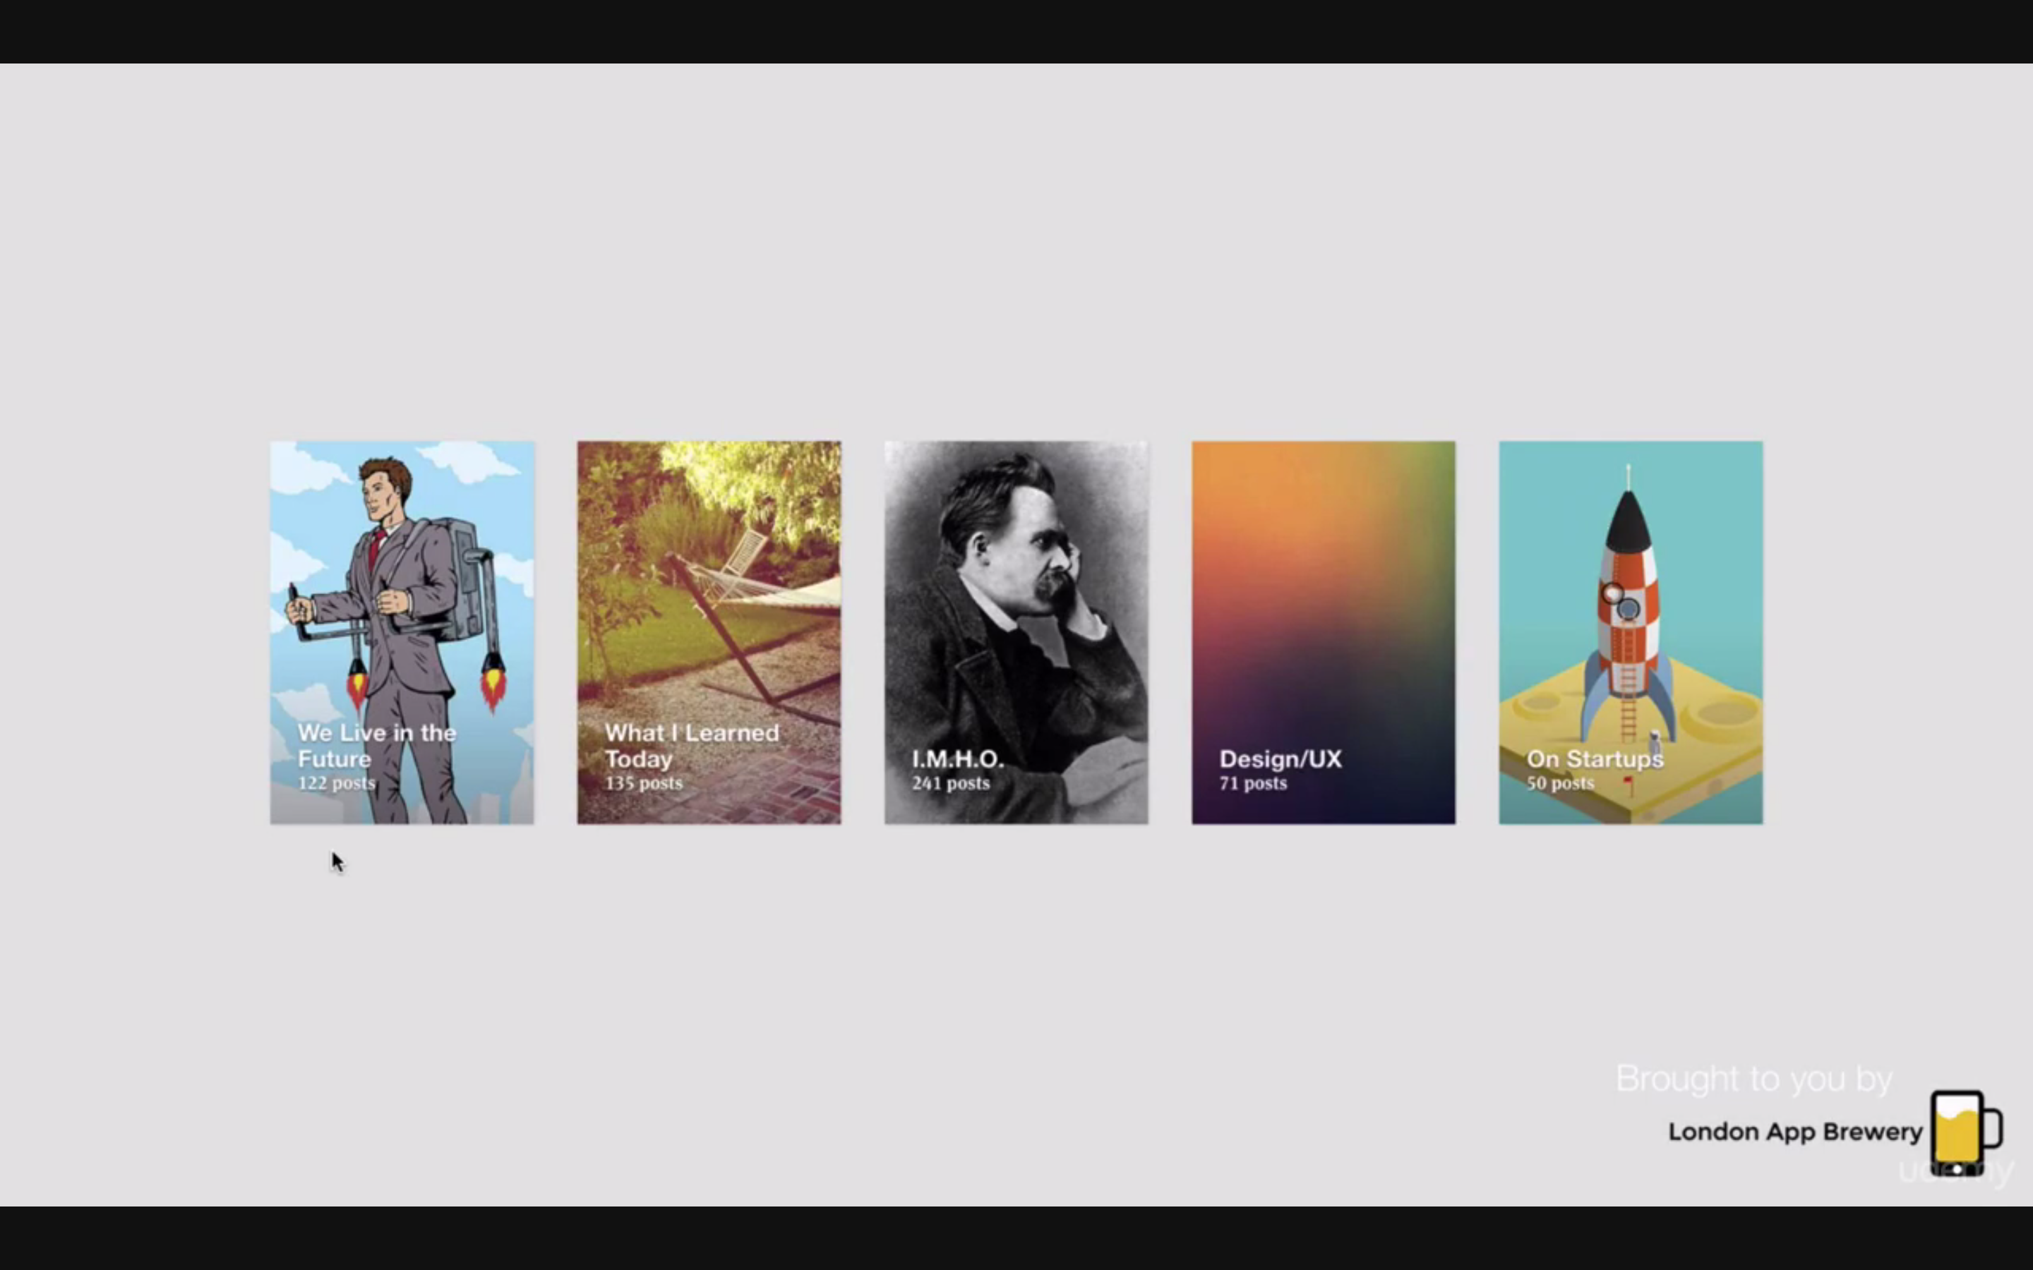

How to become an attention WIZARD

UI designers-attention wizards

First thing to see: title

play around ☺

UX

Be flexible and tailor:

What matter s is to give best user experience

Usability:

What Is my user using my app for?

DON’T be like these idiots :

Too many screens before being able to use the bathroom

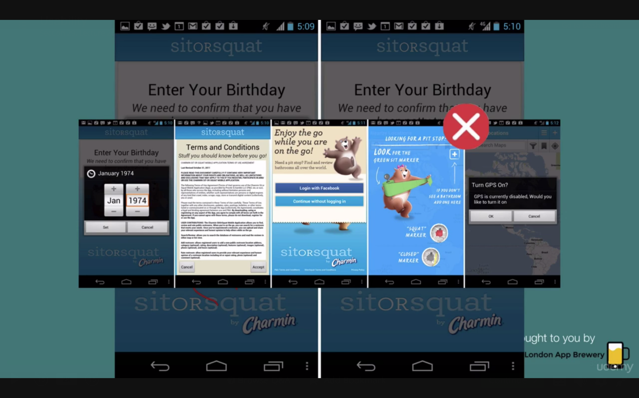

these guys do it right :

<https://yplanapp.com/>

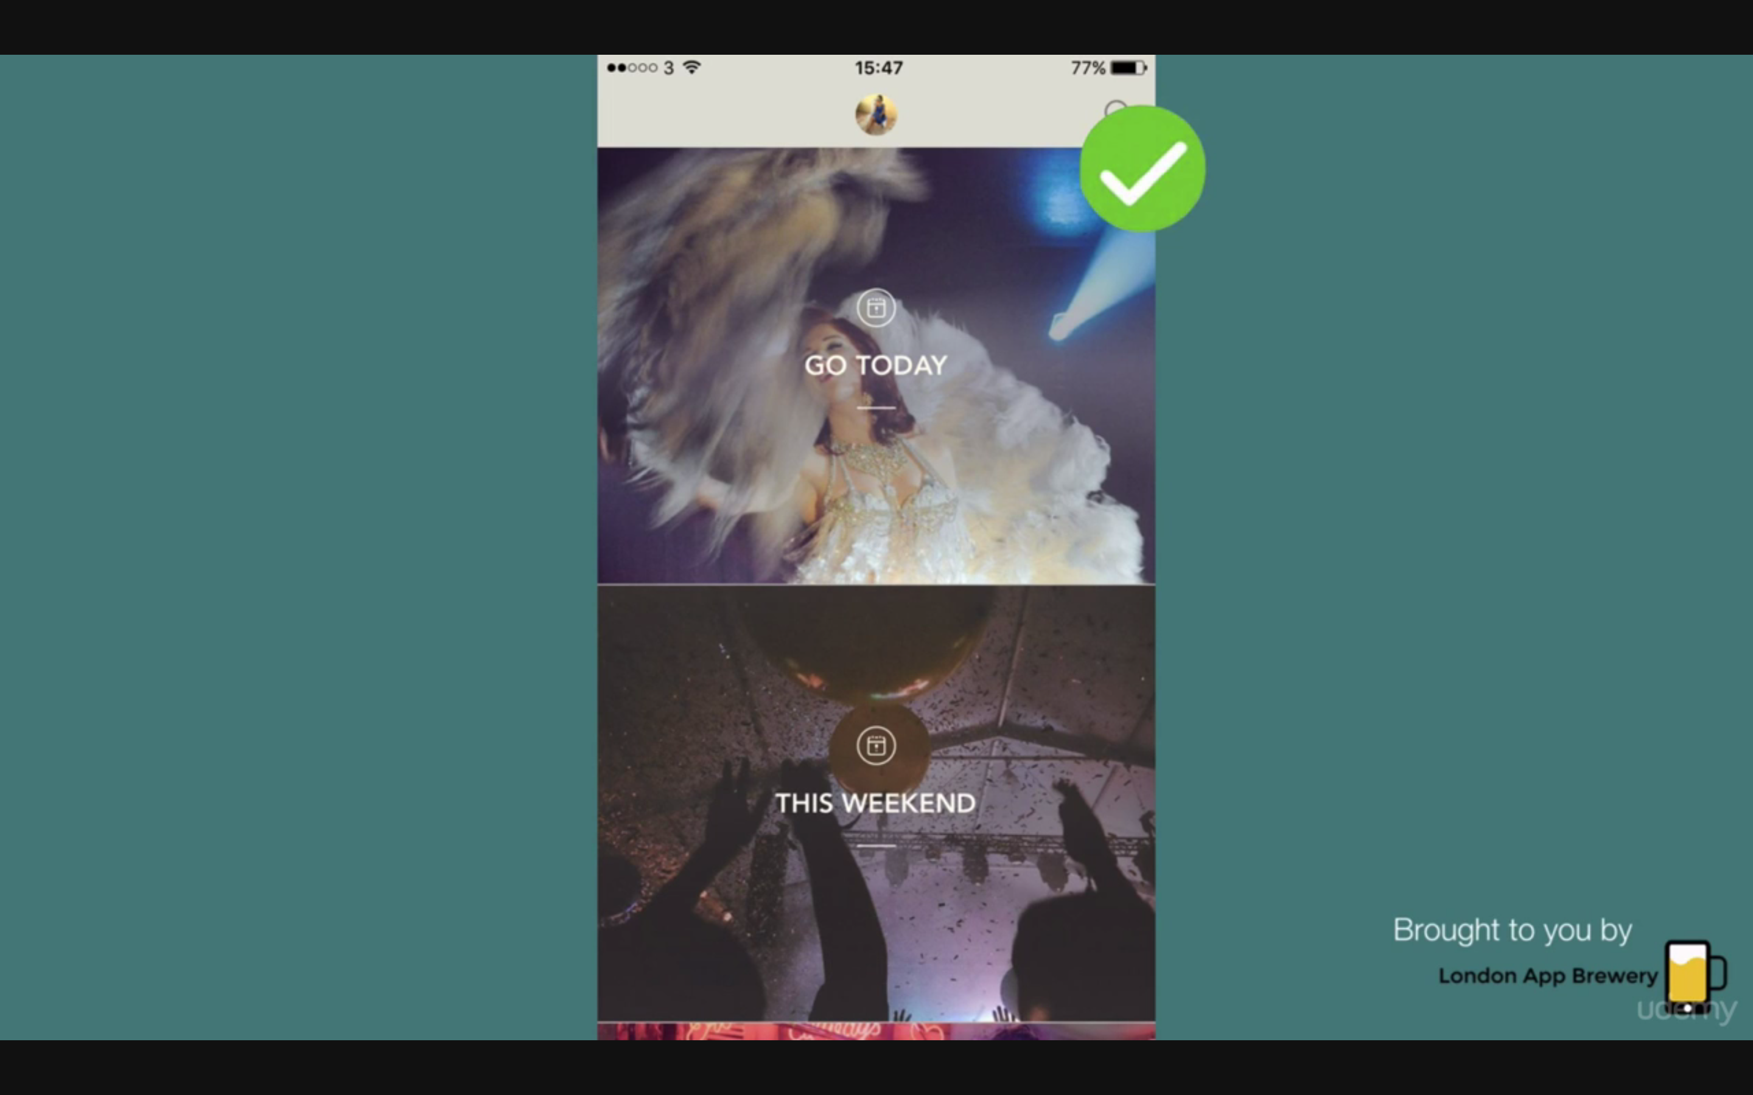

Asking for permission

If you want to ask for a favor start from a small one

That build up due to consistency ;)

Light pattern: ex improved UX such as safety

Dark pattern: slikly make them buy stuff/charging them

User Profiling

The founders of IG had just learned to code!!!

You have to know what your users use your app for

Think of your friends

Form vs Function

Am I doing it just because its clever

Always go for function

Get a SECOND OPINION

Consistency

Am I being consistent?

Ex. This is a hair design page?! Look at the airplanes and background

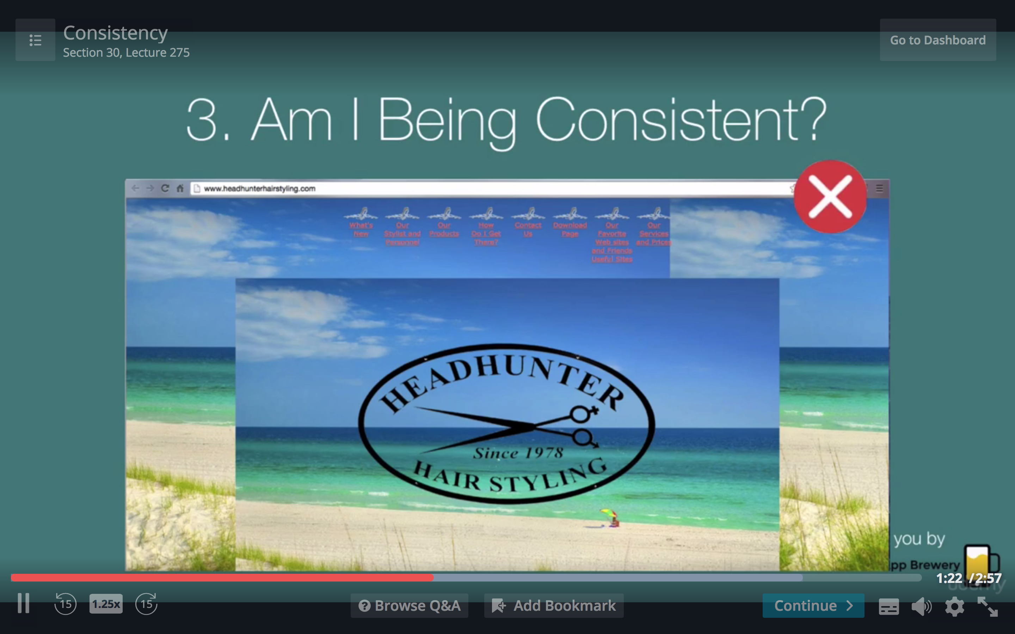

or help desk tickets being submitted made like an ecommerce app ex cart and checkout of tickets

Simplicity

Can I make it simpler?

This is why apple is so appreciated design-wise

Avoid making two rows of buttons

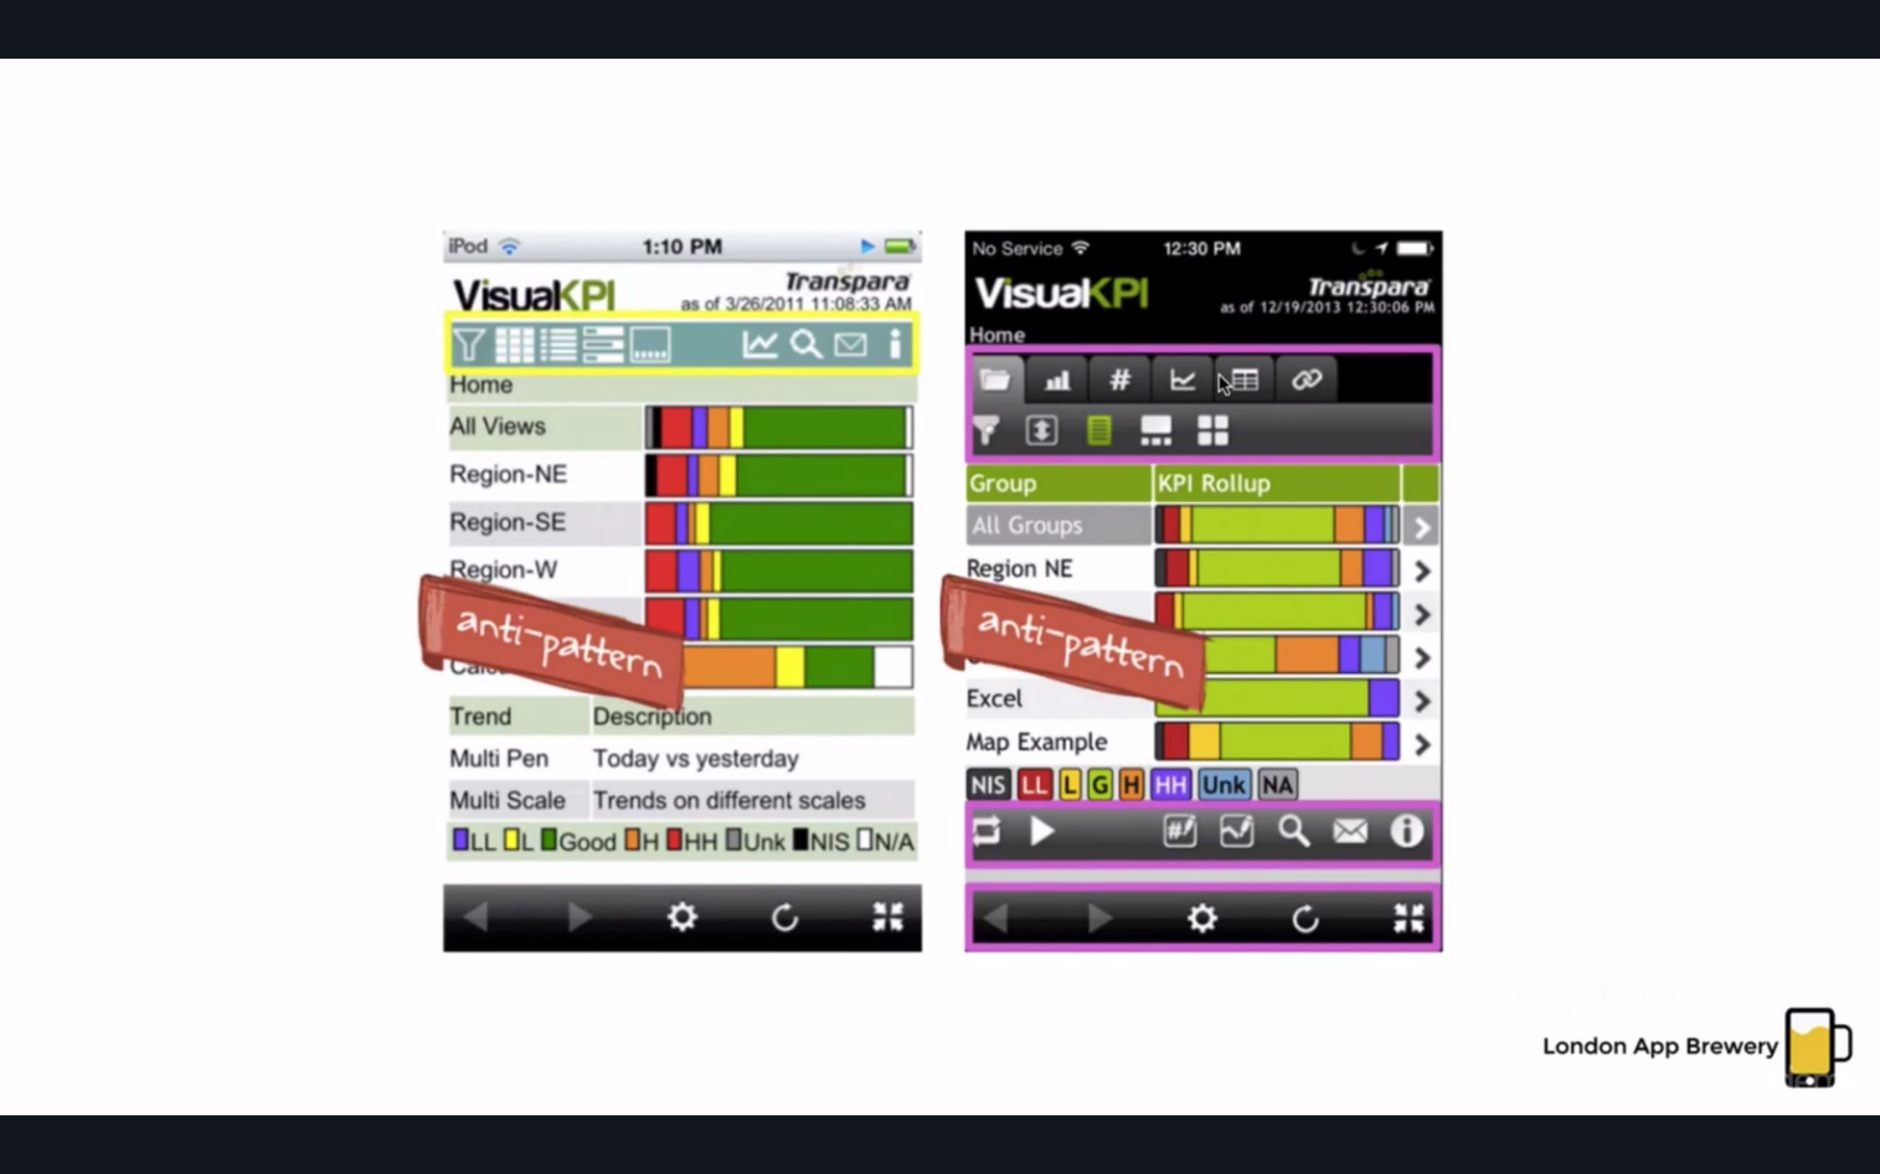

don’t have tutorials of simple stuff

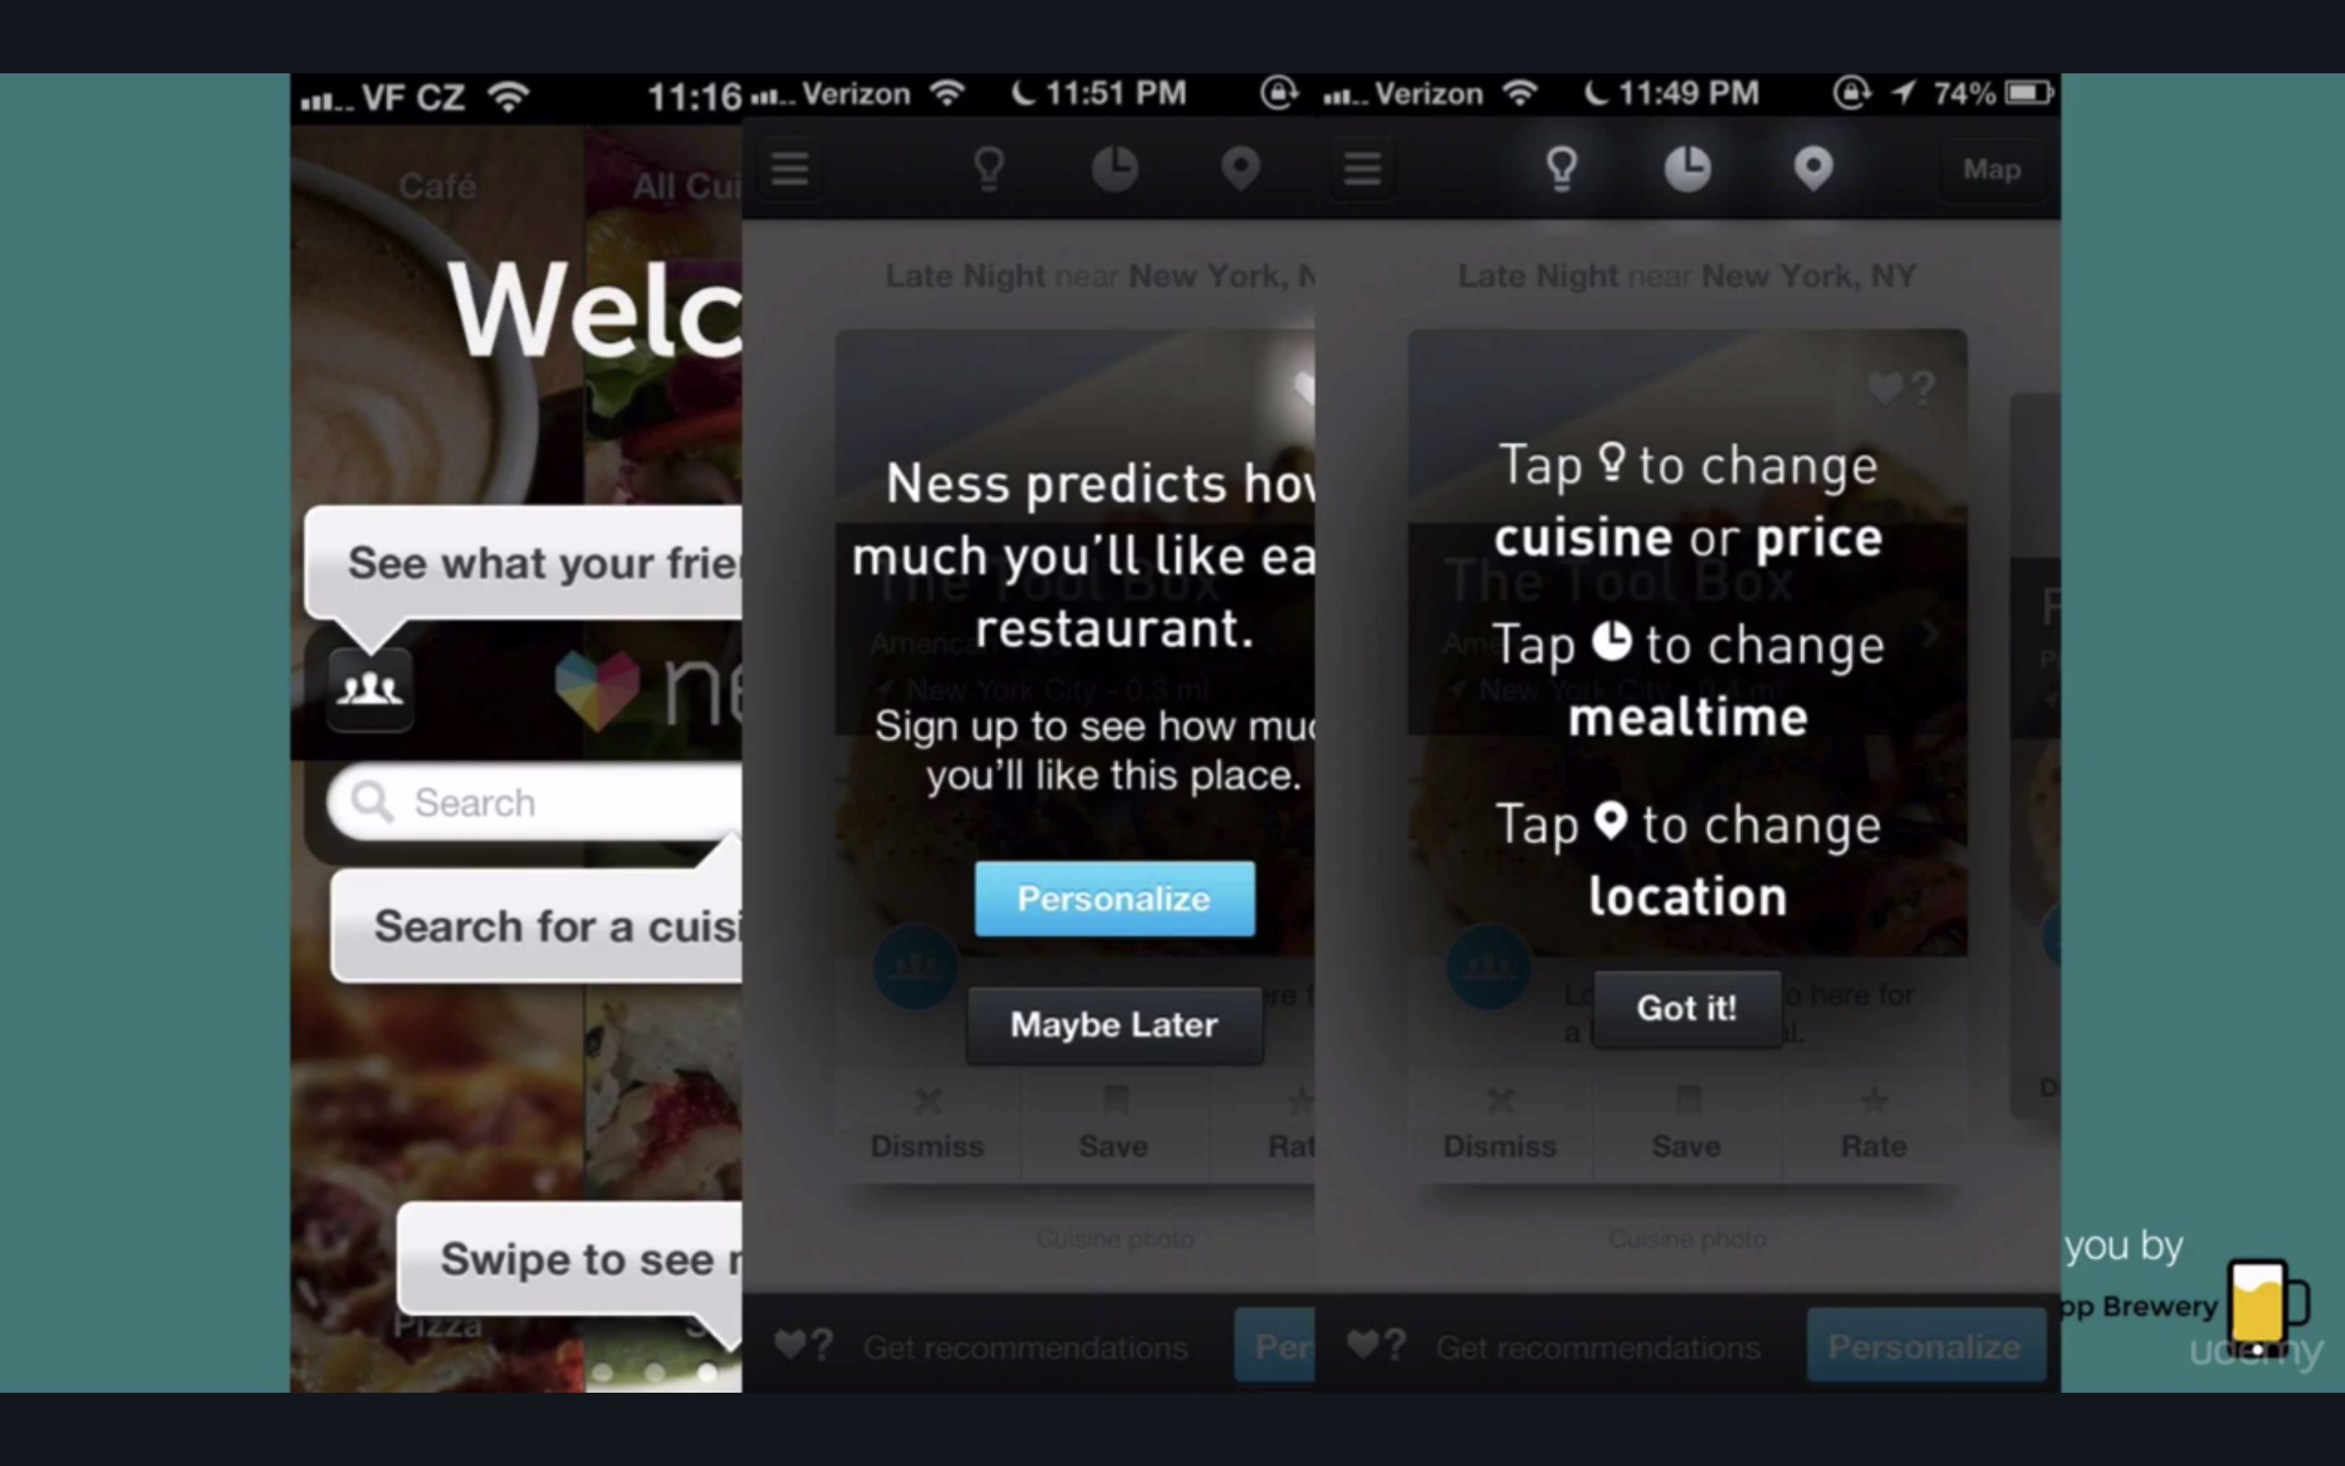

these guys get it right, the user gets what they want in one step (like Yelp)

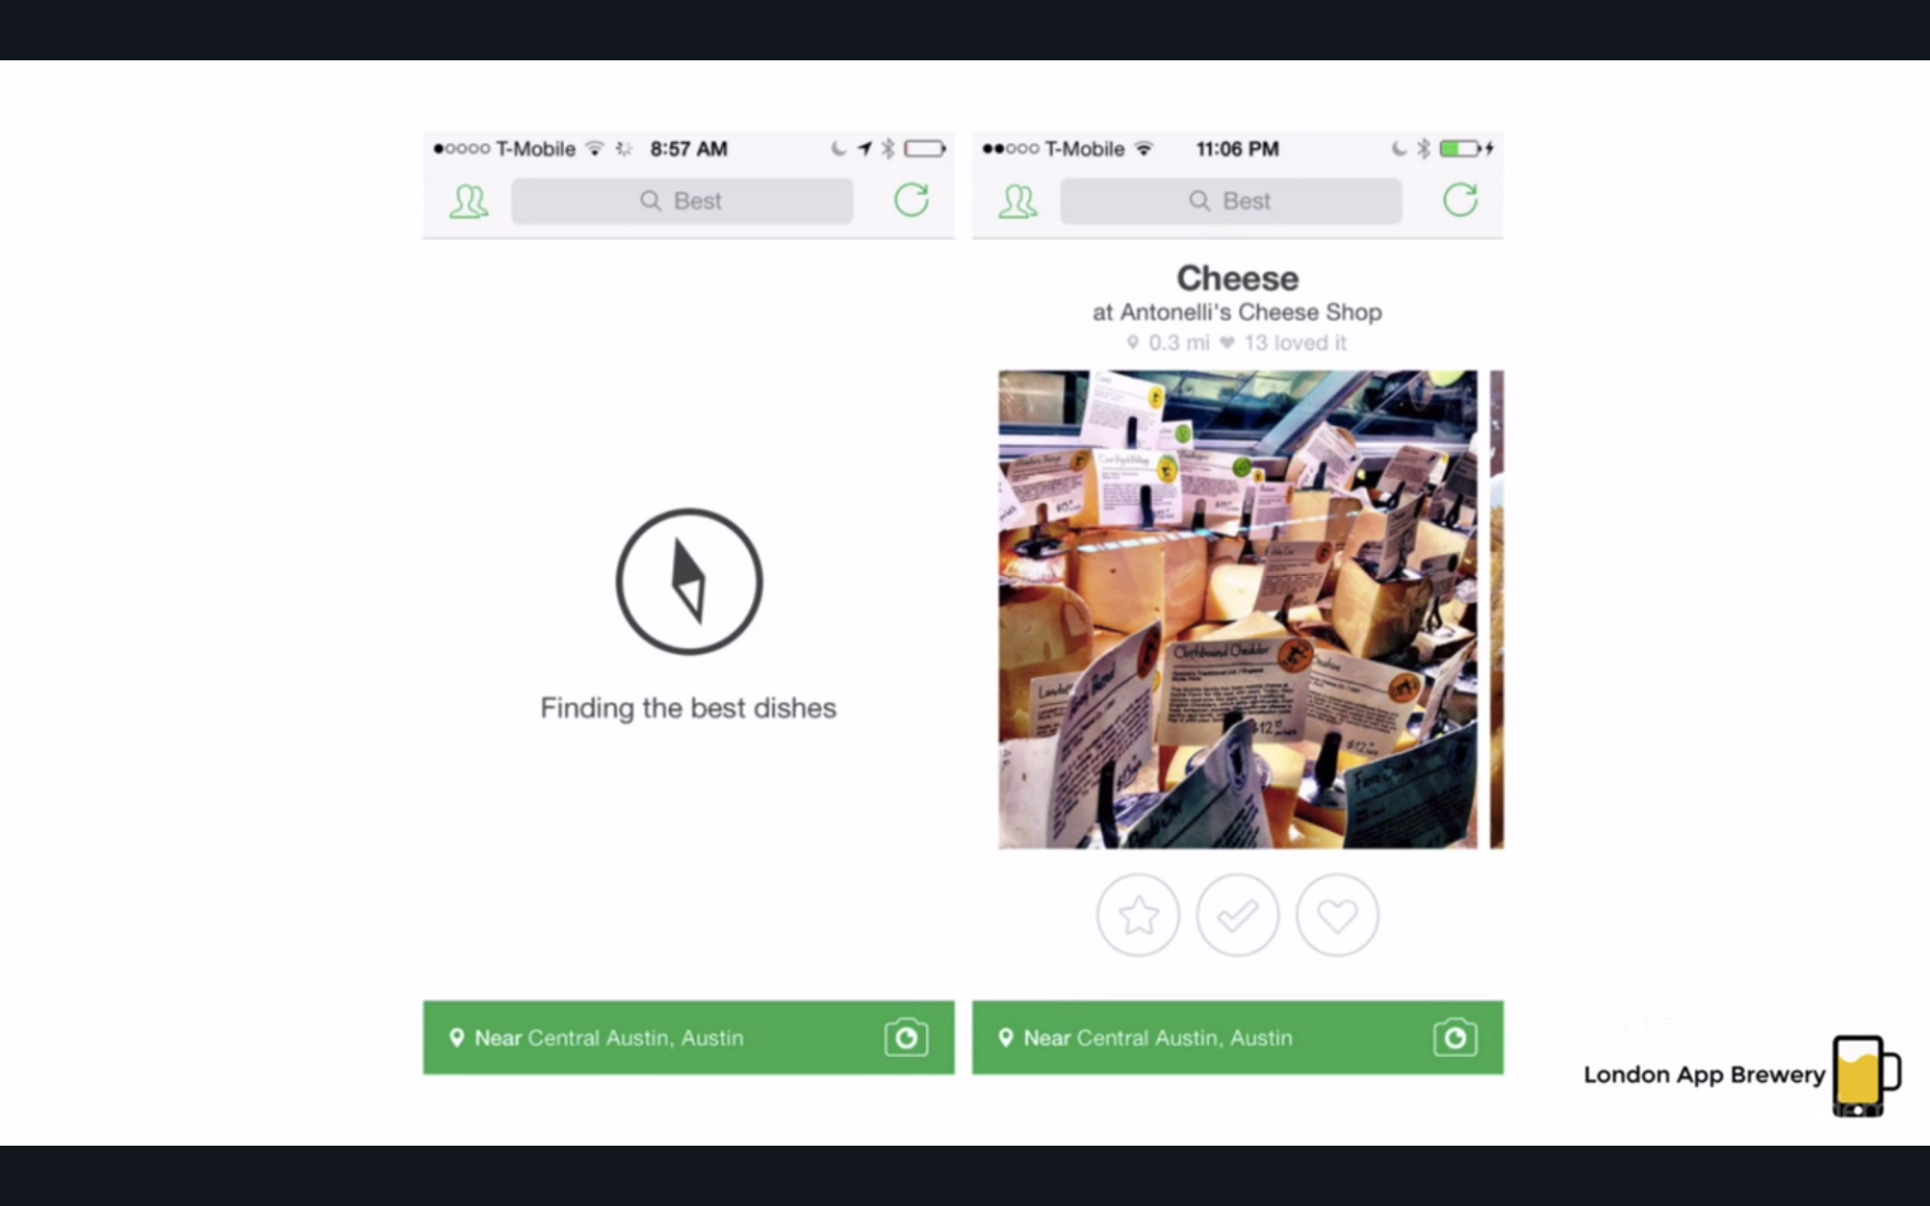

Don’t make me think

Don’t toll your user’s brain RAM

TOO many rules:

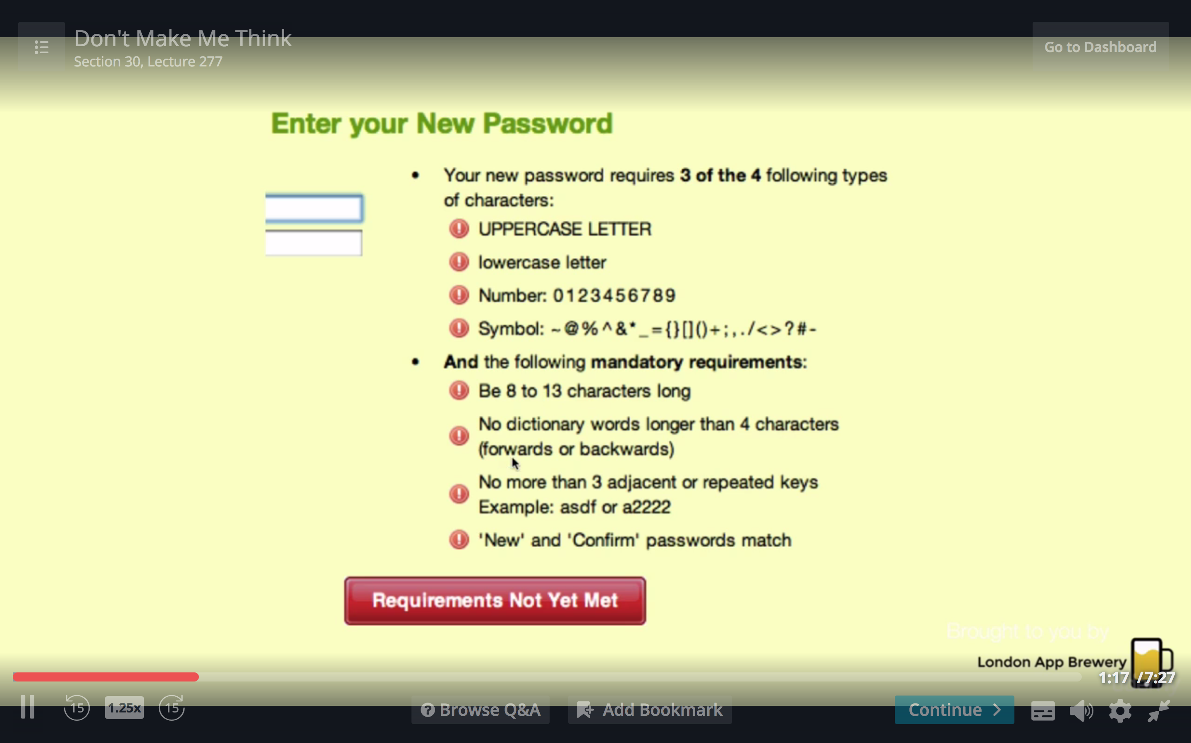

theres a happy medium keeping users secure and happy

equivalent mistake with apps-EXTREME long tutorials

instead, relevant tips: showing someone what they need to know WHEN they need it

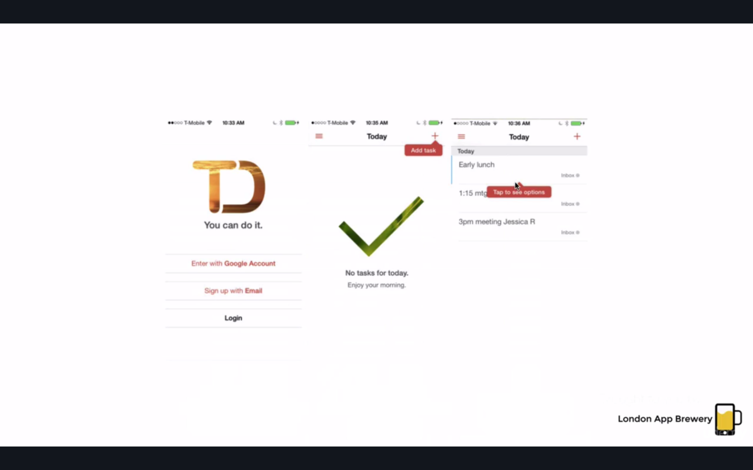

Confusion tactics ex renaming “delete” to “error”

Pulldown to refresh is popular- DON’T do anything else!!!!

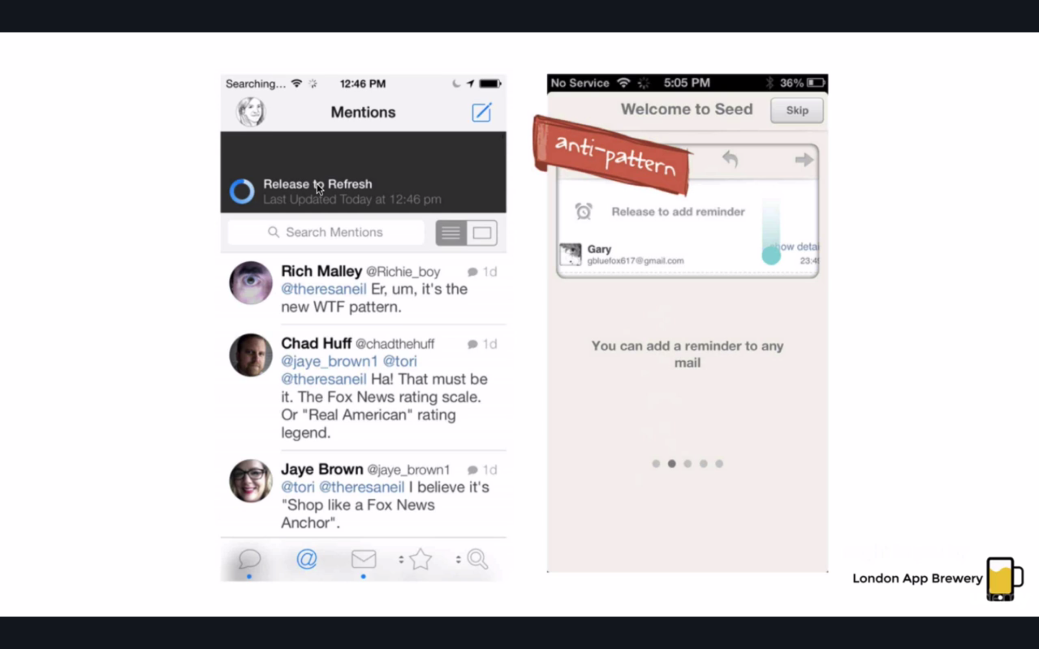

Can I teach without teaching?

Intuitive-we intend to mean that its easy to learn

If the user hasn’t interacted with the screen, the bottom pops/peaks at you ans that way you learn by interacting!

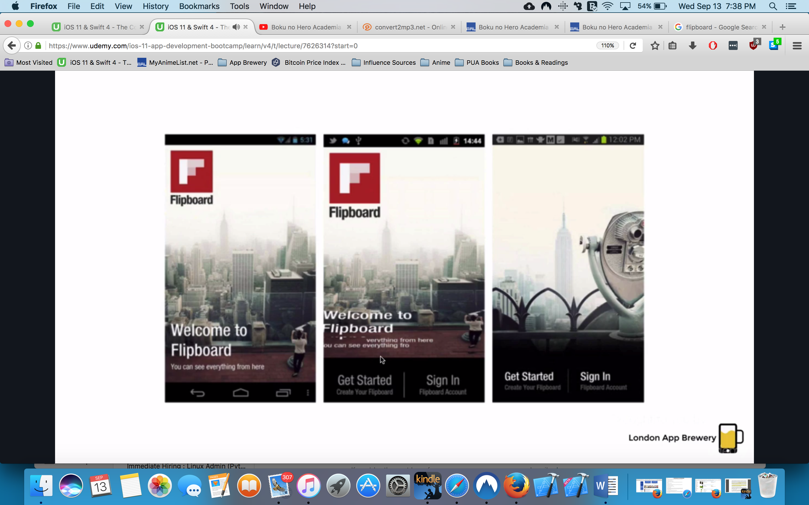

Idiot Boxes

Am I treating my users like dumbasses?

Ex amazon for android

DON’T do it!

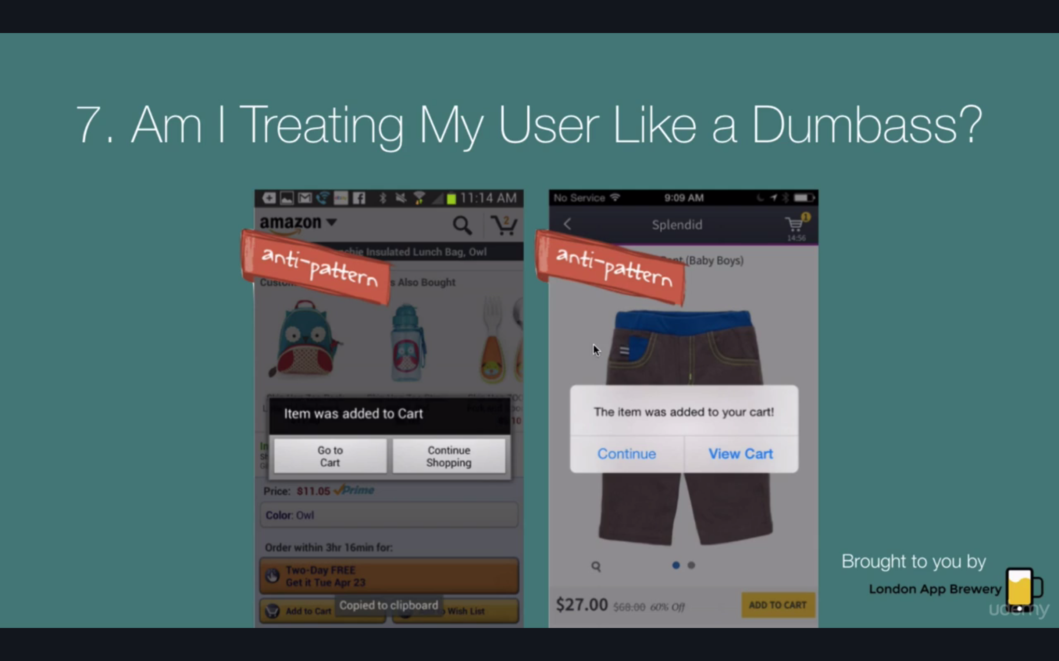

how should you do it?

iOS amazon app

it adds it to your shopping cart with an icon

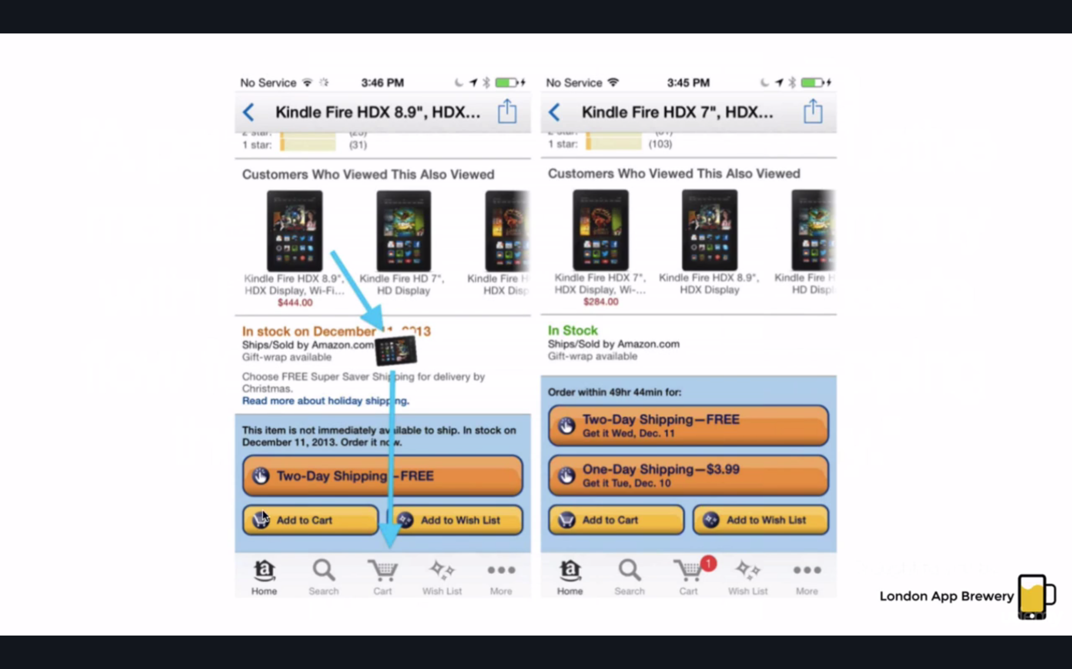

ANDROID vs iOS DESIGN

Ex app of iOS added in Google play store results in two rows of buttons

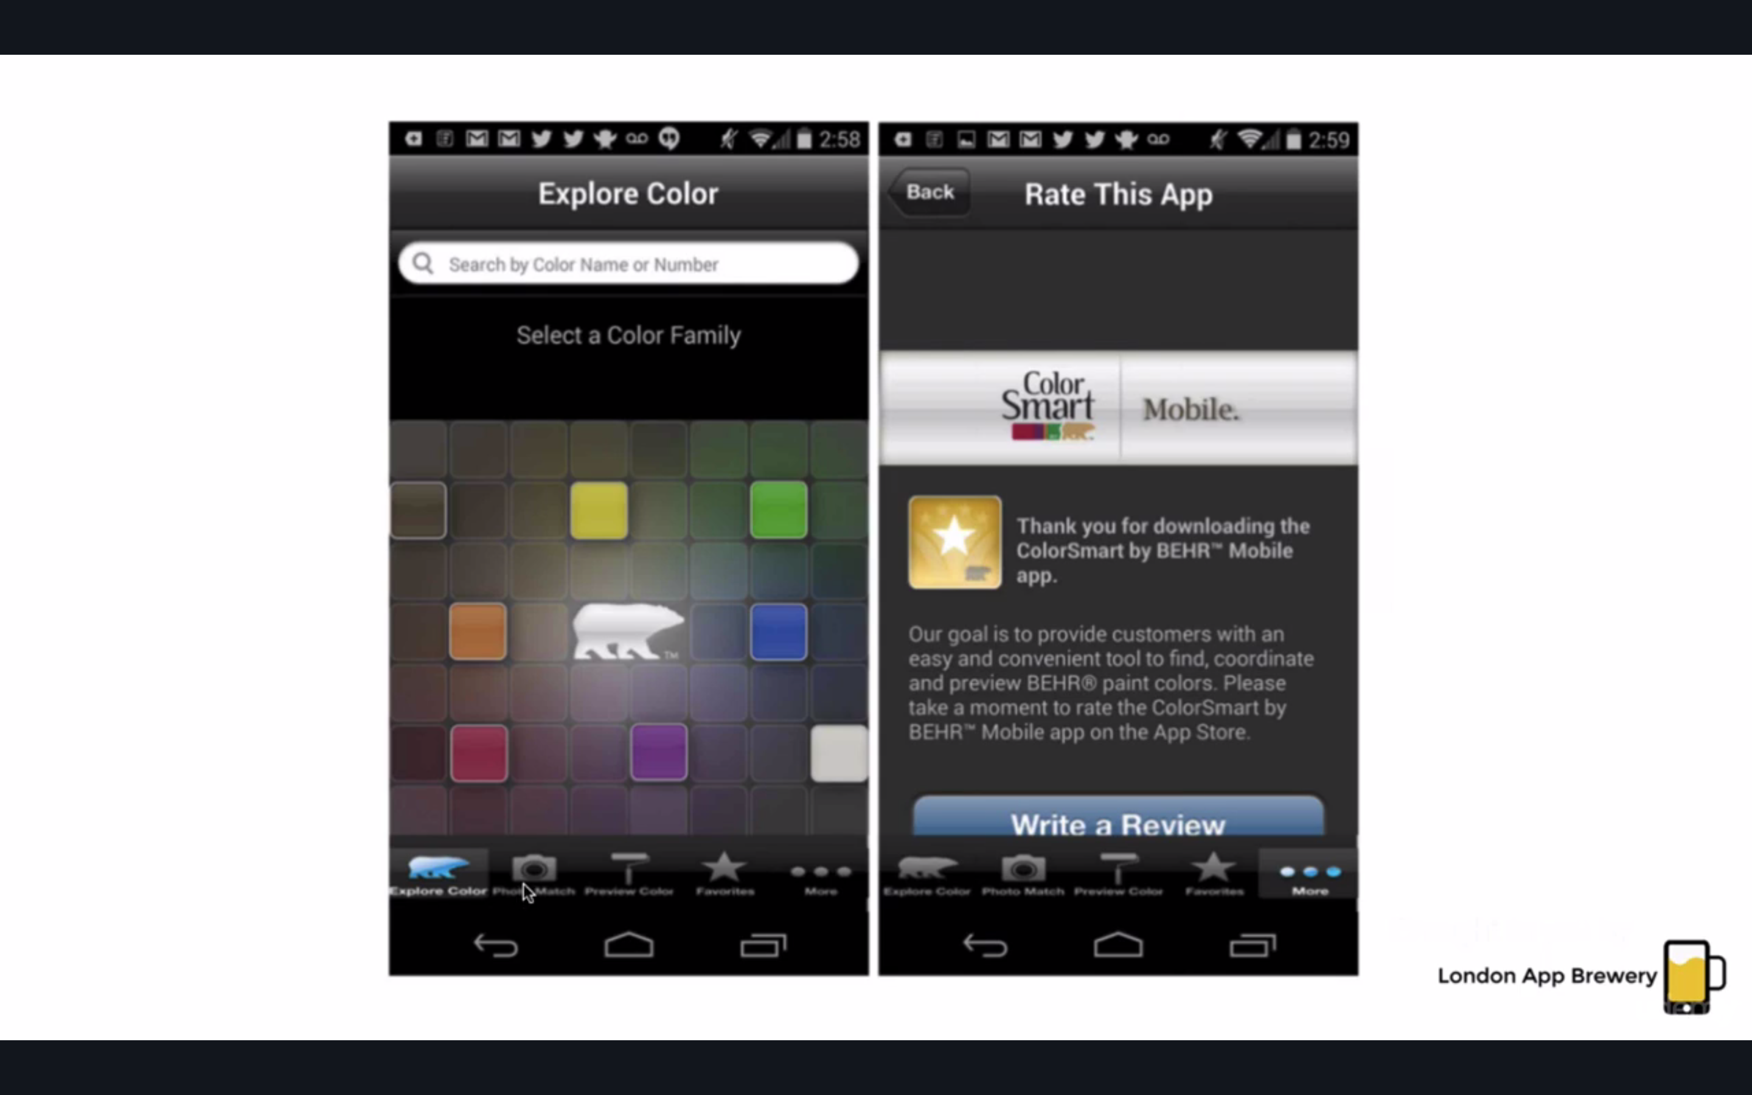

Navigation

Going back

Android- hardware

Ios- top left of page

Navigation

Android: hamburger menu-lot replace it with a swipe bar at top

Ios: 5 items in bottom

Placement

Android: title on left

iOS: in center

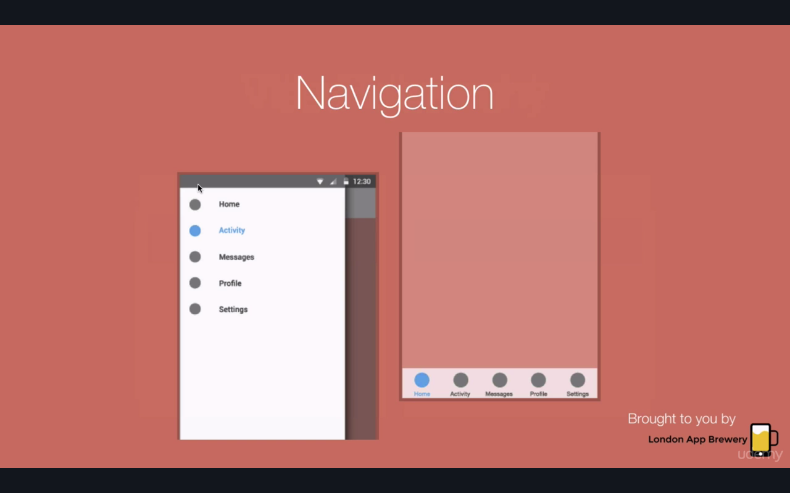

Android only: dropdown menu:

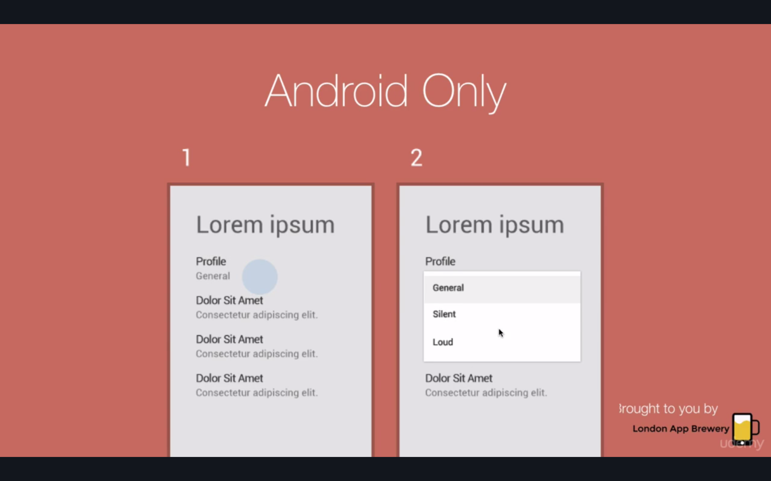

difference in icon design

android: blocky

ios: more lines

flat vs Material design

ex ios6 to ios7

flat-its like a glass

material design- ios and google did a swap and went to the opposite desin

Visual Hierarchy

Ex title bold

Thick text sub title

Thin text of context

iOS and Android Guidelines

Get a physical device if you want to really get how something works-get the opposite of what you have for personal use

Workout app

Choose workout

Track workouts

Guided workouts

First – check patterns

**User Flow Diagram

A users journey thorugh the app

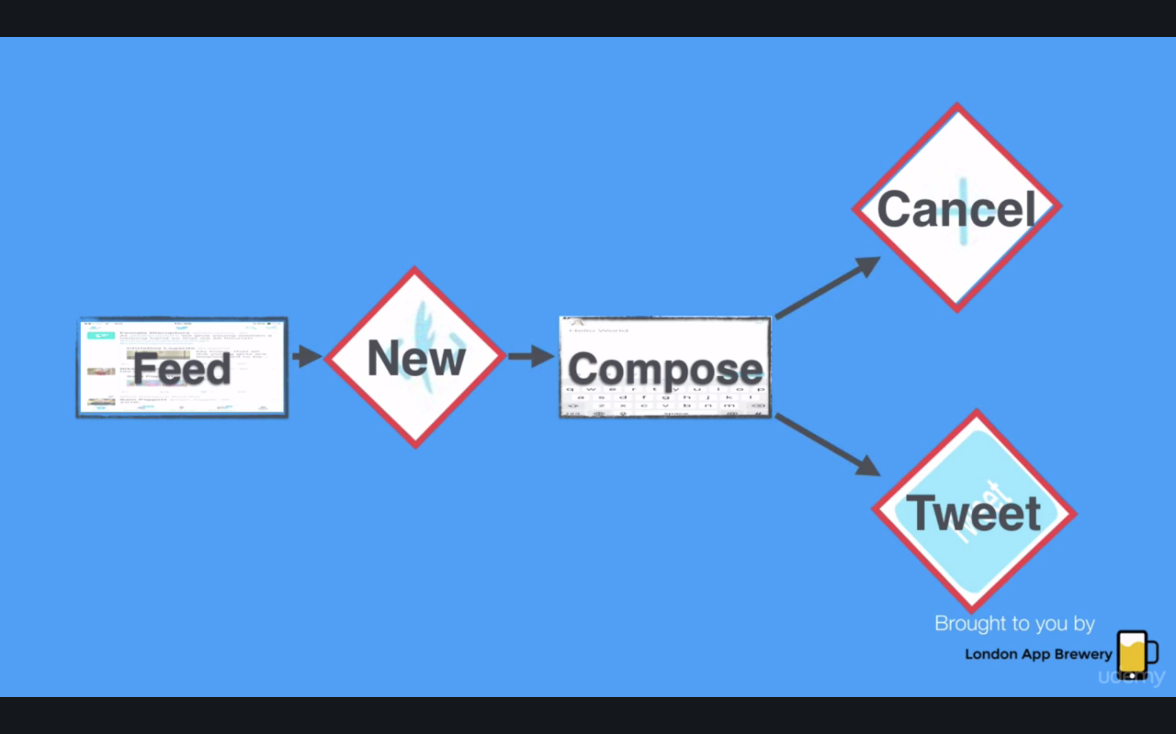

why can I not just start designing/coding?

Beause this way its easier to edit the flow of the app!

Lots of students have paid 40K-50K for an incomplete app

Because THERE WAS NO DESIGN!!

Wireframing

A schetch of how your app will look like

UI stencils

Sketch notes

Simple login screen

Buttons for navigation like ios

Exercise list which lets us add the workouts

Display of workout being

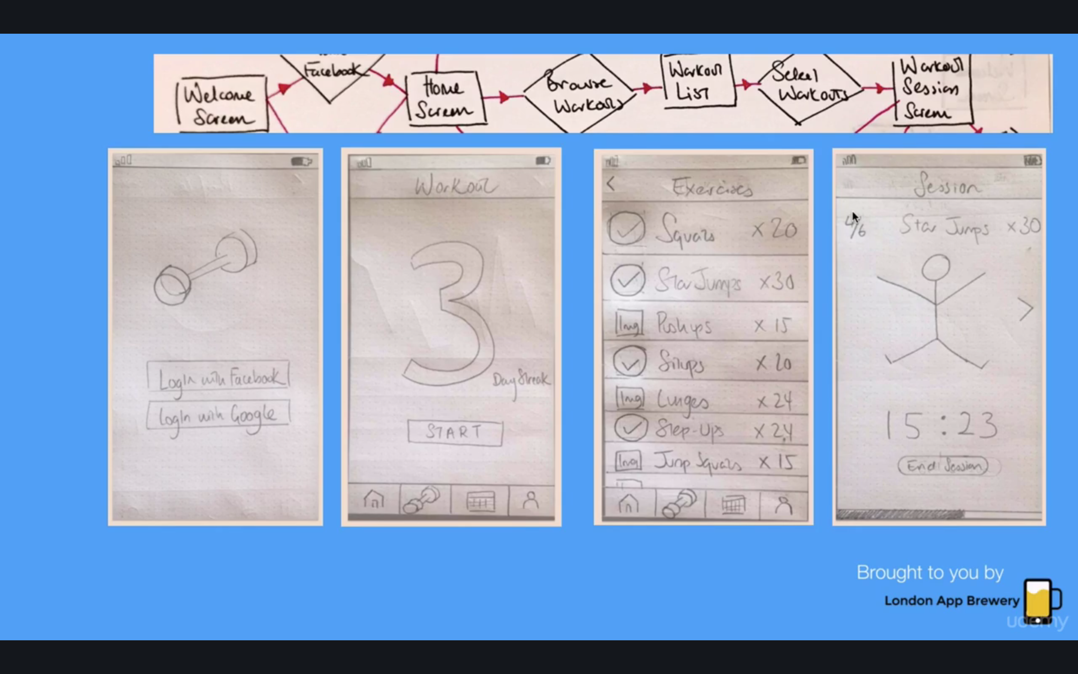

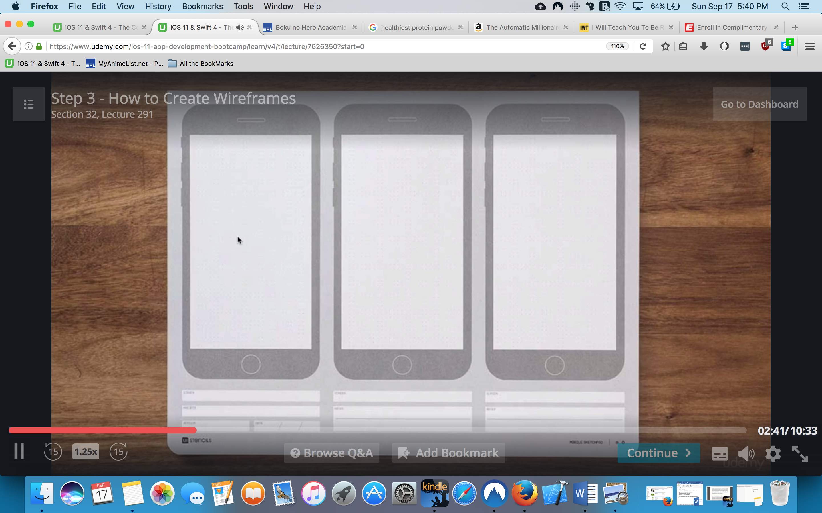

popapp.in!!!!! MAKES PAGES OF WIREFRAMES

professional mockups

Mochup –high fidelity representation of your app

Ex future pics of your apps

Photoshop-Ps

Illustrator-Ai

There might be better tools you can learn faster

They are from adobe so it can be a pain to deal with

Recommended: Sketch!!!!

Marvel-browser based app for mockups-easier to learn too

Usually you don’t need complex t ools

UXPin-was good-but sketch might turn out to be cheaper

Using Sketch

Sketchappresources!!!

Free resources

Canva

Good for social media posters and mockups

How to show?

Placeit.net

Prottypes

Animated design of how the app will work

Proto.io

Peinciple

Marvel

invision

Command line:

Kernel and Shell

The shell is used to communicate with the kernel

Bash: Bourne again shell

Why cmd?

Speed & control

UI can be oversimplified! Therefore some things might be completely hidden

Mkdir .folder creates a hidden folder that shows with ls –a

Terminal

cmd space for spot light

~ is the root of the user

you can drag n drop in the terminal

cd .. to go back

alt n click dir will take you there

control A beginning of line

control E end if line

control U to clear line

touch to create

open –a “applixation to open” “file”

rm removes files

rm –r removes dir

BONUS Game :

emacs -batch -l dunnet

**python Has uaaues with versioning**

**some update some stay 2**

**--**

AR

Putting virtual object in real world

Augmented reality

A9 plus chips

How to publish an app on the app store

Wait until you are actually ready

Bundle id, should show on dropdown or u cn add it

Archive project

Validate

Upload

Where to go from here

Don’t forget –keep practice

Plan out

Prototype

Use open source libraries!!!!! Ex swiftyjson

Don’t try to buld everything yourdself- use other services

Can cut 3-4 month of work ;)

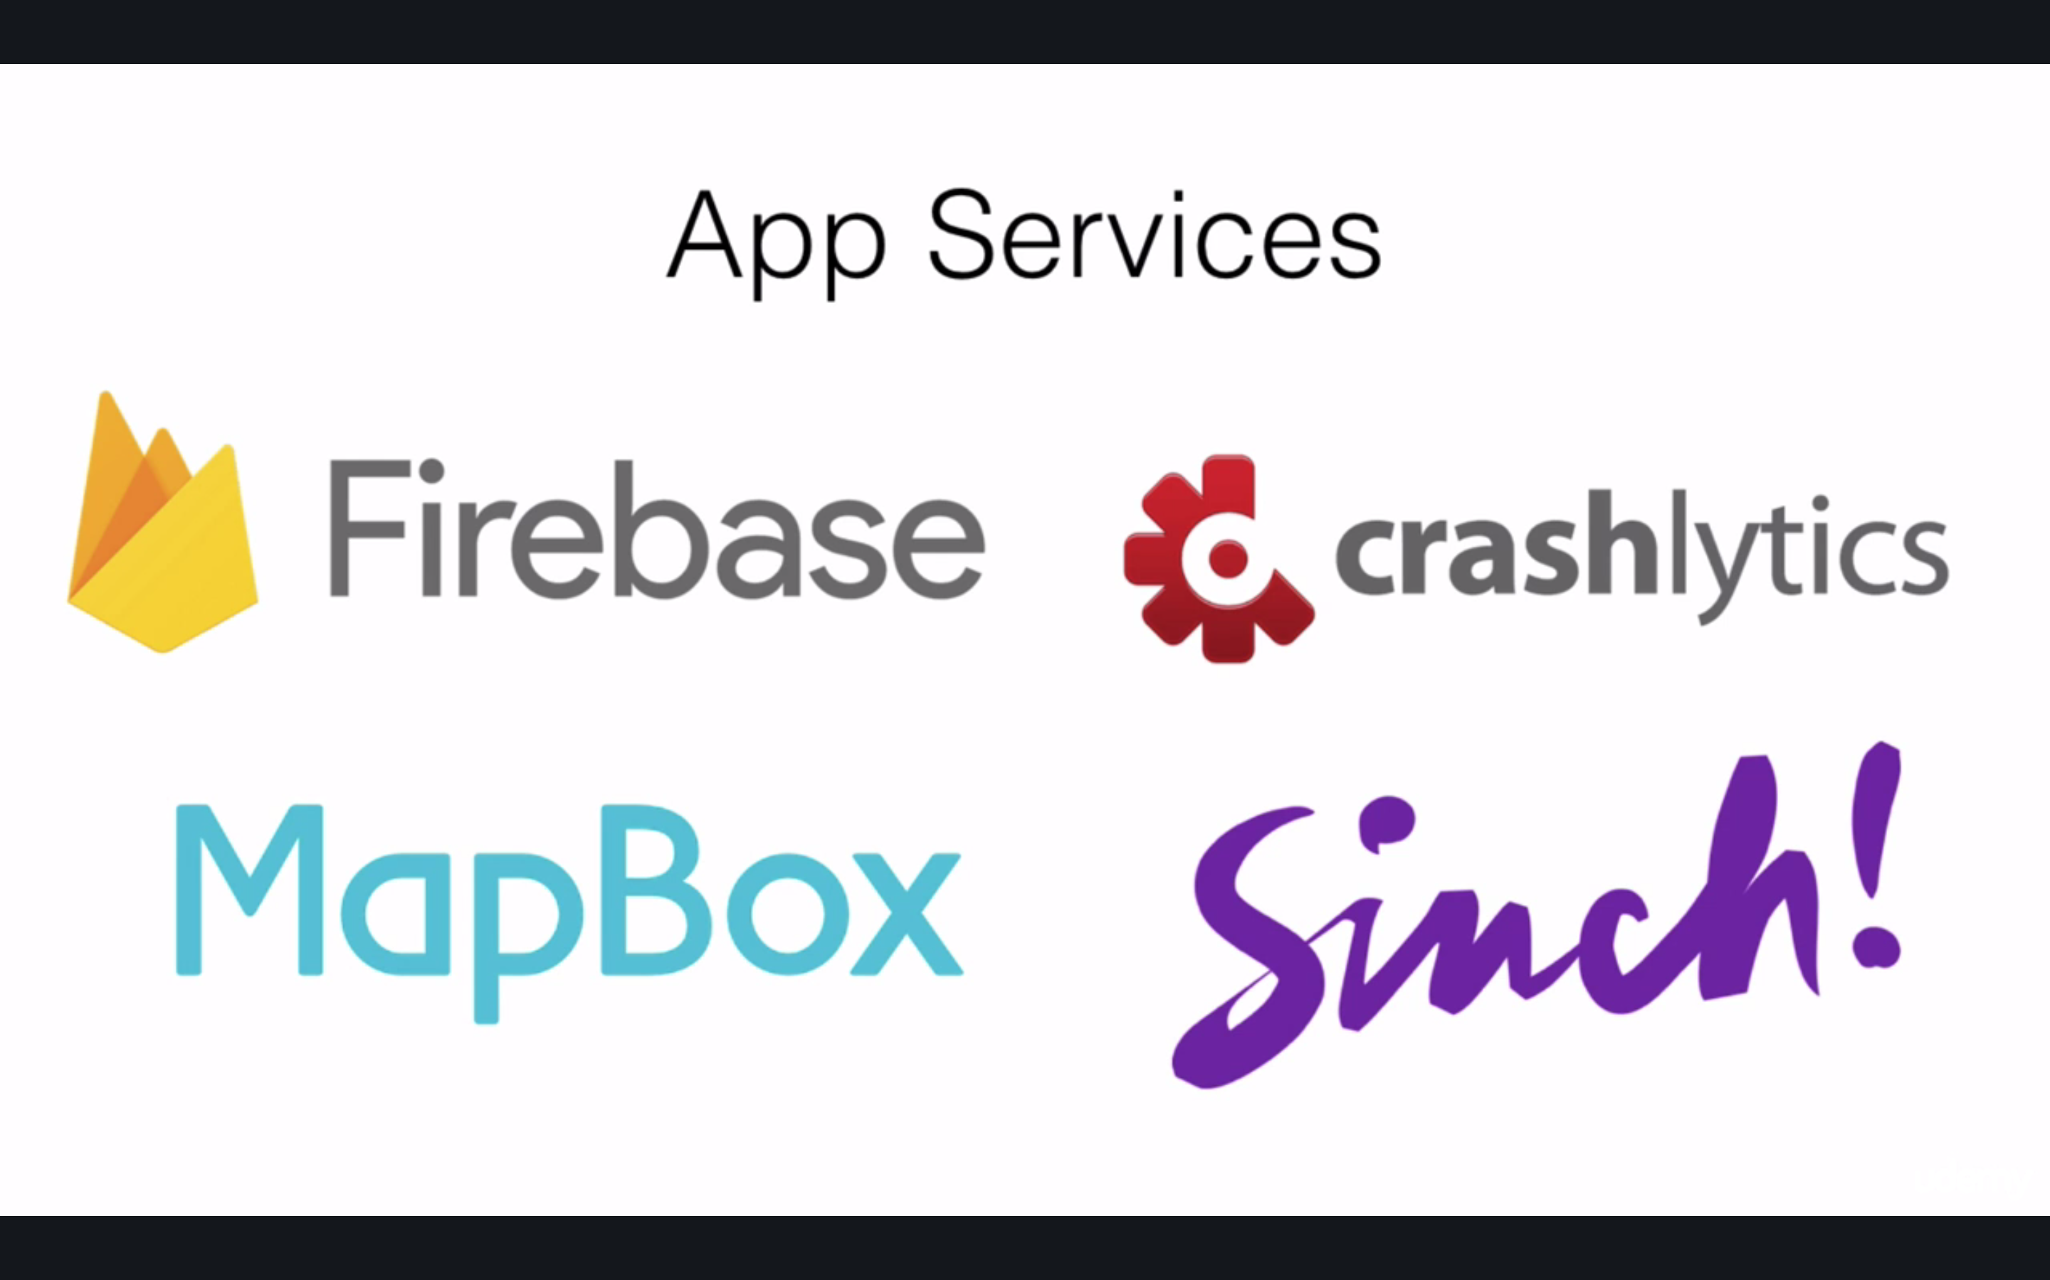

how to help yourself during development?

API reference

Github-look how exp developers structure their projects

FlappySwift-look it up lol

Check this UI out:

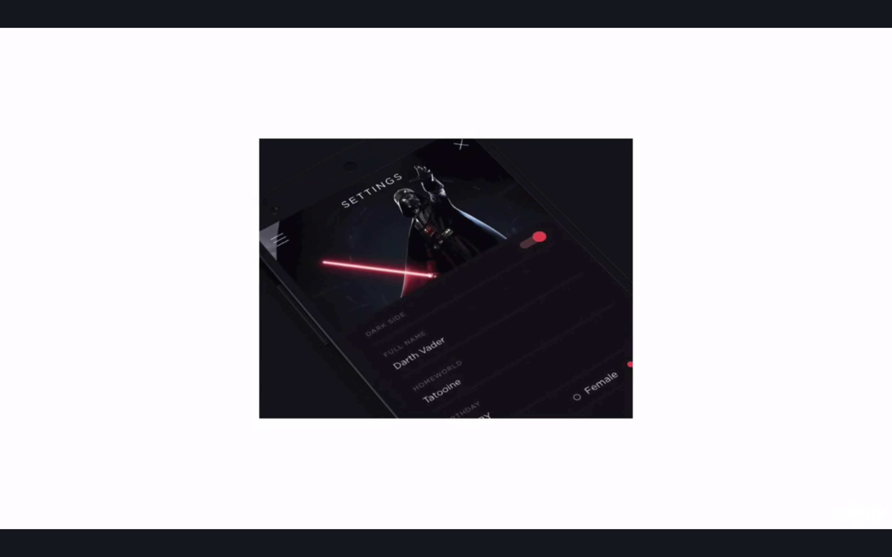

stack overflow

test your app!!! Ask friends and family to download

ubertesters

publish-LinkedIn founder said ur first version should be embarrassing lol

Join our community and events

Stay in touch!

The Complete App Marketing course

The fallacy of build and they will come

Wrong AF

Waste of time

**The Lean Startup!!!!!

MVP-min viable product

App zombies-when you got to scroll past 25th app since virtually undiscoverable

About 90% of the app developers do NO marketing

Its no 2013 anymore XD

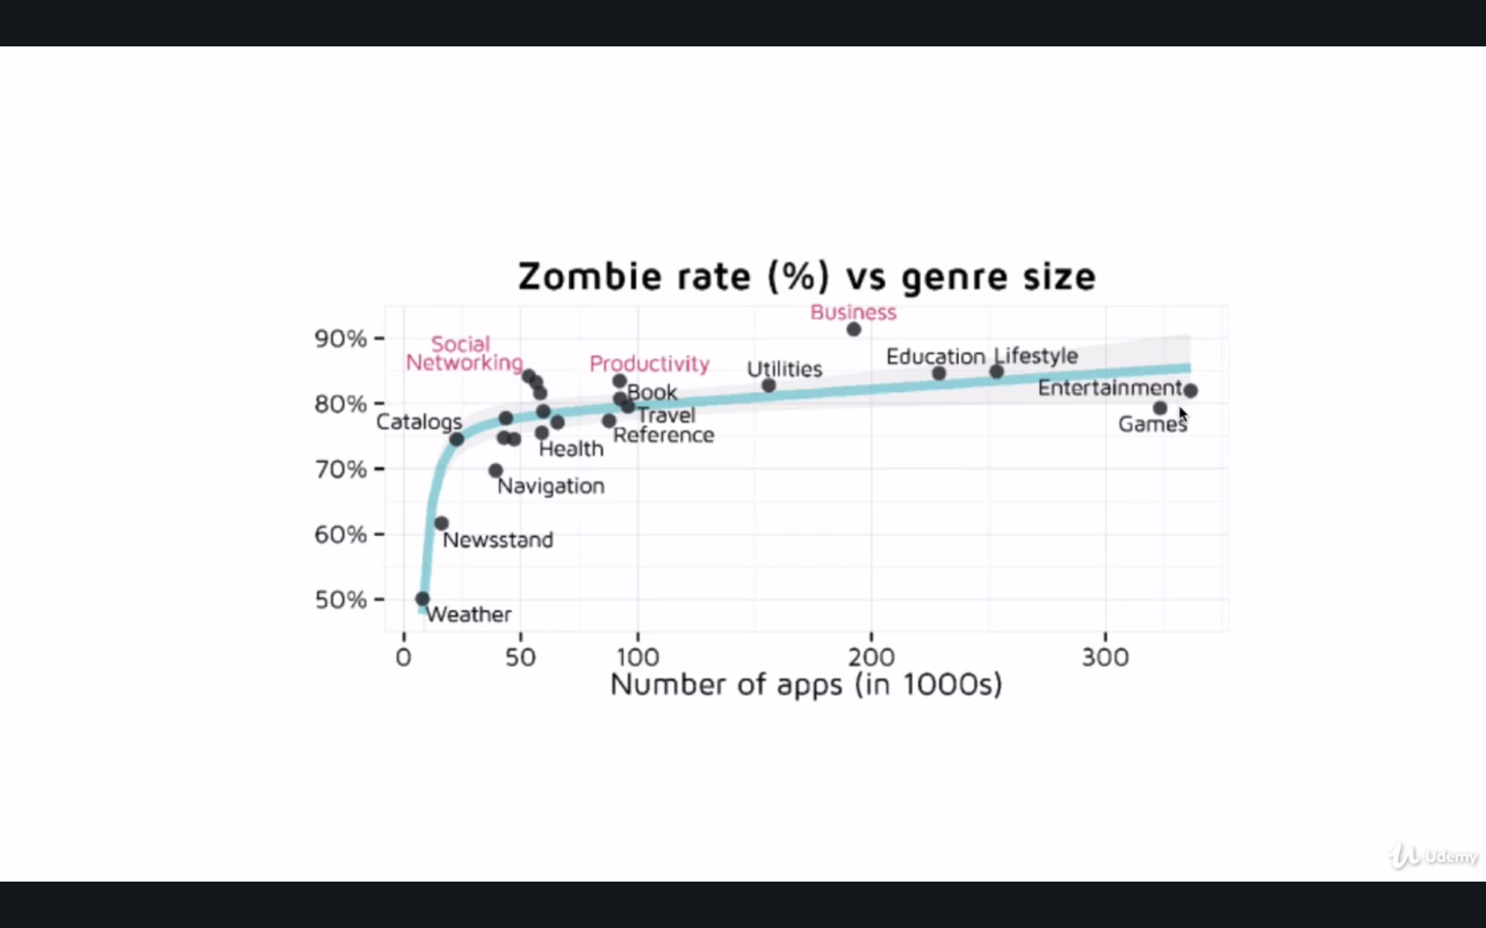

even a little marketing is better

you have to tell anyone how awesome you app is

Idea Validation-Save yourself Time and Money

Idea Validation

How do you know which idea is worth it

Your non-renewable asset-TIME

Be mindful –we as humans we can do our best and that’s it lol

THIS RARELY WORKS:

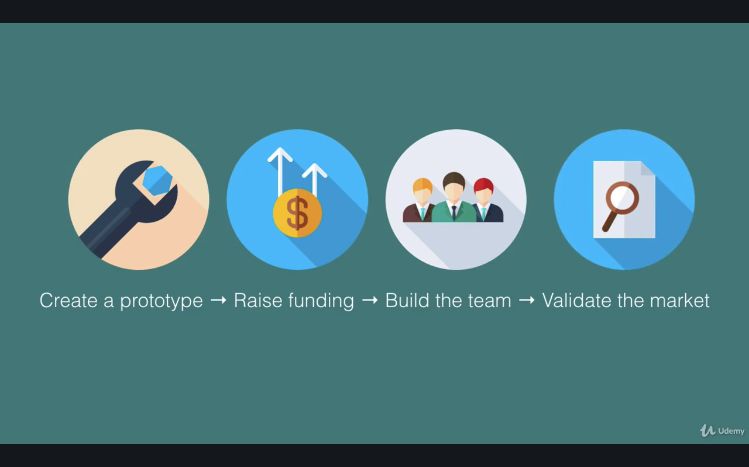

THIS IS BETTER:

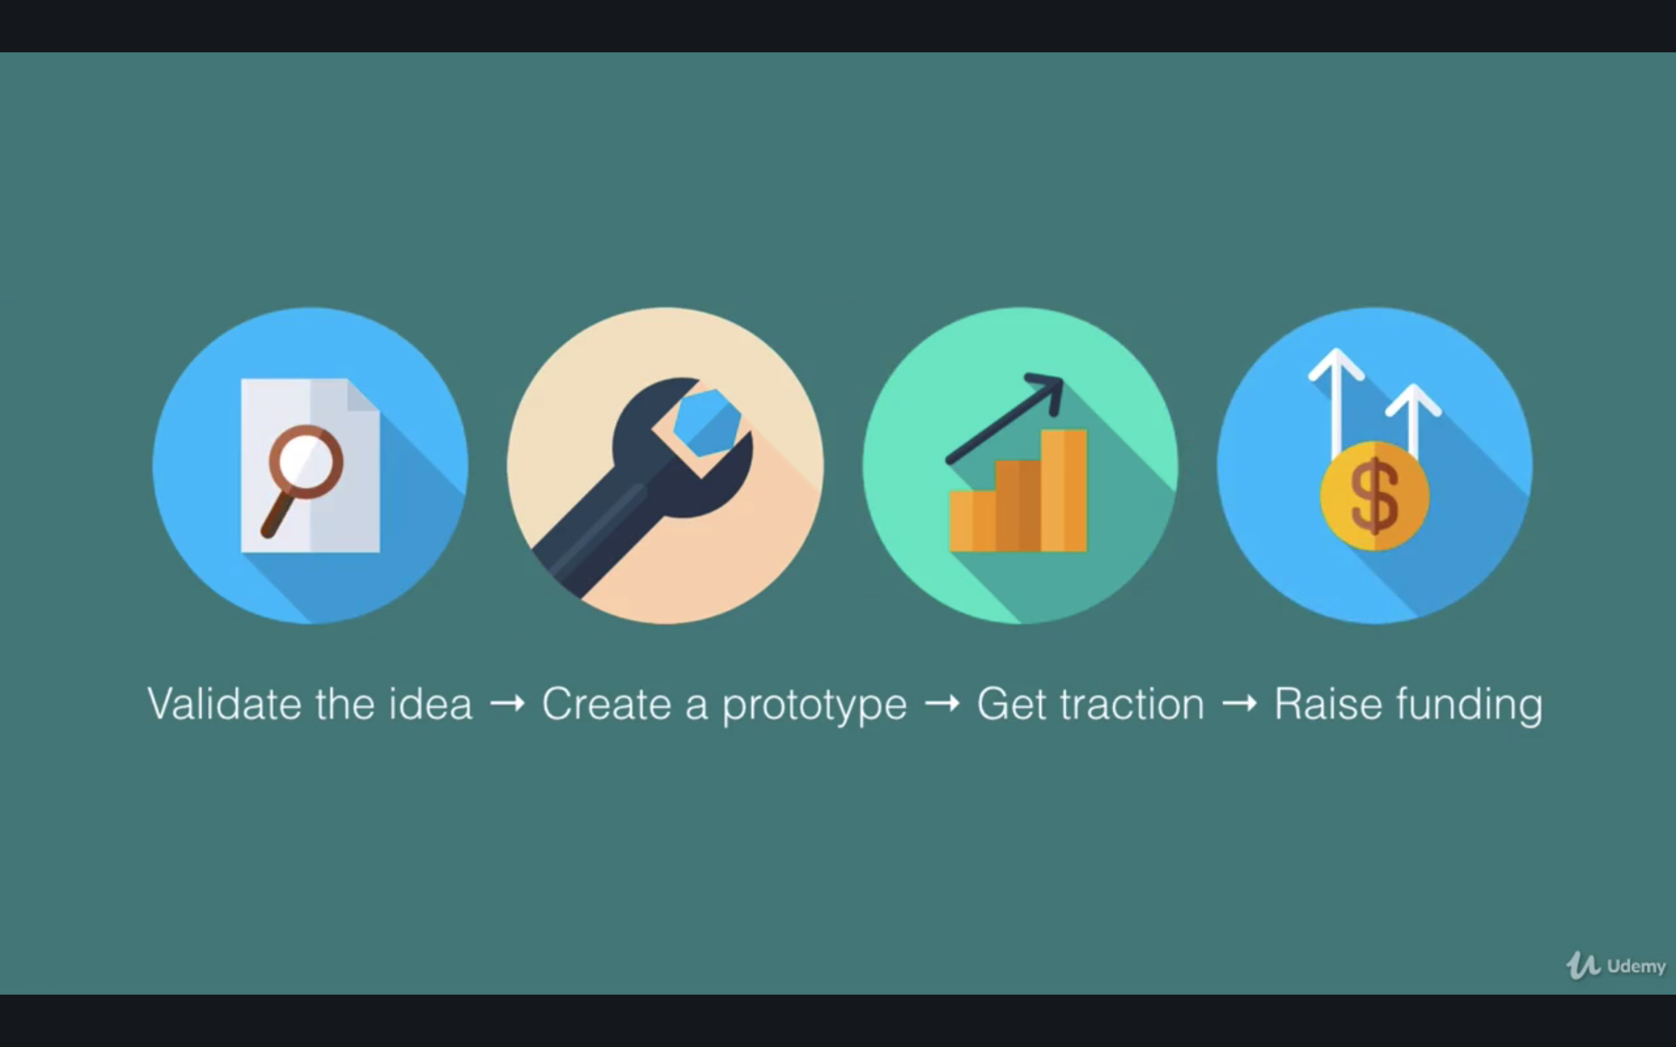

The simple way-Doing it in person

Talking to someone about it

Find honest ppl

Some might be wrong but some give balanced opinions

Make sure you’re not shutting your ears for critical feedback

Don’t give up necessarily

No one believed in uber or Airbnb

Starbucks approach

1. Chat to a stranger
2. Your brother has an idea-not you/that way they don’t feel they need to be nice to not hurt you
3. Ask what they think

Should I ask for an NDA

NO?!

If you’ve built anything you KNOW it takes way more that hyst having an idea

Action makes a difference

5 other ppl have same idea

its more important to have their honest opinion

buy someone a coffee and give it a shot!

Using Google Trends

You can look interest by time and locality

Can also look at related topics

*Keyword planner

it looks up what ppl might search in google

will determine if you have high/low competition

ASK WHY? If low is it because no action from competition or because something cant be monetized

Landing Page

3-6 months in advance landing page

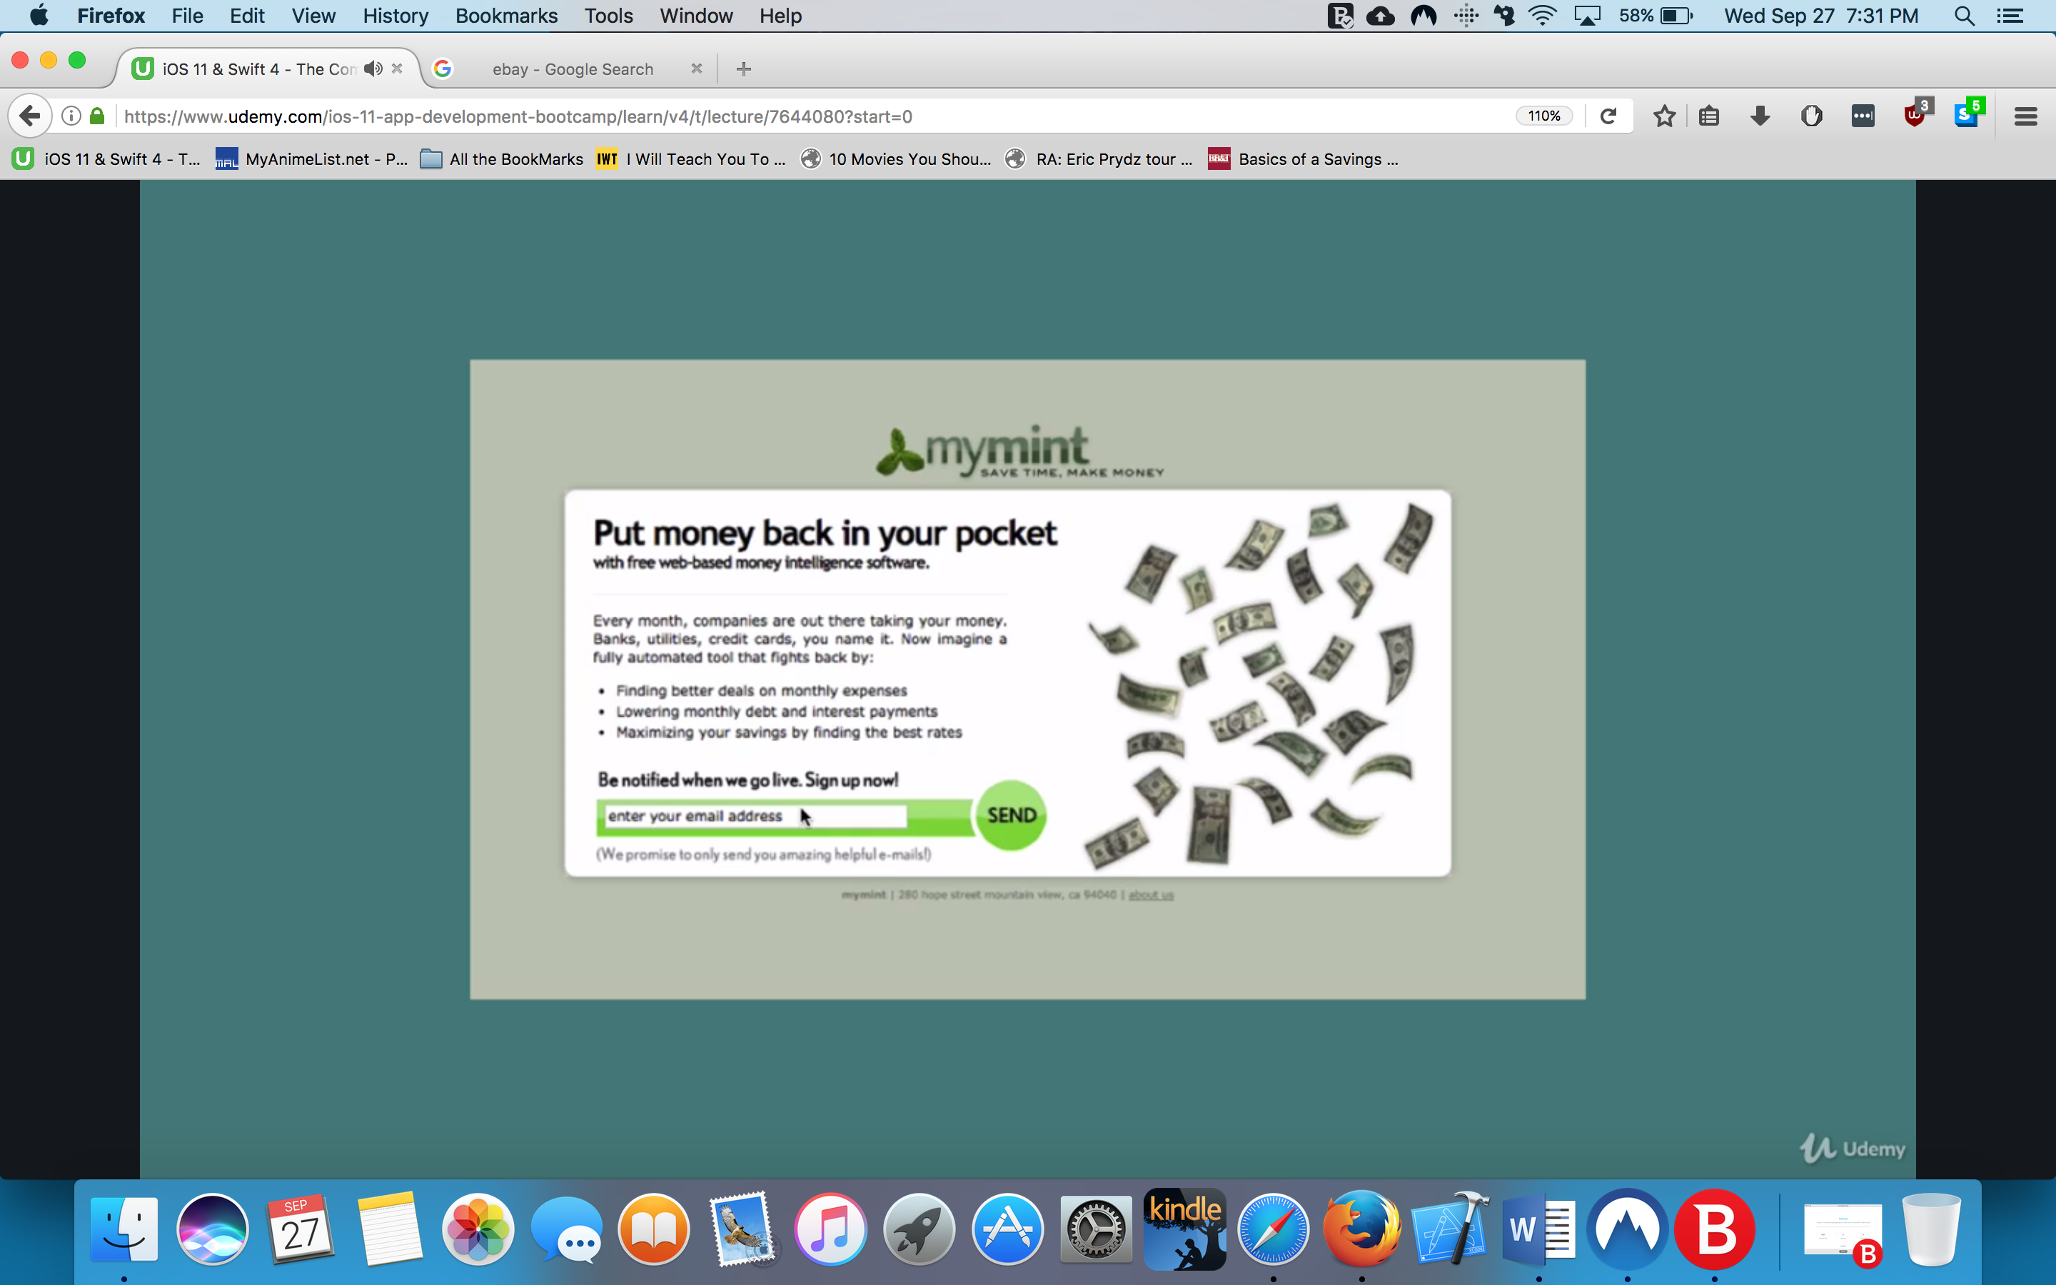

DO THIS BEFORE WRITING A LINE OF CODE

DON’T BOTHER UNTIL YOU KNOW PPL WHO ARE READY TO DOWNLOAD YOUR APP

Above and below

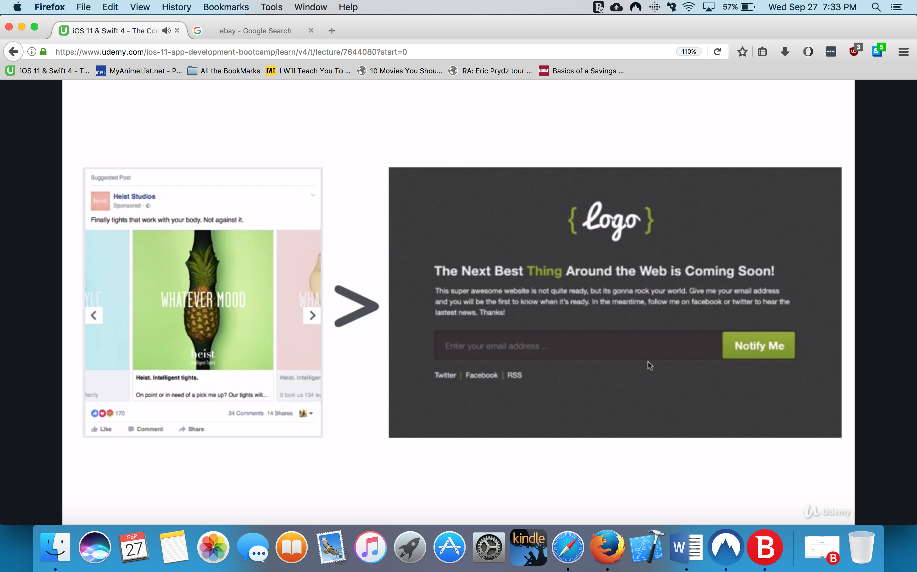

depending what the buttons say will derive to conversions ex

Buy Now will have less conversion that sign up etc

You can gear automatic bidding for Facebook ads

Reach-how many ppl saw it

Other option google AdWords

*Use result keywords ex weight loss

Impressions clicks signups

When ppl sign up it might not necessarily mean they will sign up

You can mention what your product does –you can put button buy now

*If they click buy now and be notified to sign up-they might be disappointed but they might become consistent and WILL give you better data

create landing page

best depends on your budget

most have drag n drops to design the page

squarespace is easiest

WordPress-king of field and tons of plugins-cheaper takes more time

bootstrap- framework

Create a min viable prod clean startup approach

You assume nothing of your customers and they guide you

Facebook page to help with proof of concept and see interest

These guys have no app, they haven’t build anything they just have an MVP

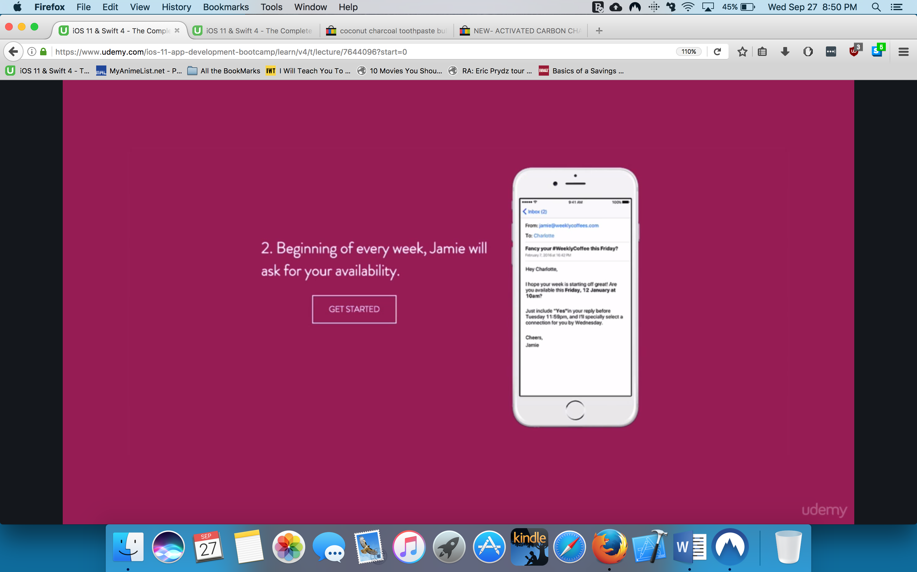

This page checks whether you need an app or a website etc check what’s the min you need

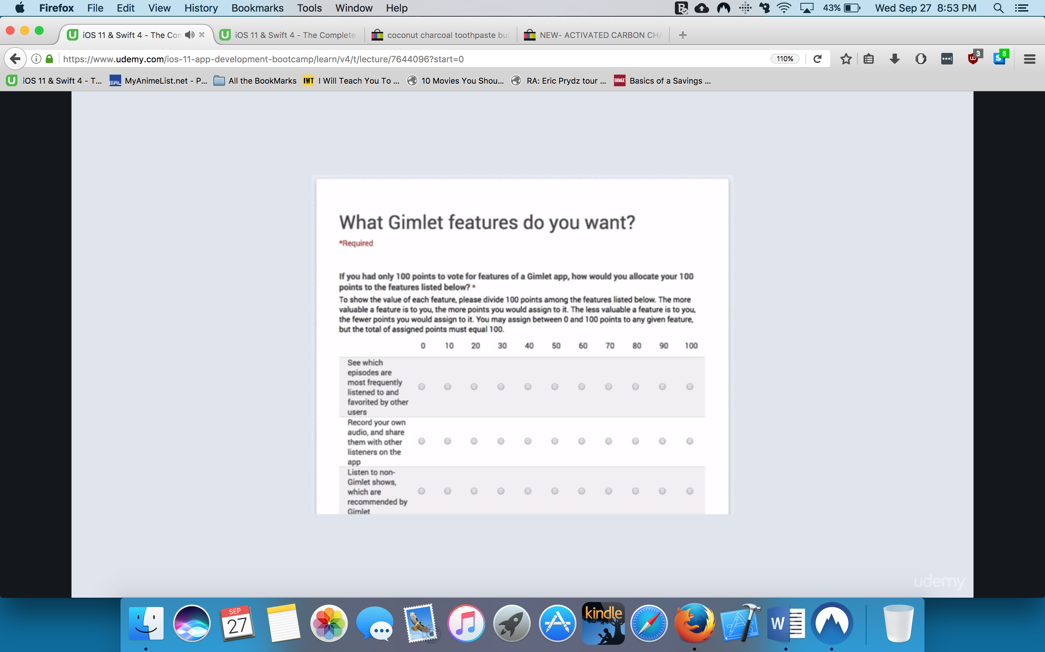

Crowdfunding

Ppl who are interested fund you idea

They get reward ex thank you t-shirts or your product or meeting with founder

Kickstarter

Indiegogo

About 30days is enough

More would create anxiety lol

*That validates you will have users AND you will have funding to start with!

Crowdfunding is excellent to test the waters

How to monetize your app iOS and Android

iOS might be willing to buy 1 or 2 dollar apps

android users are more reluctant to page upfront

more white hat are ads

more black/grayhat is selling your data ex when an app accesses your location or contacts

Why you should create paid app?

There is a number of factors behind the scenes

The guy has IG FB and a blog

That way he can gear up his followers

First 1-7-30 days are critical!!!!

Iphone has superior acoustic features since it was made after the ipod

Stethoscope pro

If you Have domain knowledge ex law or medicine, you can make question banks

Some can be ok w/ 99c other can be >1.99 which the app needs to be

When to us in app Ads

iads lol

banner ads-we are virtually blind to them!!!!!!!!

*Traditionally I don’t like ads

BEST performing- ads that cover the entire screen

*The key is when they show At some point when the user is in a good mood

ex beating a boss/when a user completes a task

Preferred

In content adds

But look like content of the page

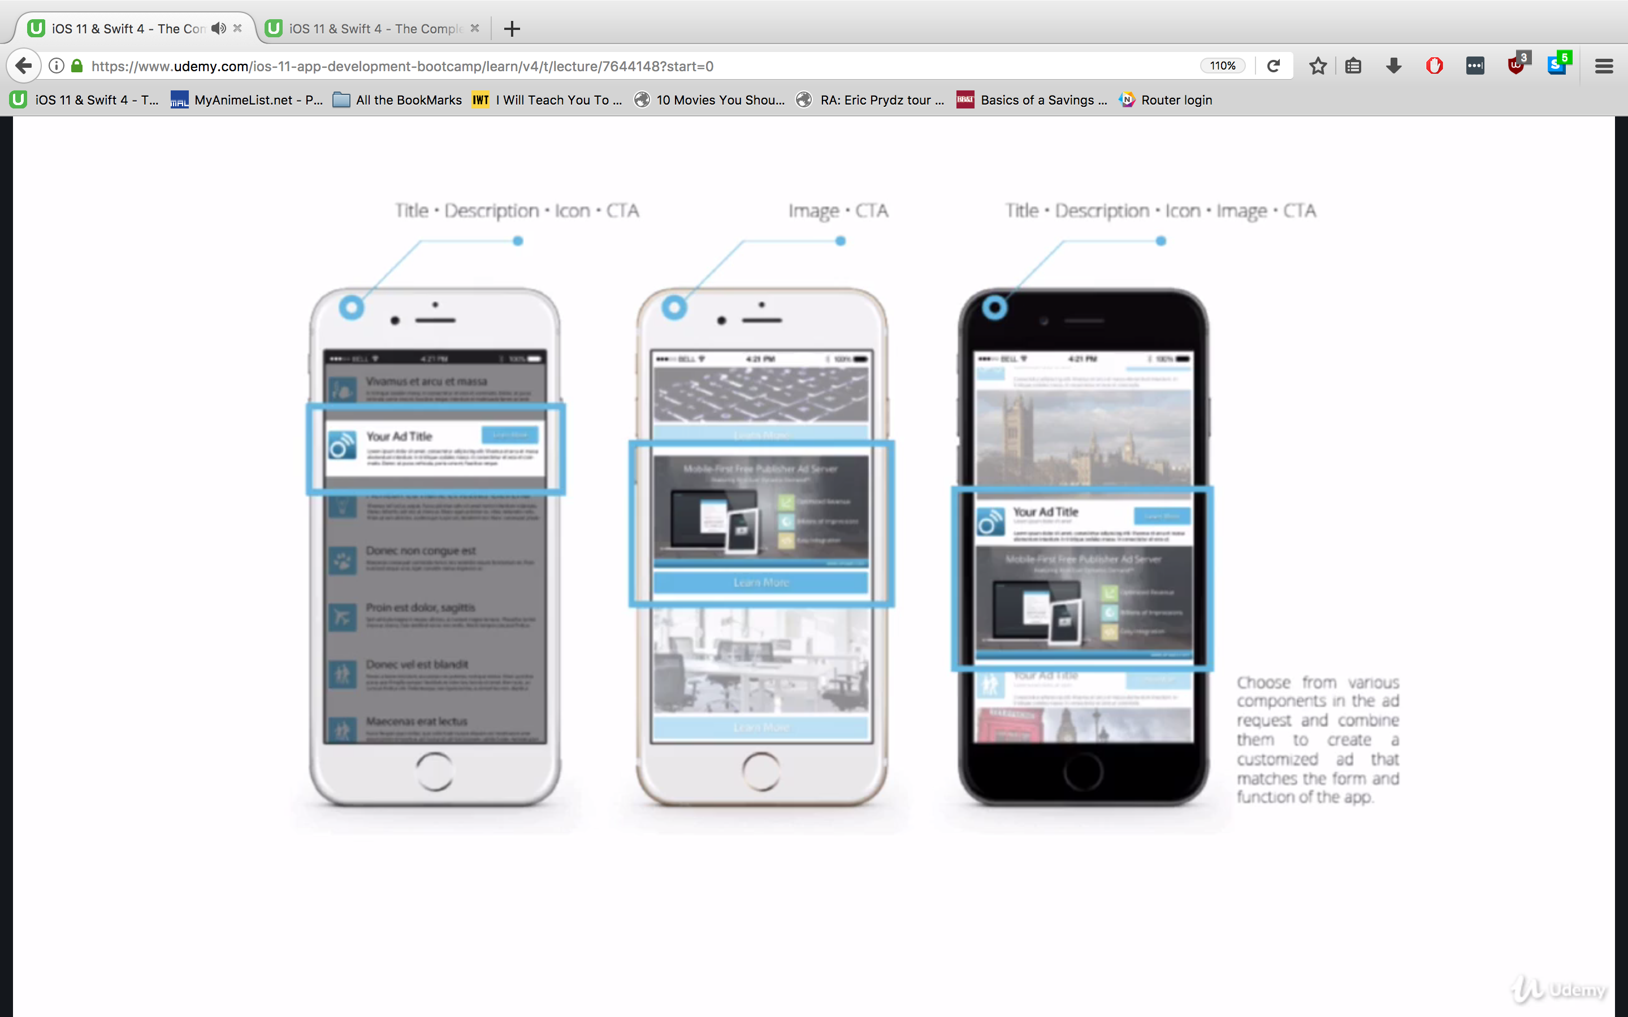

In app purchases

Virtual ex gems time energy etc

Both apple and Google take 30%

Freemium-free app and premium has extra features

*highly urged to consider

give most of features preferably

*White label: you create something ex one app and you can go on to diff business ex gyms and reskin it to their logo

partnership: user developer and advertiser all win ☺

selling your user’s data: ethical-some companies can sell your customers health

Optimize app store Listing

How to get app icon without breaking the bank

**Design is super important because it generates emotion to your users

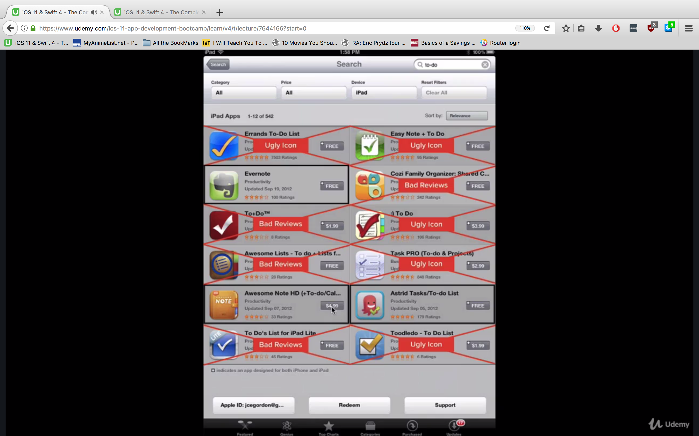

if you’re not a pro you can check fiverr

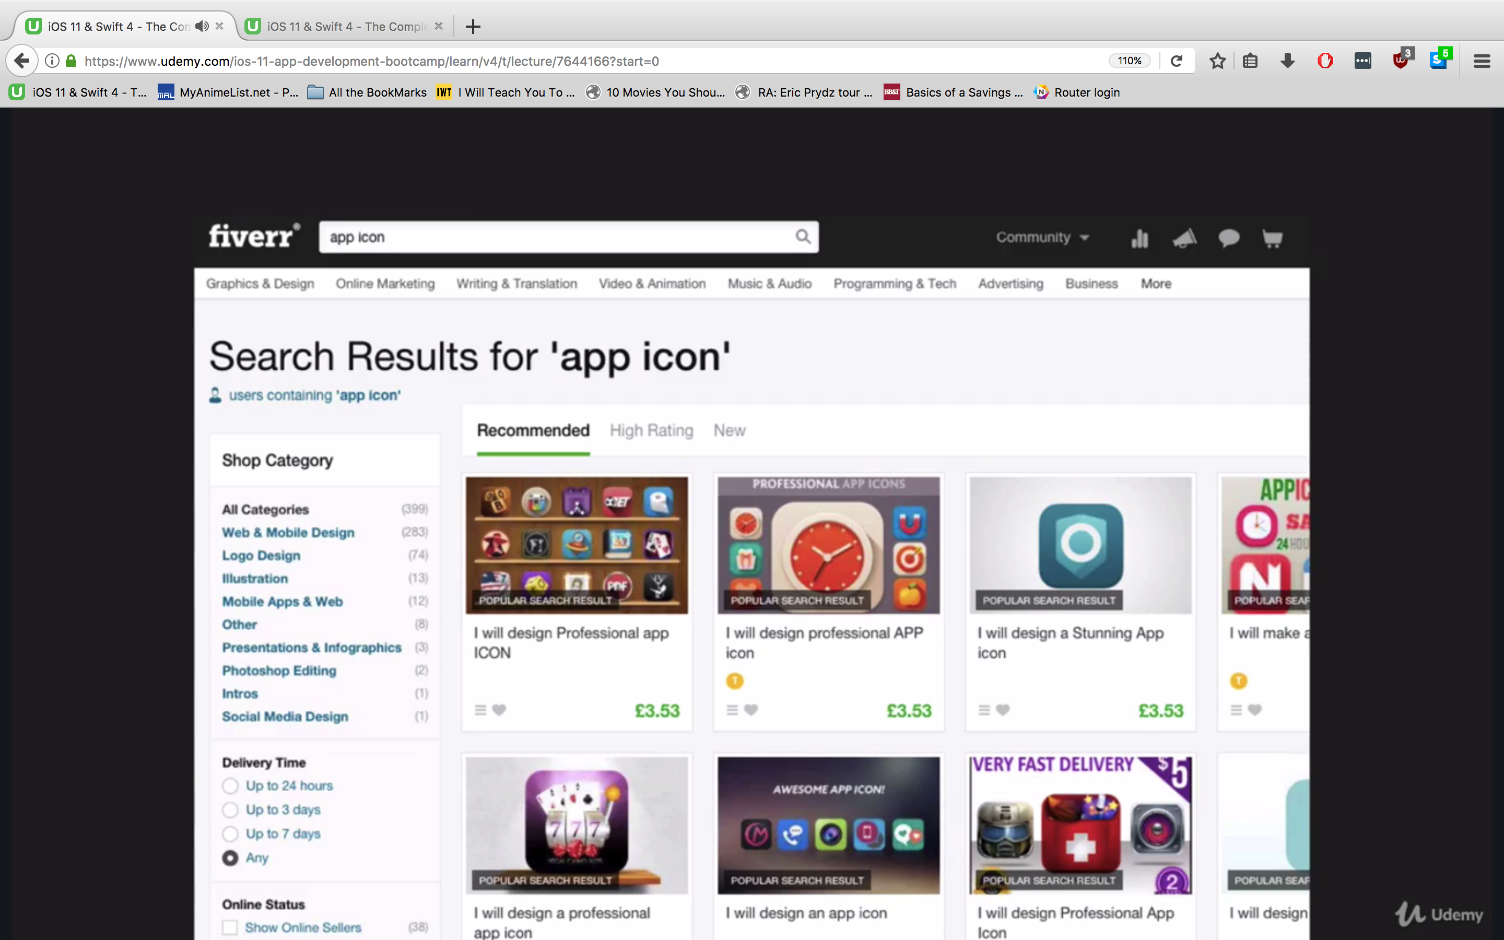

MAKE SURE YOU GET SOMETHING FOR COMMERCIAL USE-they might have it as an add on

Always make sure you’re good to sell it XD

Some designs might be from somewhere else!!!!!!

Reverse search it

99designs

designers will create you cover based on what you post ex super human

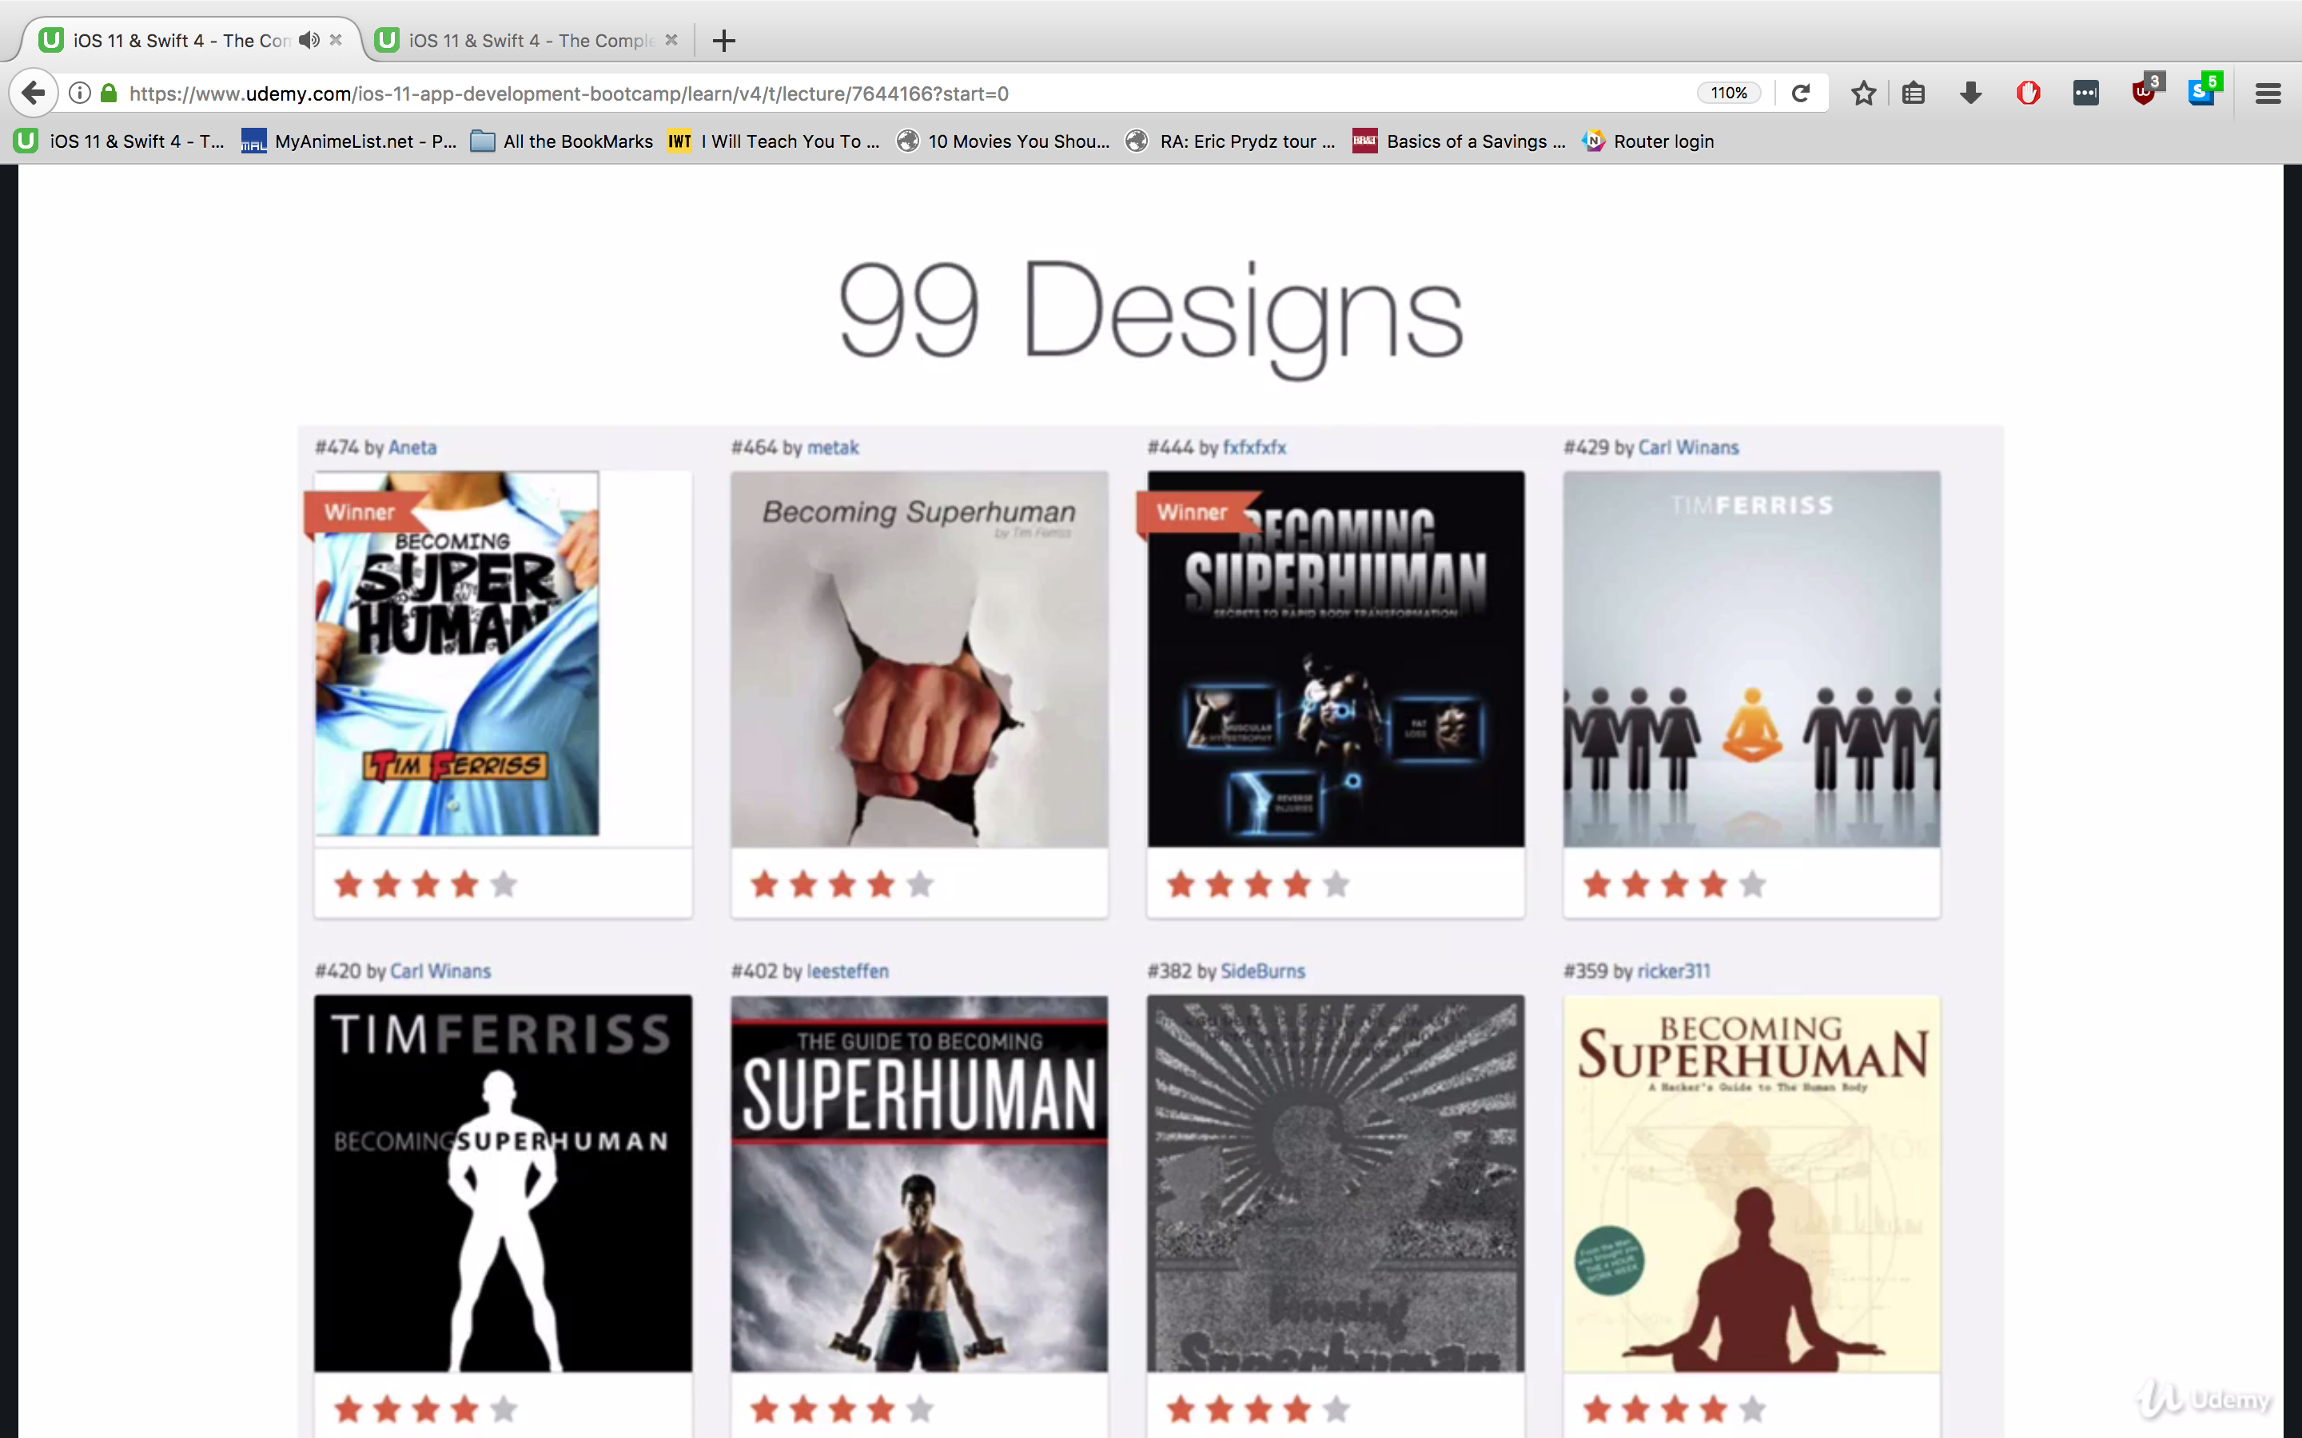

Split Testing

Most downloads from

Data can be really revealing

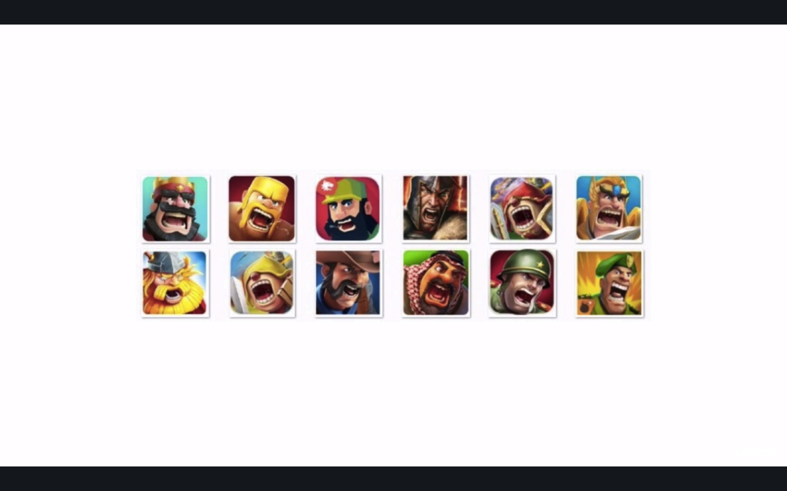

what makes a good icon?

Never have text lol

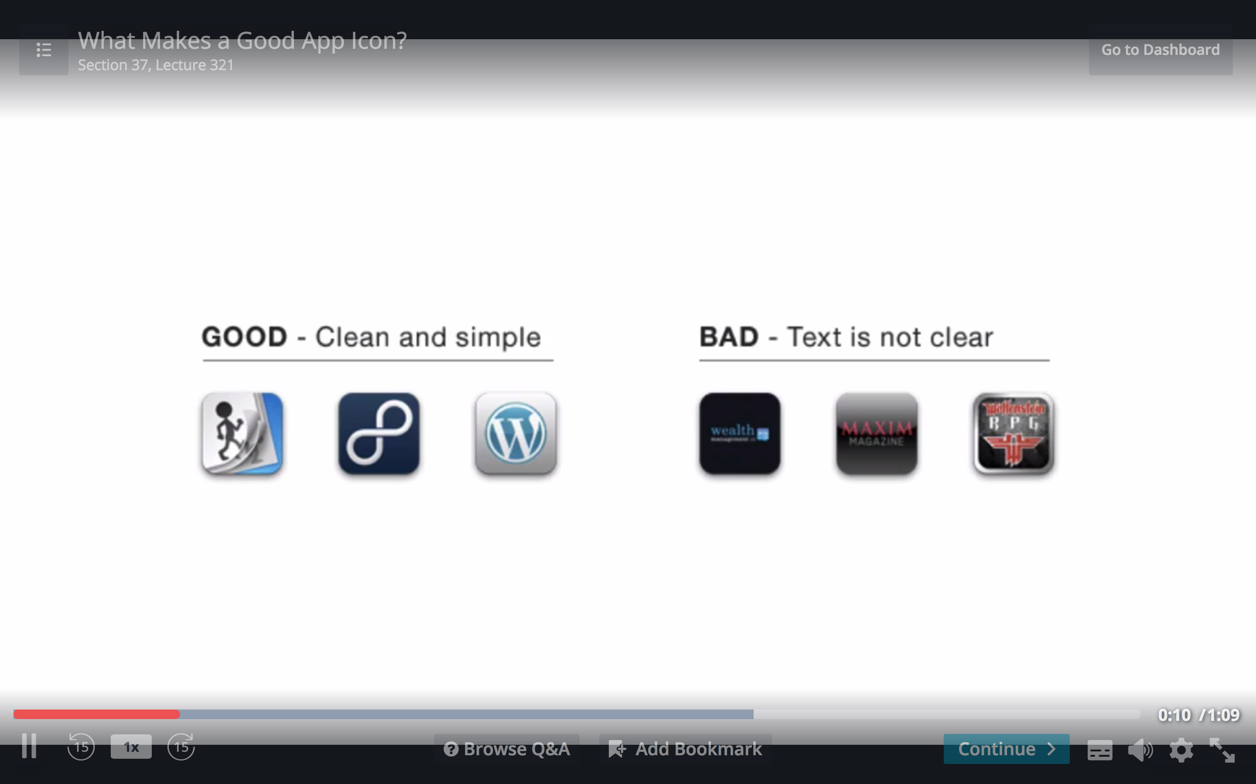

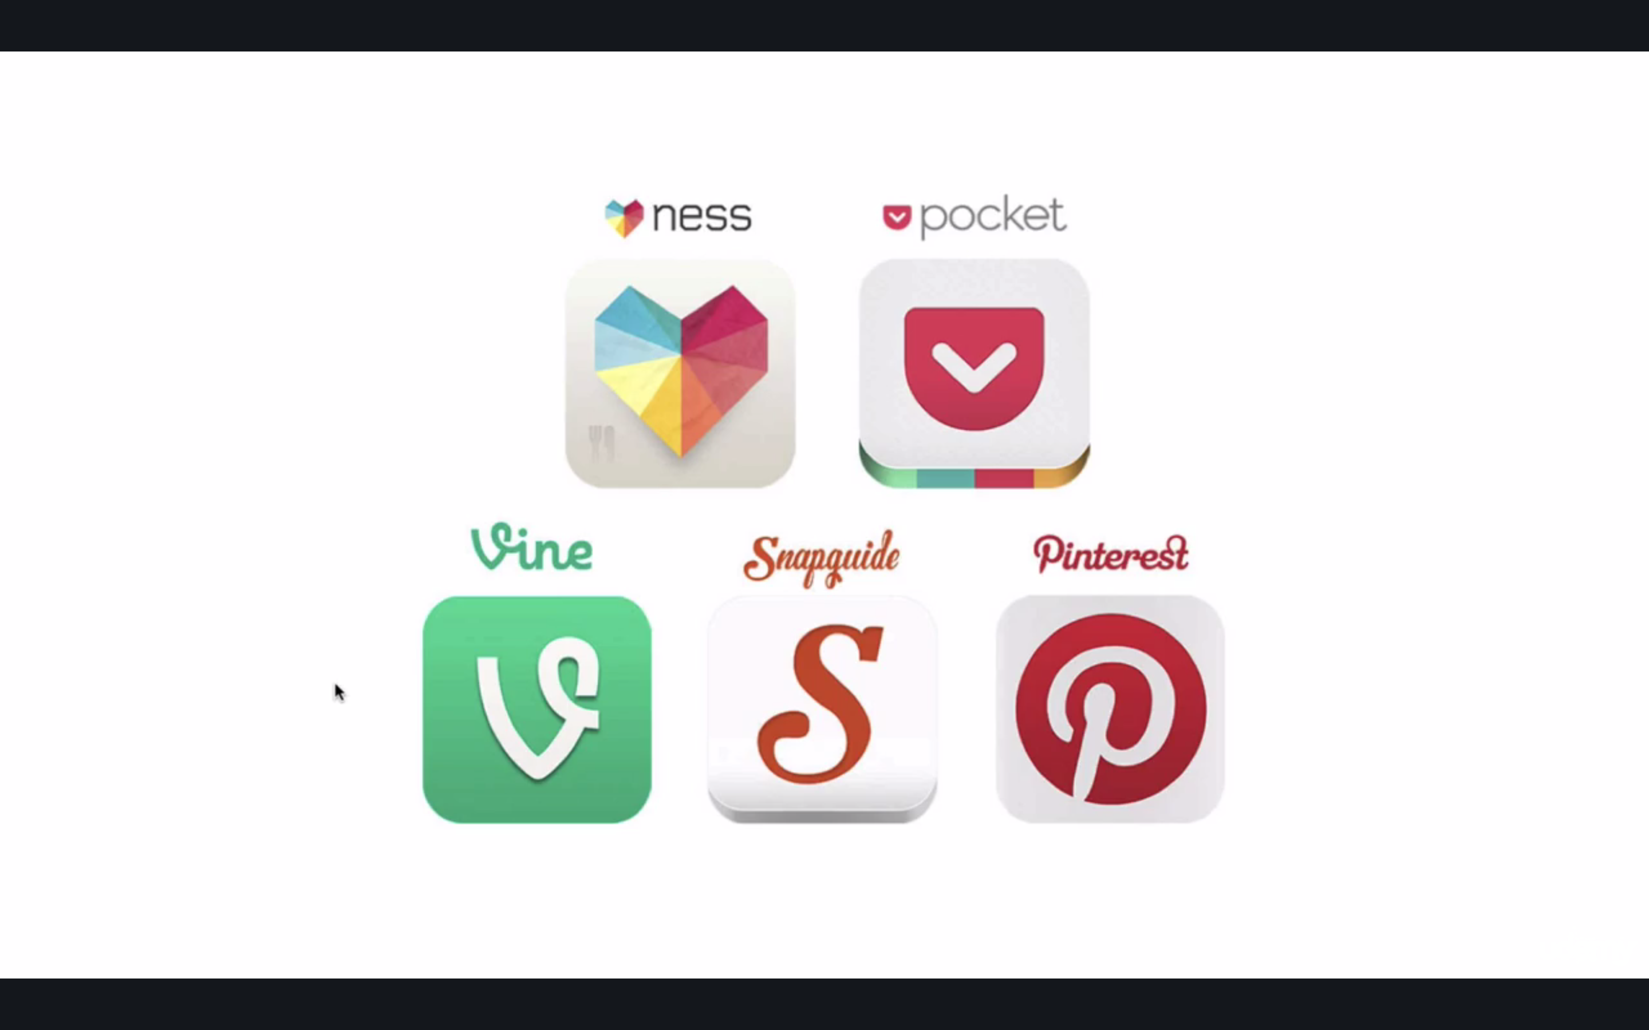

Dos and Don’ts of app screenshots

dos

1st simple a

simple screenshot of the app in use

2nd

desc action

3rd

you show off app

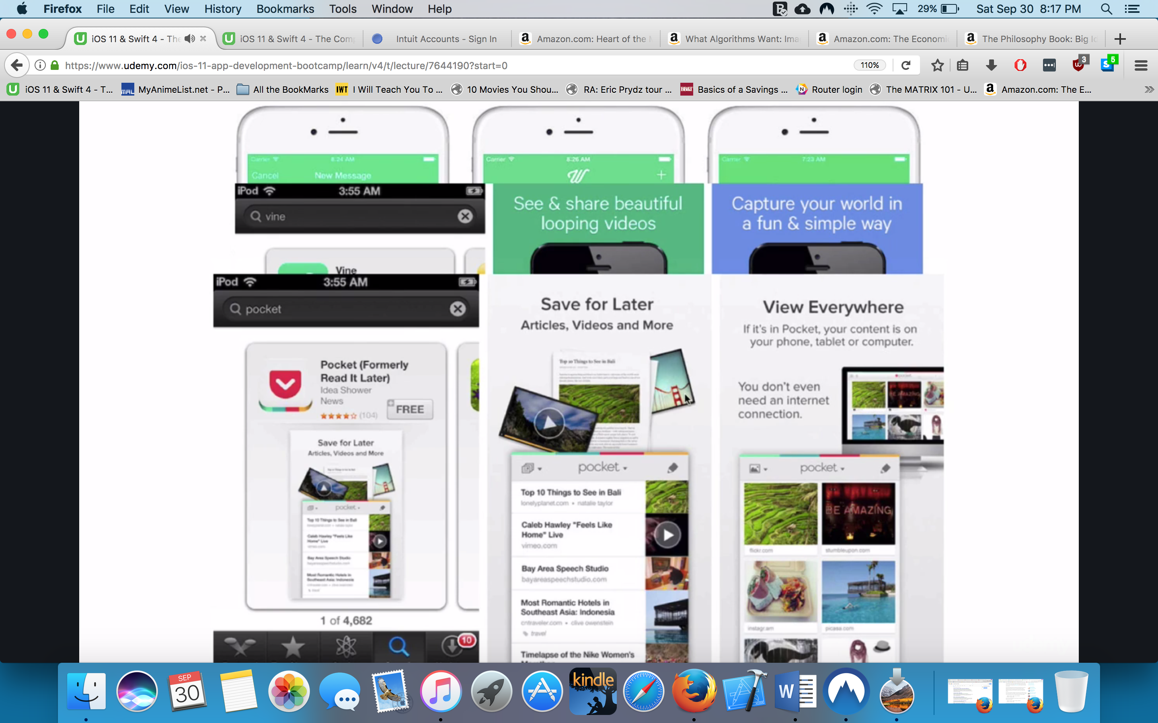

DON’T

Don’t use stock photography

DON’T put too much text explanation

DON’T put pixelated pcs –makes sure pics look good

Tools for screenshots

Mockupphone

Launchkit.io

GROWTH HACKING

Your first 1000 Customer

Your most important ppl in your launch career

The Technium-1000ppl who love you

Methods to discuss:

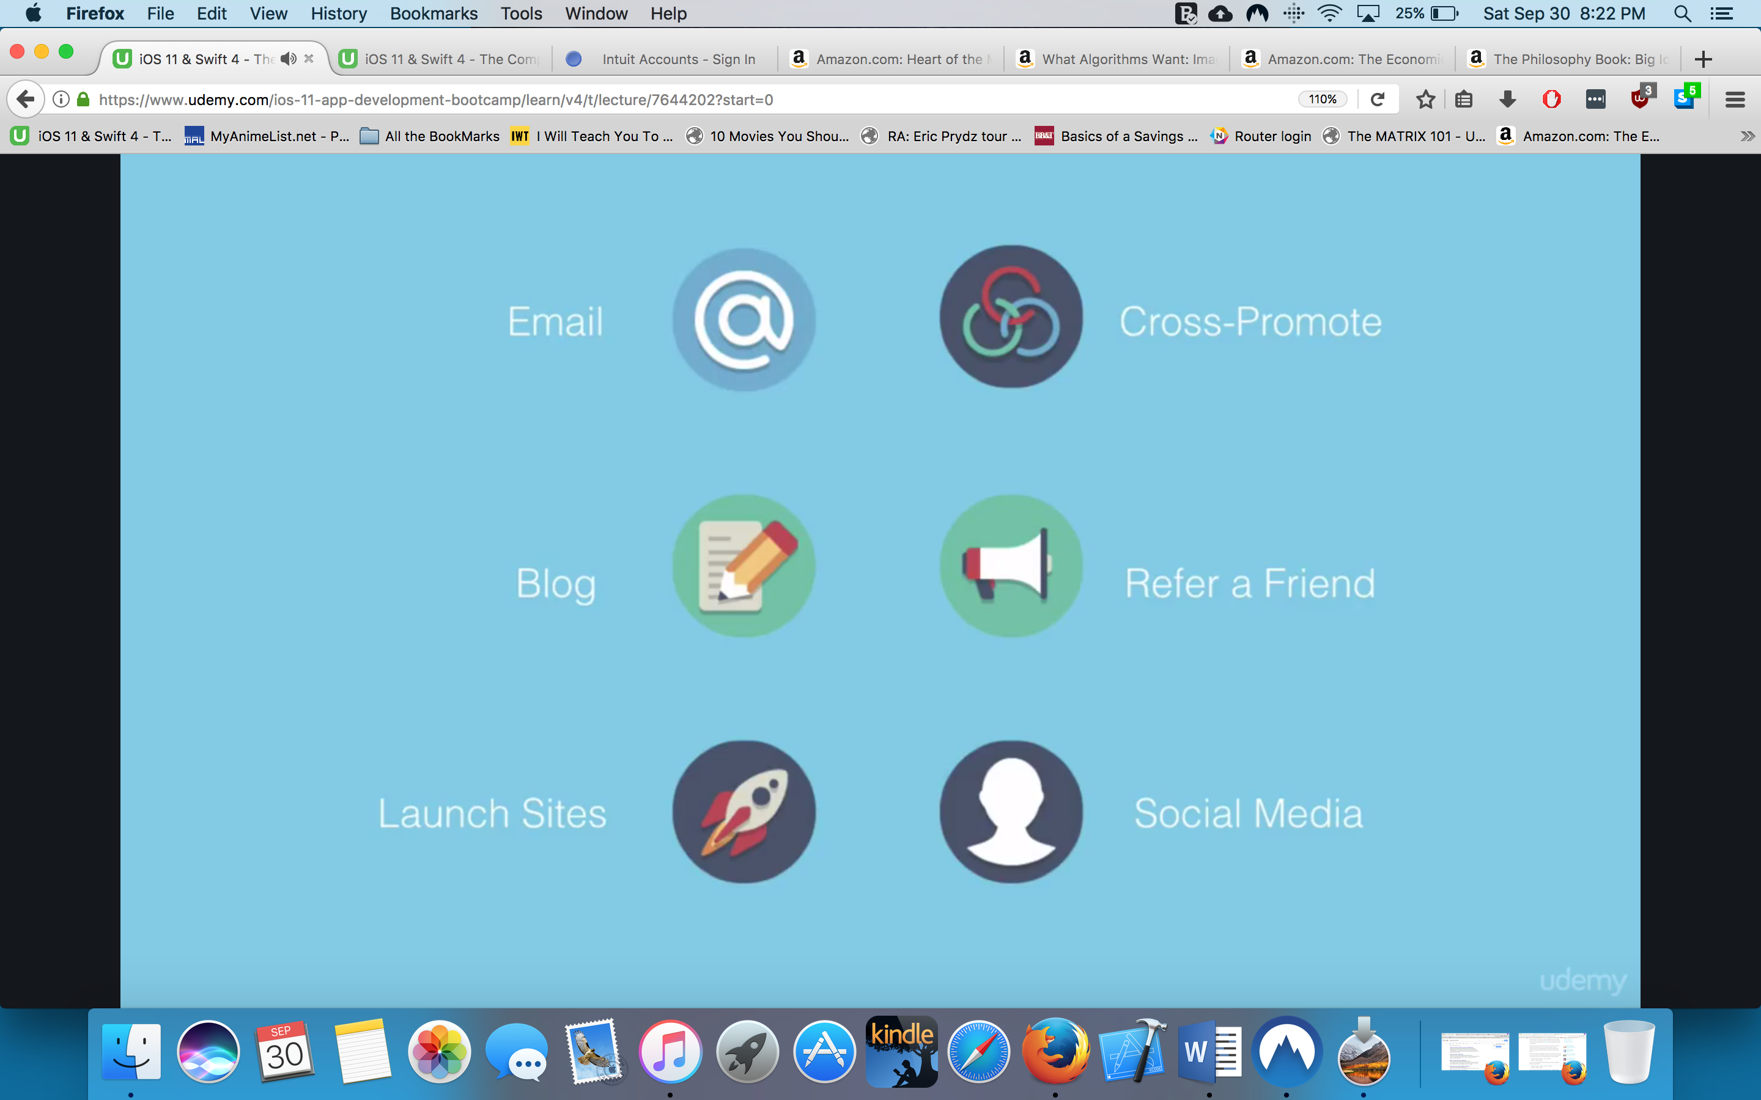

Email marketing

Both app store look at your 1-7-30 days of ur app

They detect the metrics of your trends before they feature you

The All important Landing Page

Look at the number of the Founding Member for social proof

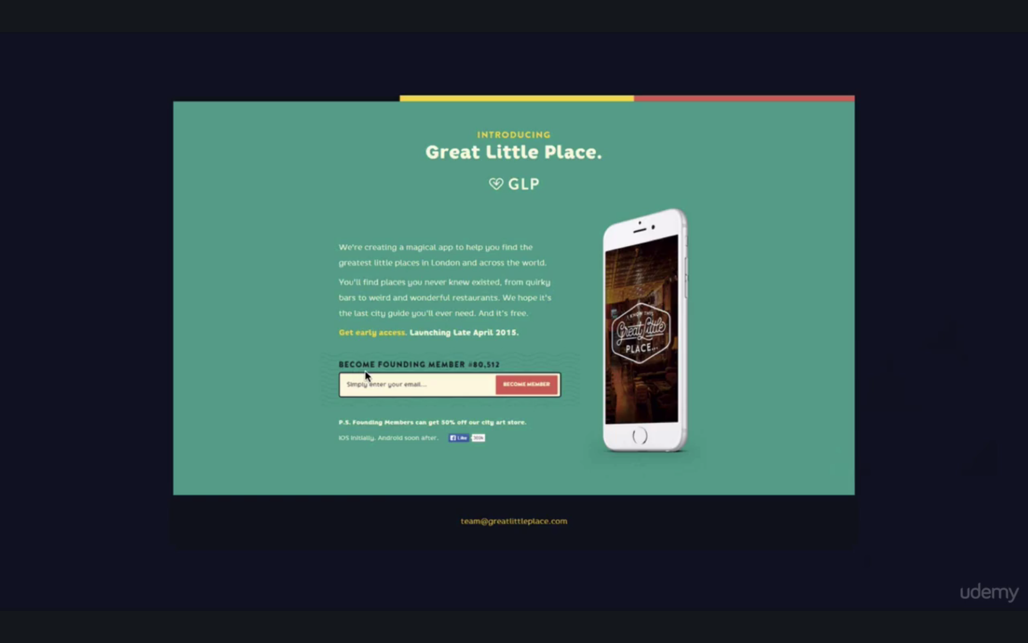

THE FOUNDER UPDATED THE NUMBER TO SOME RANDOM VALUE!!!!!

ETHICS GAGA

Rober Cialdini’s book ;)

Thinking Fast and Slow-decision and heuristics/we follow certain rules

Heard rul-it will keep you safe as a Neanderthal lol

Know how influence works

Bloggin your way to success

*Medium.com-as easy as blogging can get!!!!

Humans love story telling

You underestimate ppl’s procrastination w/ stealing ur idea

Get loose leaf.com

This guy documented his journey to making the app

Start writing your journey

Content marketing

You give away your secret sauce

Stuart hall-how I did well on the app store

Catchy title/they’re open about their secrets

How to successfully launch on Product Hunt

Piggy backing on someone elses audience

Best place to be on bleeding edge of tech

Things to be aware:

1 thers popular and newest

to show up at first starts 8am GMT

]

get in touch with infliencers –find htem on twitter

give them the below

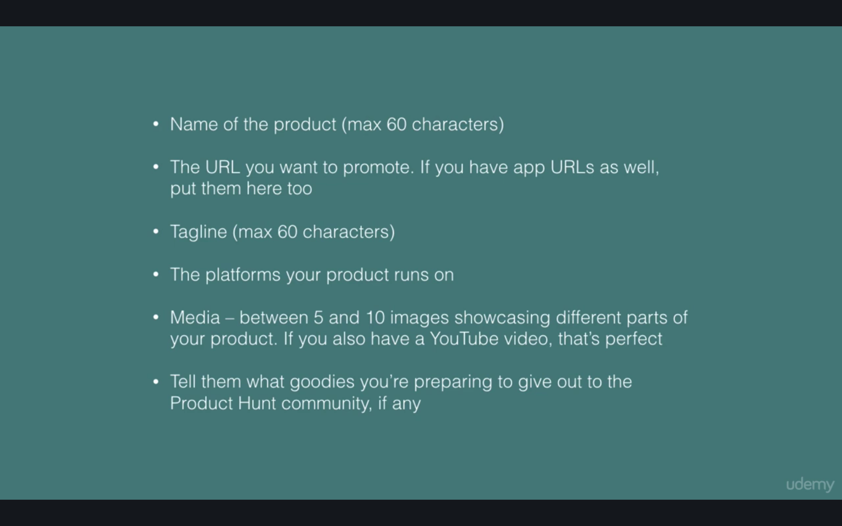

check leaderboard

prducthunt is linked to twitter

you cant solicit for upvotes-you cant copy paste the link!!!!

What you CAN do you can share the link of the search bar

This s a great place to get hots downloads etc

How to launch on BetaList

It has declined in popularity!!

Less hits and requires more money

Still one of good launch sites

How to Launch on Hacker News

PPL here are more TECHNICAL

Huge audience

Hard to get upvotes-you need al ot within the first hour

You can get upvotes from the same IP address

Get your friends across the world to upvote the first hour

What if at first you don’t succeed

Don’t be disheartened

Your launch day is the day you get traction/when you get featured

Launch-it’s a term that doesn’t really mean anything

Its more important what your audience is before you try to acquire those users

Cross promotion

Works sometimes

If you push diff thing to them it wont help much

But

Helo your usersfind your other APPS

These users never leave you ecosystem!!!

Social referring

Ex Robin Hood

The more ppl you refer, you can skip the queue

You encourage ppl to take action NOW-which leads to exponential proof

Maitre

Use for social proof

How to make social media work for you

It can suck up all your time lol

Focus on your customer

Ex

Food –IG is visual

News-Twitter

Figure out who and where your users are

Make sure u get the big 4 FB Pinterest IG Twitter

Grab your handles!!! Some ppl buy them and selling them for a couple thousands

The love app is RANDOMIZED!

Ppl would share if love score was too low or too high

Make your app leverage your social media

How to get Press Coverage for your app

Get PR firm?

If small company its best to have a small company

Its best if the founders pitch than a PR firm

Figure out your audience

Get exposure to where your audience is

How to craft a story

Imagine yourself as a journalist

It cant be some unknown company

Help them in their job

Ex rainier humping right before Christmas

What is something that would combine traditional and comical lol

They chose to present the story in a way that journalist will want to write about!

How to craft your pitch

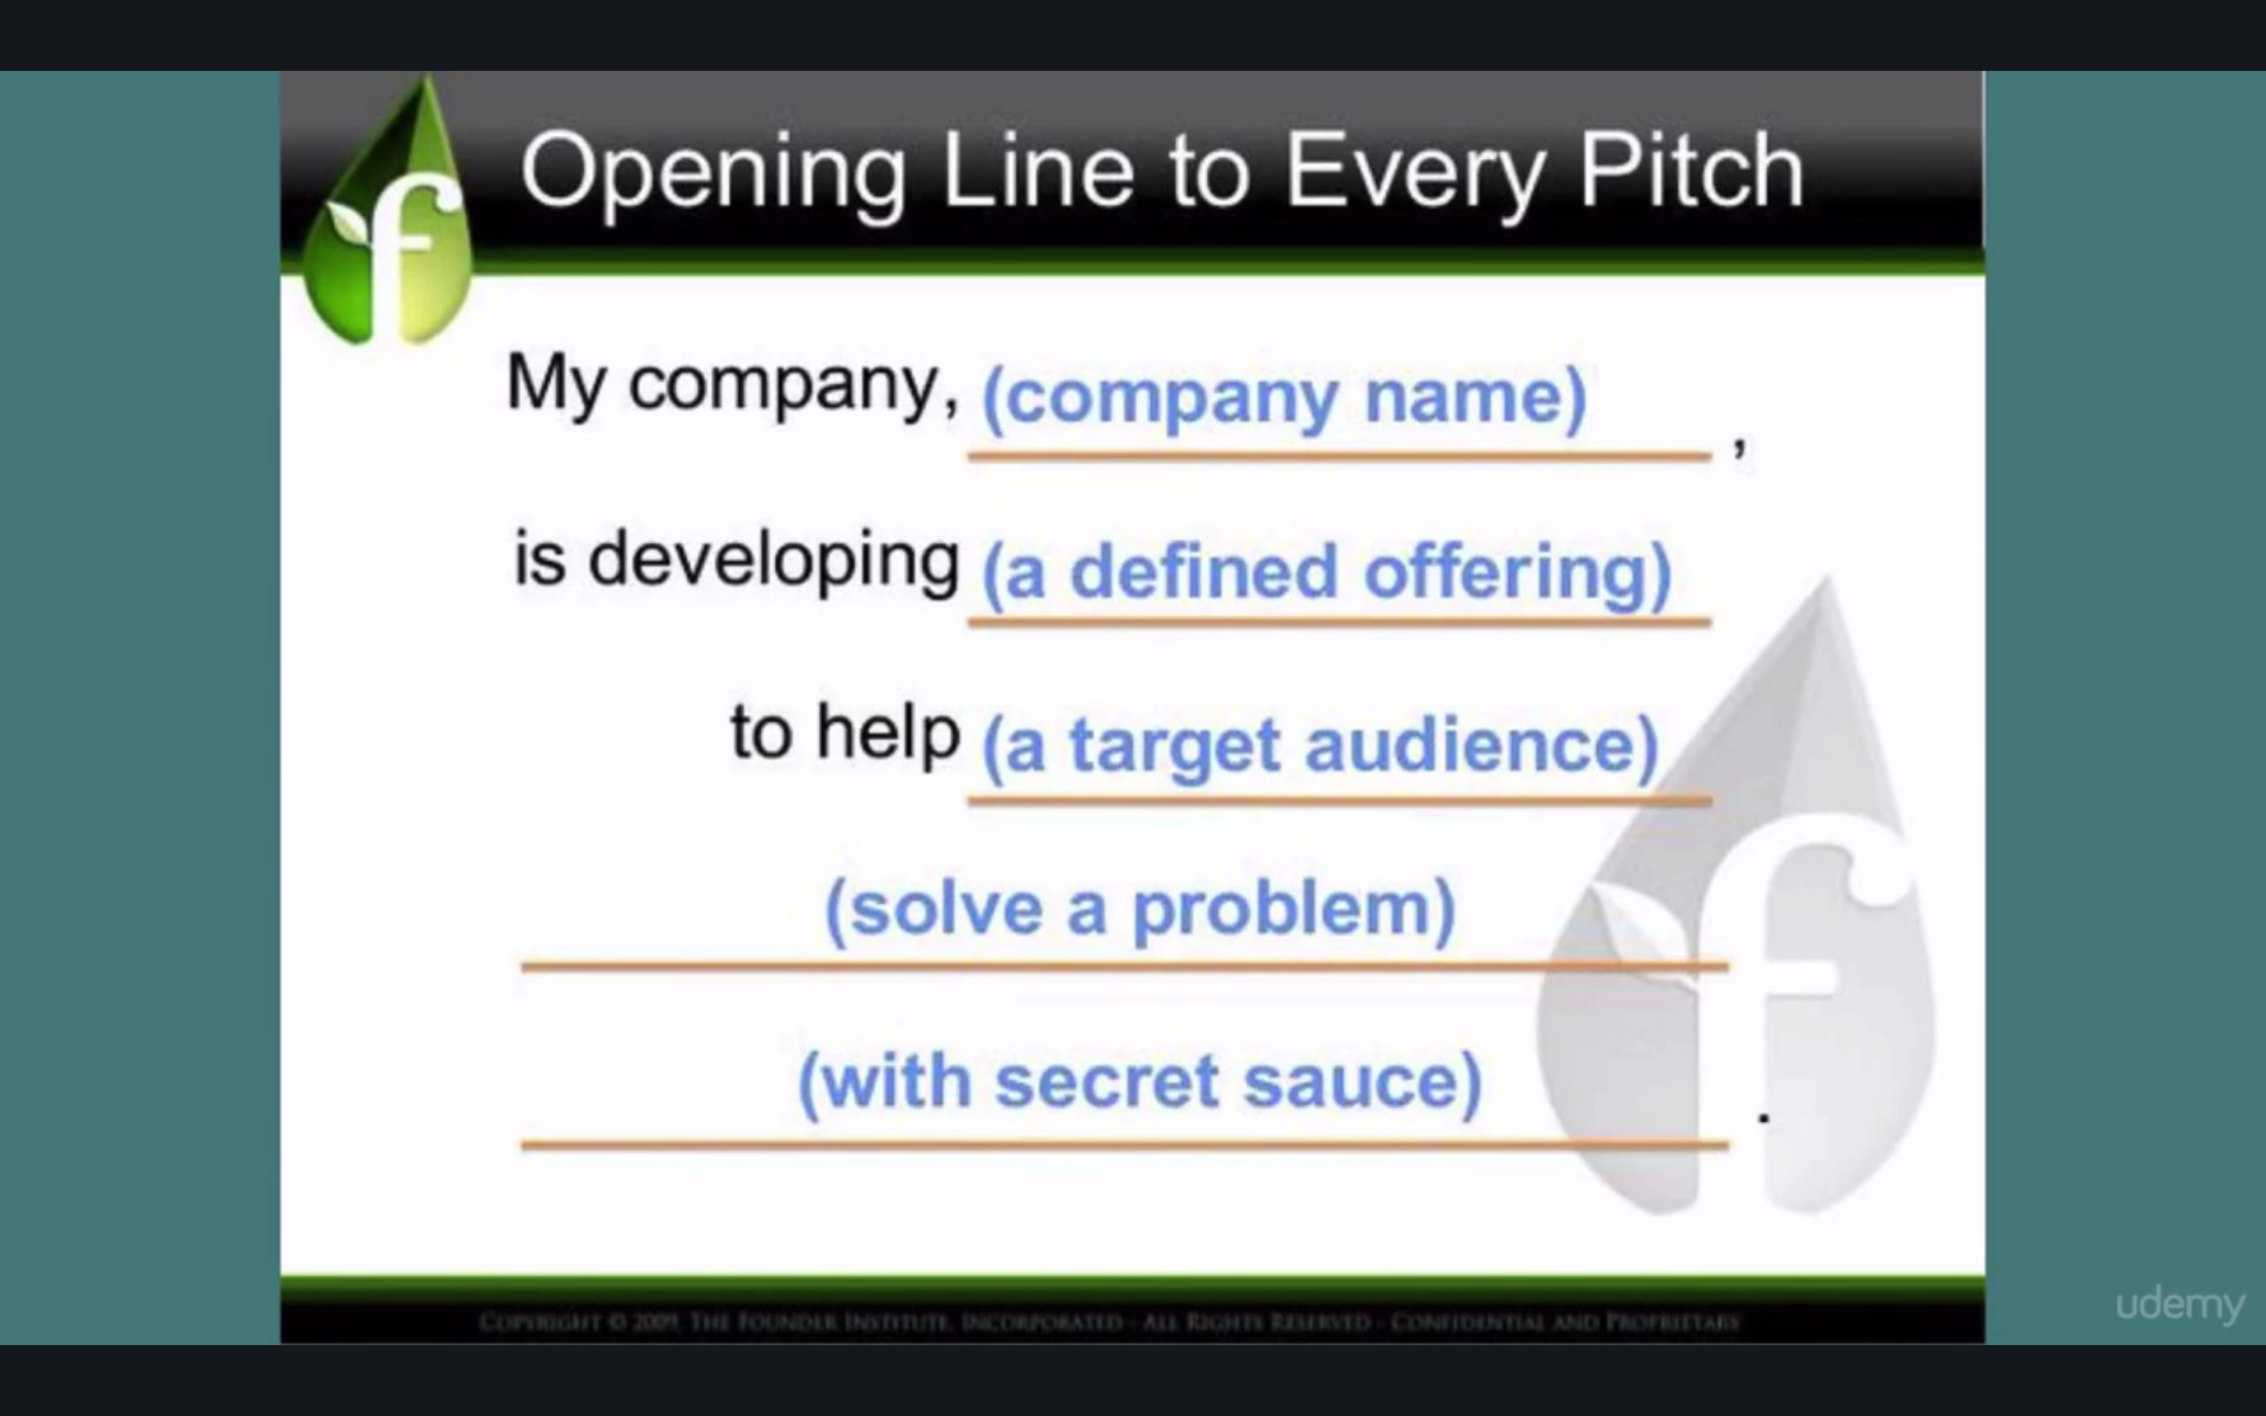

make sure its an elevator pitch that all make sense to anyone

most building in Sandhill Rd San Francisco buildings are 2-3 sotries high-so limited time

How to figure out which journalist to pitch

Find the ones that have written about your topic

Or

Use Buzzsumo

Show them you know what they do

Tailor it to their interest

They get pitched all the time lol

How to find anyone’s email

VoilaNorbert

How to pitch a journalist

Email is king

Kepp to 200 words

Give them a couple links to look out

What is the best time to reach them out?

First in the Day!!!!!!!

You can look at their twitter account-you can see their activity and tell when they wake up

Boomeranggmail.com

You can schedule it when it gets sent

Getsidekick.com-tracking your email-you get notified by your email gt opened!!!!!!!!

You can resent it a week later in case its not opened

Make their life easy- add a pic like this one

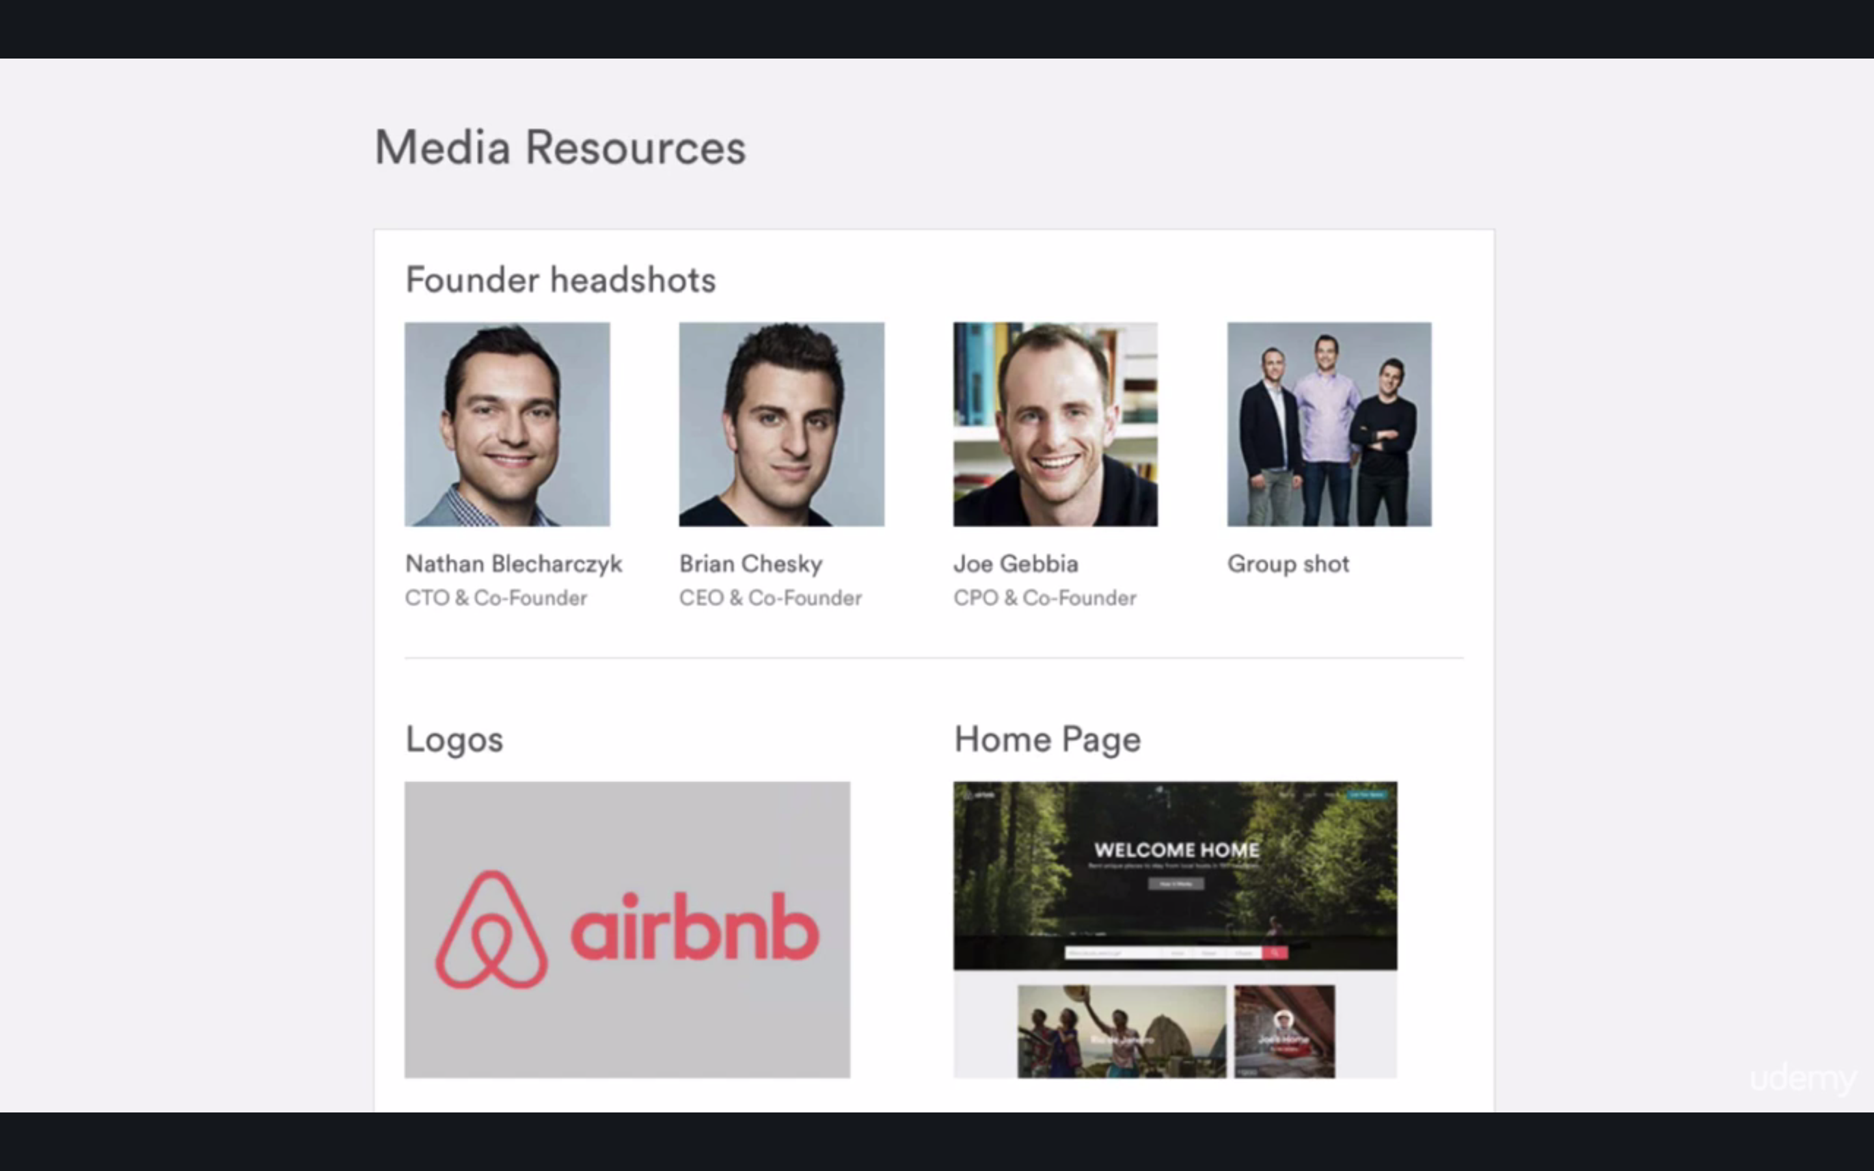

Build a relationship with a journalist

What if you cant get anyone to write for you

HelpAReporter

Journalrequests

Last resort

App giveaway-giving away your paid version to a company

Final Tips

Lol look up

**Trust me im lying- the way modern journalism works

How to get Featured in the App Store

Estimated in the app store

300K in marketing equivalent!!!!!!

KEY: performance 1-7-30 days

Only in the App Store

*Only on the app store line-

That’s why a lot of ppl make their app ONLY for the app store and THEN

Make the android app a year later

You might get a call from a manager asking whether you got ur app only for iOS

Apparently that’s a HUGE Deal to them

Lol

So if you wander android iOS both or which to do first, you know now ☺

Understand the corporate mindset

First comes the company

And THEN whatever makes the company look good

Native vs non-Native apps

Why make native and not hybrid

Pro-more customers

Con-inferior UI experience

Remember Android and iOS subtleties

BOTH stores prefer native apps

Tips and tricks of getting features

Localizing-translating your app

Design-if your app is serious of getting feature-get a pro designer

Generate Buzz!!!!

Contact –REAL LIFE CONNECTIONS matter more than anything else

ASO-app store optimization

Appear at the top when a keyword is searched

Top 3 -> 65%

1st 35% of ALL downloads

Top tips to optimize you app store listing

Keywords don’t need SPACES  
**KEYWORDS WILL AUTOMATICALLY FORM ALL POSSIBLE COMBINATIONS

YOU CANNOT UPDATE THEM- you need to push another release

My ASO workflow

One potion-you type a word and see suggestions of app store

Or use OneLook reverse dictionary!!

SensorTower Pro!!!!

App store optimization

Use scraper at chrome!

If traffic above 3 and difficulty below 3-solid keyword!!!

Apple search ads

You can display like an ad

Maybe not the best choice but:

Theres a good tool in the apple account login

Search Ads

Early vs late game strategies

If early-no reviews or metrics to rank highly for diff keywords

Ex ninja

Maybe instead of ninja you can use warrior or samurai

THEN you can target the hard ones

Diff between google play and app store

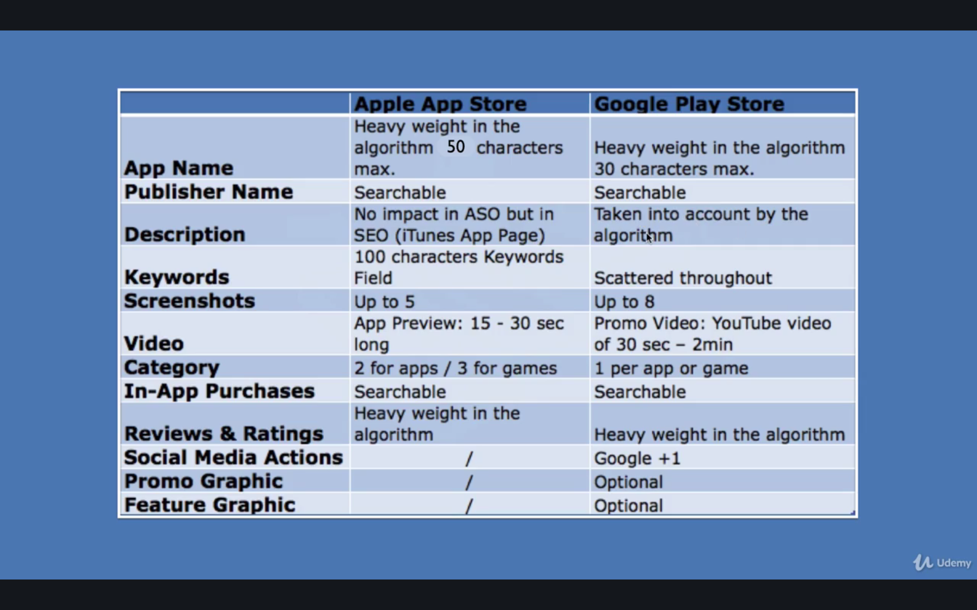

reviews count as keywords?!!!!!!

Ex ppl who hate Pandora and say they like Spotify

Spotify shows up when searching Pandora

When to use paid advertising

It has to be calculated per user to bring profits

Always test before you advertise

Make sure you TEST it!!!!

Otherwise you get bad reviews

AND you practically paid for ppl to leave you a bad review -____-

TESTING

Monkop –for android

For iOS:

UserTesting.com

Or PreApps

You can recruit beta testers there

Beta Test for free-either all over the world

Or in certain countries

For first 3M

AppBrewery released first in new Zealand and Canada

Small demographic with similar culture as USA etc

Which platform to advertise on

FACEBOOK IS KING!

How much does it cost?

50c to $1

two forms to advertise:

1 PPC pay per click

2 cost/1000 impressions

you should try to improve so that the 1000 are made to count

How to setup FB ads

Don’t make your pointer TOO specific ex to the red area of the needle

Use your competitors ad budget

Split testing

Don’t make only one add-make 10-20 more diff

Facebook tells you which ones get more clicks and higher conversions

see what they do

maybe it’s the character faces

or the object setup

figure out what they’re doing hat makes them stand out

Where can I dind more customers

Facebook SDK

Fb will sent it to a lookalike demographic

One weird trick to get more money from the Apple

Apple takes 30% of profits

*You can join the iTunes affiliate Program

as a commissioner you make 7% from what apple makes

HOW TO GET 5 STAR REVIEWS

The more you get them more visible you become

A lot make the prompt WRONG!

Ex this is BAD:

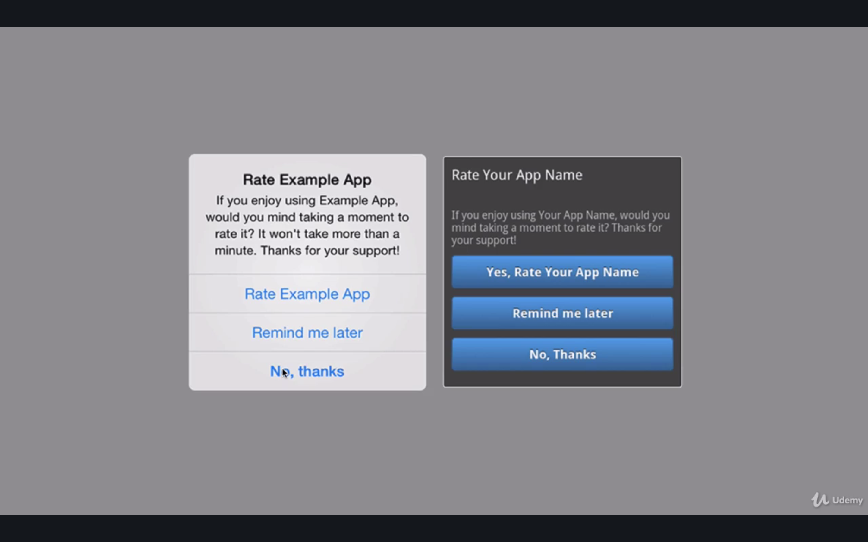

this is good:

happy –review

confused- guide

unhappy-developer feedback

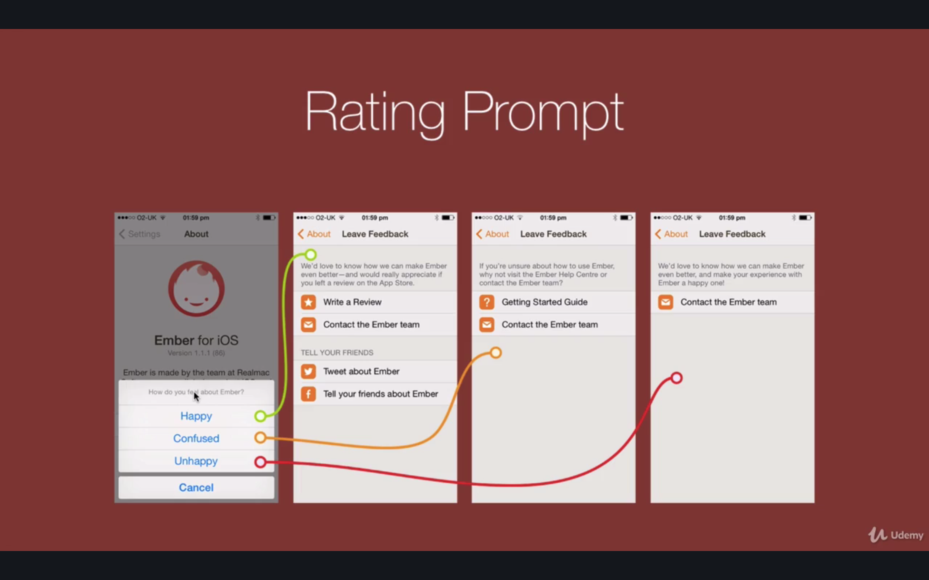

once a user tells you- you get on it asap and email them once you release the fixed update

target also the confused

Monitor app Reviews

Review Monitor

That way you’re informed if ex. Your app worked for iOS 9 but crashes at 10

How to use app analytics

Flurry!!!!

Mixpanel!!-more intuitive

*The app store will start deleting apps that don’t get updated!!!!

Getting more downloads

Whitehat

1 in app video

can be about niche or the app itself

lol Chinese android stores- since google play is banned

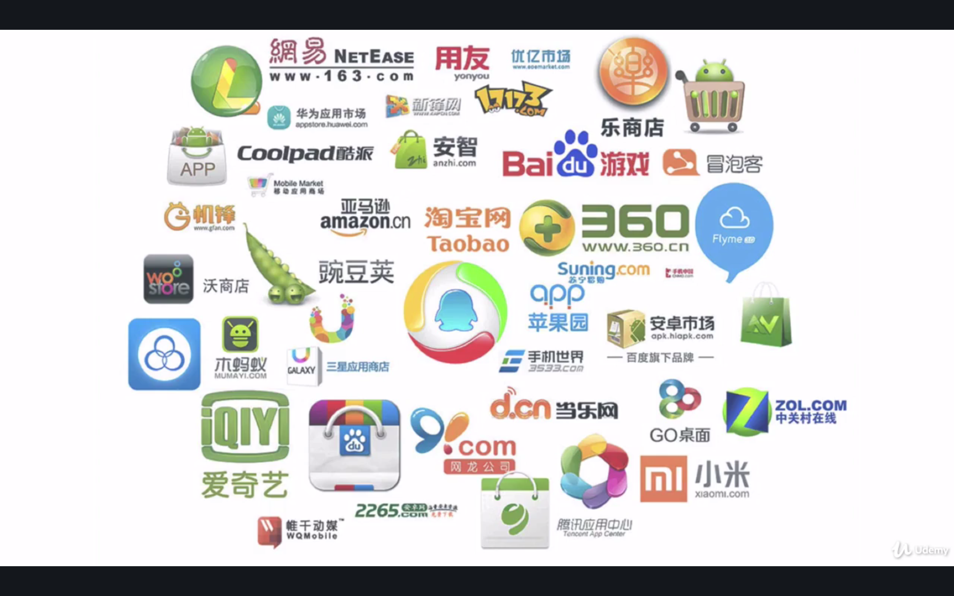

Black hat

Holy crap

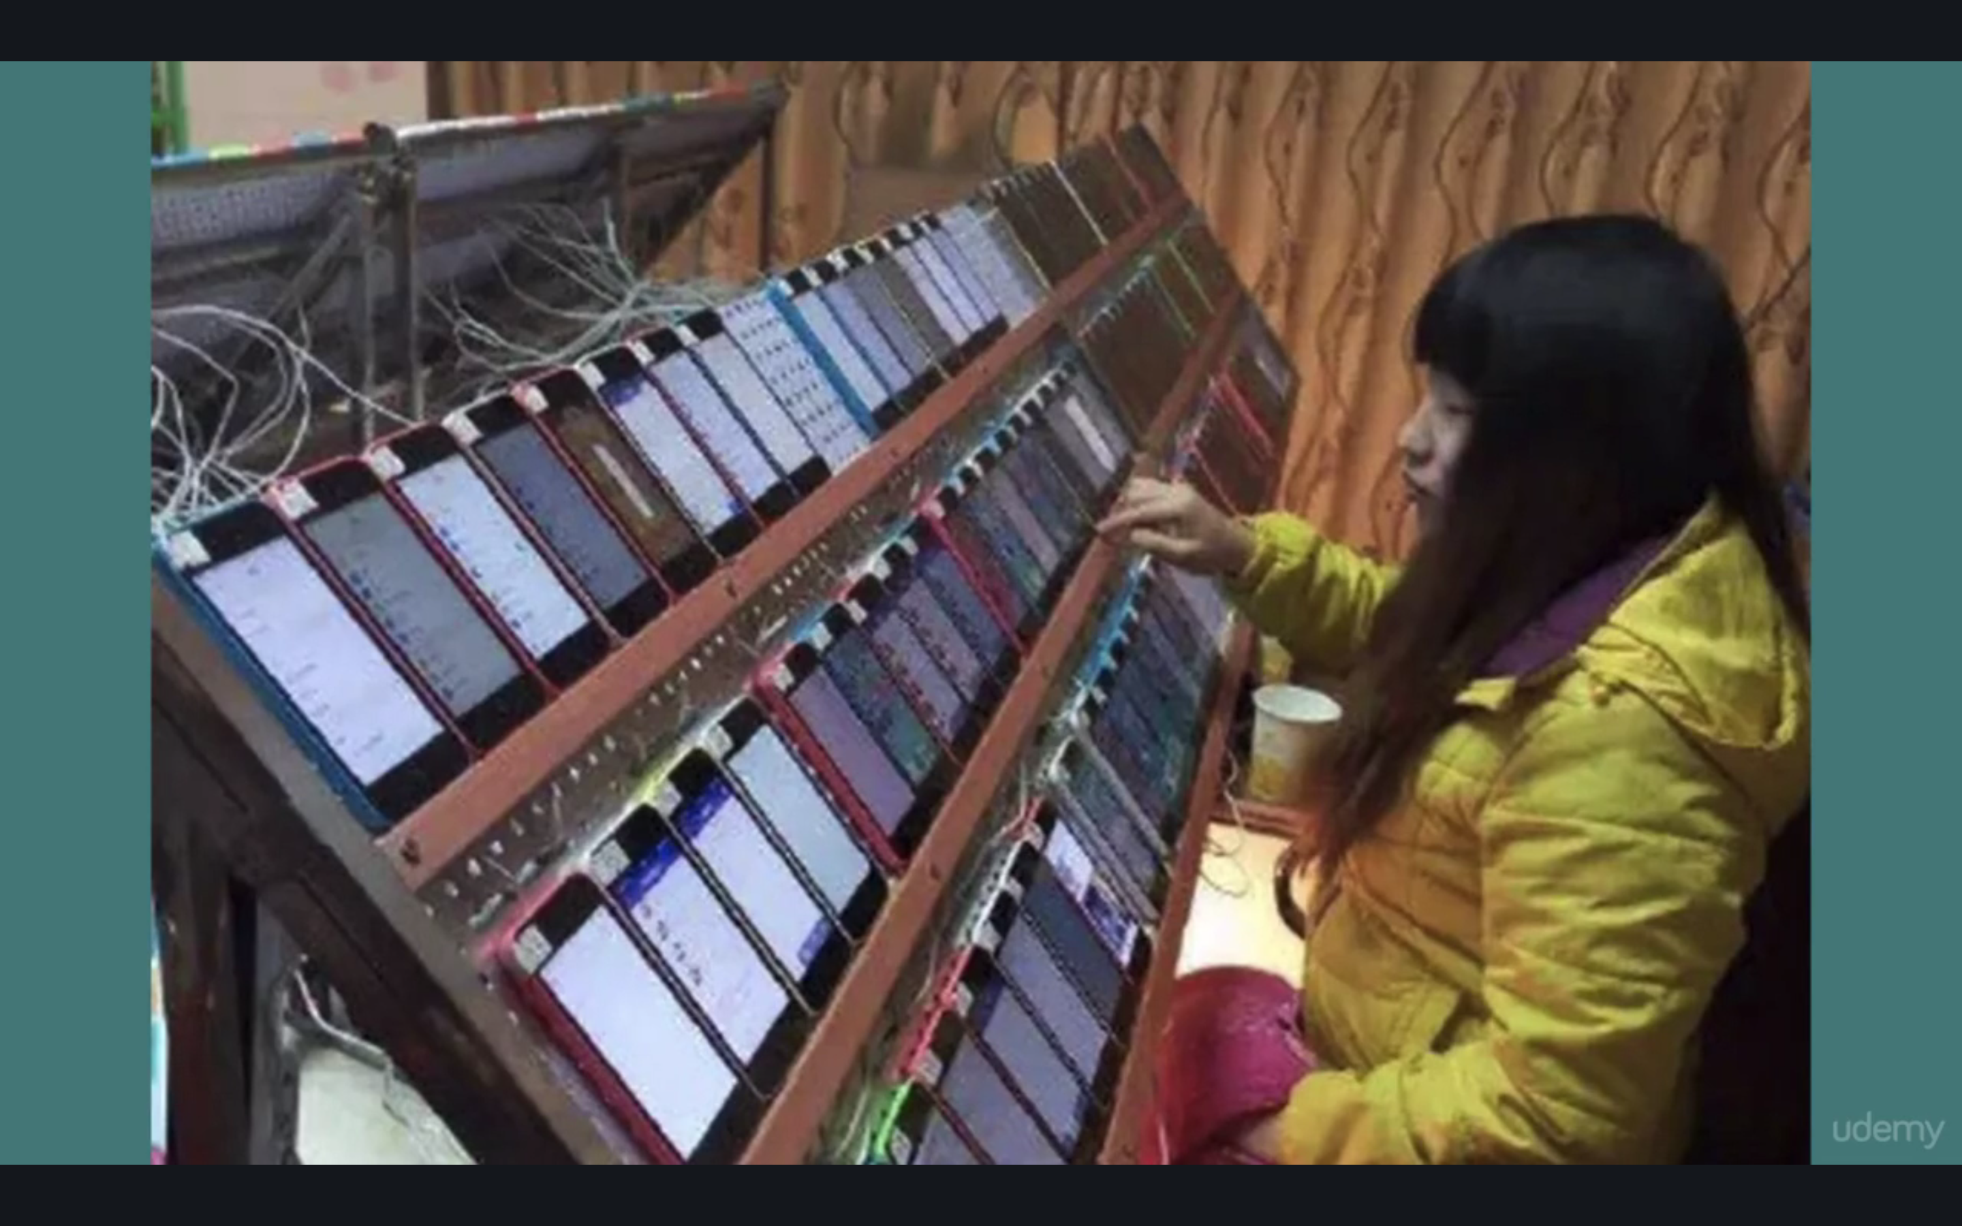

lot of these practices are illegal

*hmmmm fiverr-stay away from this!!!!

YOU CAN GE BANNED

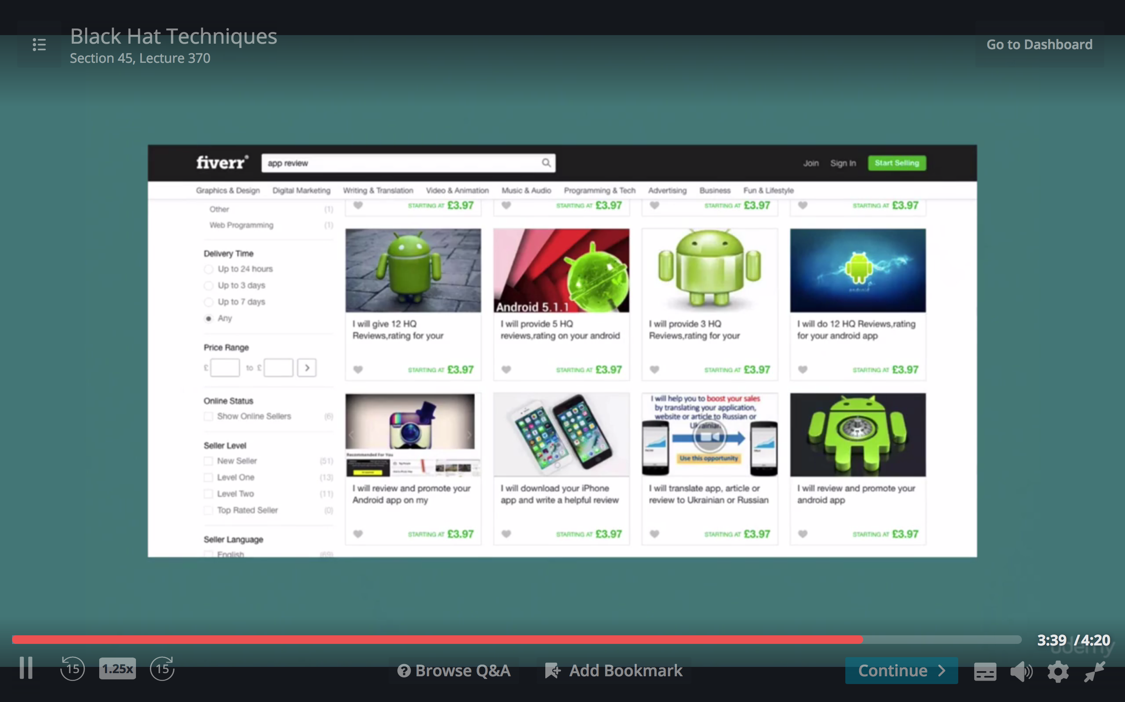

product page

screenshot and video

it JUST displays

*AppStop!!

You can aso use a Bootstrap

Git

Origin remote

Master branch

.git is the local

**You can clone and work on an open source app**